Spanish I
Chapter 4.1

Hoy es lunes cuatro de enero del del dos mil diez y seis.
Hace frío. Está nublado. Está nevando. No hace calor. No hace viento. No hace sol.
Nieva. No llueve. No está lloviendo

¿Cuánto estudias? Yo estudio..... minutos

LEARNING TARGET Spanish I

- –AR verbs
- Regular verbs
- Irregular verb Jugar
- Review of past chapters
- Spanish Prepositional Pronouns

CORNELL NOTES  SHEET | Name: KattyaRomero  Class: Spanish I  Topic: Spanish  Date: Hoy es del dos mil diez y seis  Period primero, tercero
PREGUNTAS | APUNTES
What are we studying? | - –AR verbs  - Irregular verbs  - Regular verbs  - Reviewing all verbs covered in pass chapters
What is our focus? | Conjugations of -ar Regular verbs and conjugations of –ar irregular verbs  Spanish Prepositional Pronouns
What are we reviewing? | GUSTAR, ENCANTAR, ESTAR, NECESITAR, SER, TENER, SER, ENCONTRAR, COMPRAR
What’s an irregular verb?  What’s a regular verb?  What the endings for ALL verbs in Spanish?  Why is it important to learn how to master Spanish verb conjugations? | Irregular verbs have a change in the root  Regular verb keeps the same root of the verb  All verbs in Spanish end in –ar, -er and –ir.  Verbs are a vital part of every language, and being able to use them correctly makes the difference between being understood or confusing the person with whom you are speaking. Spanish verbs are conjugated in such a way that they can express WHO is performing an action and WHEN they are performing it in a single conjugated verb. A correctly conjugated Spanish verb form expresses who is speaking and what verb tense is being used.
What is the vocabulary we are reviewing? | Daily activities such as: to look, to need, to find, to buy, see list below.
SUMMARY: Write 4 or more sentences describing specific learning from these notes.
The BETTER I memorize the verb forms, the better I can read, write, speak, and understand the Spanish language.

Useful Websites

https://www.youtube.com/watch?feature=player_embedded&v=gmjWWphCx5k
https://www.youtube.com/watch?v=gmjWWphCx5k
https://www.youtube.com/watch?v=4Ex3k3yKjYk
https://www.youtube.com/watch?v=DdIu6S5Frb0

EXTRA CREDIT and good websites to study
https://quizlet.com/691153/what-you-or-others-likewant-to-do-flash-cards/
https://quizlet.com/16824204/ven-conmigo-level-1-capitulo-4-paso-1-flash-cards/
https://quizlet.com/691153/what-you-or-others-likewant-to-do-flash-cards/
https://quizlet.com/64372755/spanish-i-chapter-4-paso-1-ven-conmigo-flash-cards/

VOCABULARY LIST for the whole chapter. The chapter it’s divided in 3 steps. The vocabulary in red we have not covered yet.

http://conjuguemos.com/print_vocabulary_list.php?id=137&source=public
Ven Conmigo 1: Chapter 4

English |  |  | Spanish
1. Friday |  |  | 1. el viernes
2. I |  |  | 2. yo
3. I like to |  |  | 3. me gusta/a mí me gusta
4. Monday |  |  | 4. el lunes
5. Saturday |  |  | 5. el sábado
6. Sunday |  |  | 6. el domingo
7. Thursday |  |  | 7. el jueves
8. Tuesday |  |  | 8. el martes
9. Wednesday |  |  | 9. el miércoles
10. What do you do after school? |  |  | 10. ¿Qué haces después de clases?
11. What do you like to do? |  |  | 11. ¿Qué te gusta hacer?
12. Where (to)? |  |  | 12. ¿Adónde?
13. Where are you going? |  |  | 13. ¿Adónde vas?
14. Where? |  |  | 14. ¿Dónde?
15. Who likes to? |  |  | 15. ¿Quién le gusta?
16. Who? |  |  | 16. ¿Quién?
17. after |  |  | 17. después de
18. before |  |  | 18. antes de
19. downtown |  |  | 19. el centro
20. during free time |  |  | 20. en el tiempo libre
21. far from |  |  | 21. lejos de
22. he |  |  | 22. él
23. here |  |  | 23. aquí
24. in order to... |  |  | 24. para
25. near |  |  | 25. cerca de
26. next to |  |  | 26. al lado de
27. on top of |  |  | 27. encima de
28. she |  |  | 28. ella
29. that's why |  |  | 29. por eso
30. that, which, who |  |  | 30. que
31. the (social) walk, stroll |  |  | 31. el paseo
32. the day |  |  | 32. el día
33. the dinner |  |  | 33. la cena
34. the guitar |  |  | 34. la guitarra
35. the gym |  |  | 35. el gimnasio
36. the house, home |  |  | 36. la casa
37. the ice cream |  |  | 37. el helado
38. the library |  |  | 38. la biblioteca
39. the movie |  |  | 39. la película
40. the movie theater |  |  | 40. el cine
41. the park |  |  | 41. el parquet
42. the piano |  |  | 42. el piano
43. the post office |  |  | 43. el correo
44. the restaurant |  |  | 44. el restaurante
45. the soft drink |  |  | 45. el refresco
46. the store |  |  | 46. la tienda
47. the supermarket |  |  | 47. el supermercado
48. the swimming pool |  |  | 48. la piscine
49. the week |  |  | 49. la semana
50. the weekend |  |  | 50. el fin de semana
51. the work, job |  |  | 51. el trabajo
52. there |  |  | 52. allá
53. they (fem.) |  |  | 53. ellas
54. they (masc.) |  |  | 54. ellos
55. to be |  |  | 55. estar
56. to dance |  |  | 56. bailar
57. to draw |  |  | 57. dibujar
58. to drink, to take |  |  | 58. tomar
59. to listen to music |  |  | 59. escuchar música
60. to paint |  |  | 60. pintar
61. to play (an instrument) |  |  | 61. tocar
62. to practice |  |  | 62. practicar
63. to prepare |  |  | 63. preparar
64. to rest in the park |  |  | 64. descansar en el parque
65. to return |  |  | 65. regresar
66. to ride a bike |  |  | 66. montar en bicicleta
67. to see |  |  | 67. ver
68. to sing |  |  | 68. cantar
69. to spend time with friends |  |  | 69. pasar el rato con amigos
70. to study |  |  | 70. estudiar
71. to swim |  |  | 71. nadar
72. to take care of your brother |  |  | 72. cuidar a tu hermano
73. to take care of your sister |  |  | 73. cuidar a tu hermana
74. to take out the trash |  |  | 74. sacar la basura
75. to talk on the phone |  |  | 75. hablar por teléfono
76. to the (fem.) |  |  | 76. a la
77. to the (masc.) |  |  | 77. al
78. to walk the dog |  |  | 78. caminar con el perro
79. to wash the car |  |  | 79. lavar el carro
80. to wash the clothes |  |  | 80. lavar la ropa
81. to watch TV |  |  | 81. mirar la televisión
82. to work |  |  | 82. trabajar
83. under, beneath |  |  | 83. debajo de
84. we |  |  | 84. nosotros
85. with |  |  | 85. con
86. with me |  |  | 86. conmigo
87. with you |  |  | 87. contigo
88. you (formal) |  |  | 88. usted
89. you (informal) |  |  | 89. tú
90. you (plural informal) |  |  | 90. vosotros/vosotras
91. you (plural, formal) |  |  | 91. ustedes
2000-2015 CONJUGUEMOS (Yegros Educational LLC)

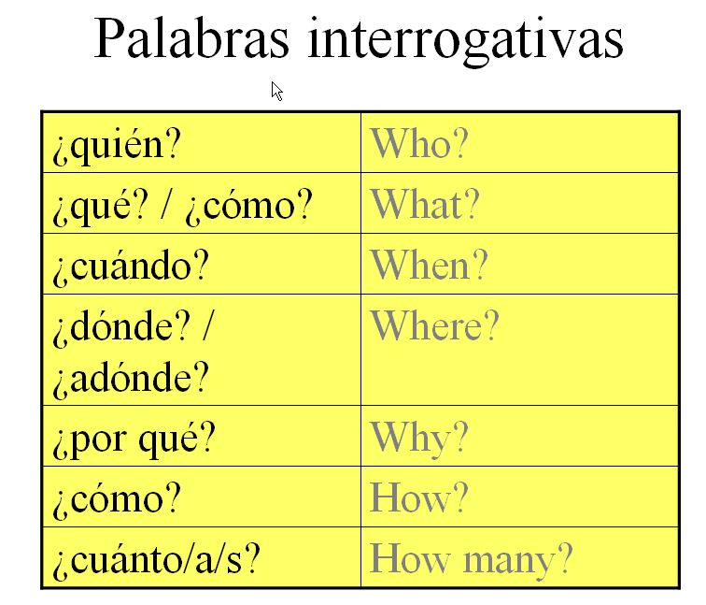

--AR Verbs and --AR Verb Conjugation

- Why is it important to learn how to master Spanish verb conjugations?
Is it simply because your Spanish teacher just wants to "torture" you? No, actually, that ISN'T the answer. Verbs are a vital part of every language, and being able to use them correctly makes the difference between being understood or confusing the person with whom you are speaking. Spanish verbs are conjugated in such a way that they can express WHO is performing an action and WHEN they are performing it in a single conjugated verb. A correctly conjugated Spanish verb form expresses who is speaking and what verb tense is being used.
It is really important that you learn the correct conjugation of each verb in your high school foreign language classroom, much like you learned your multiplication facts for math class in elementary school. There are no approximations. Just like the multiplication fact of "5 x 5 is 25," you need to know that the "a" verb ending in --AR verbs is used for sentences for "ella," él," and "Usted." You can't say that "5 x 6 is maybe 26" or "5 x 6 is approximately 21." You need to know the correct answer for math to solve an equation or a math problem. In Spanish class, you need to know that the "amos" ending goes with "nosotros" and "nosotras" form verbs. It is not a guessing game or an approximation.
The BETTER you have memorized your verb forms, the better able you will be able read, write, speak, and understand the Spanish language.
While all of us might like a "shortcut," there really is only ONE way to learn the conjugation patterns of Spanish verbs and that is to memorize each of them. This is going to require some effort, time, and work on the part of the student. Your teacher and your parents cannot memorize these verb forms for you, just as they couldn't memorize your math multiplication tables for you to use in math class. However, once you memorize these forms, you are well on your way to understanding a lot of information about what is being said in Spanish from a simple verb form.

--

AR VERB VOCABULARY
[Note: These are the --AR verbs for your quiz. There are many more --AR verbs than this list in the Spanish language.]
1. hablar to speak
2. pagar to pay
3. buscar to look for
4. preguntar to ask
5. pasar to happen; to pass; to pass by
6. llevar to wear; to carry
7. entrar to enter
8. mirar to look at
9. enseñar to teach
10. preparar to prepare
11. comprar to buy
12. desear to want
13. andar; caminar to walk
14. escuchar to listen to
15. ayudar to help
16. contestar to answer
17. usar to use
18. necesitar to need
19. esperar to wait for; to expect
20. gritar to yell; to scream
21. cocinar to cook
22. estudiar to study
23. sacar to earn; to take out
24. bailar to dance
25. llegar to arrive

IRREGULAR VERB JUGAR A (AL A EL) (A LA) TO PLAY A SPORT not AN INSTRUMENT

Useful videos:

https://www.youtube.com/watch?v=TR4bIn0WH4E
https://www.youtube.com/watch?v=hGkNWt3jAfo
https://www.youtube.com/watch?v=aTb6IzM1LRk

Jugar = to play (a sport / a board game)
Stem-changing verb: "u" to "ue" verb

This video conjugates the verb jugar and uses some additional activity ("actividades")vocabulary:
el ajedrez – chess
el básquetbol – basketball
el béisbol – baseball
el fútbol – soccer
el fútbol americano – [american] football
el golf – golf
el tenis – tennis
el voleibol – volleyball
las cartas – cards
las damas– checkers
los videojuegos – video games

USEFUL: PAGE with all verb conjugations

http://users.ipfw.edu/jehle/VERBLIST.HTM

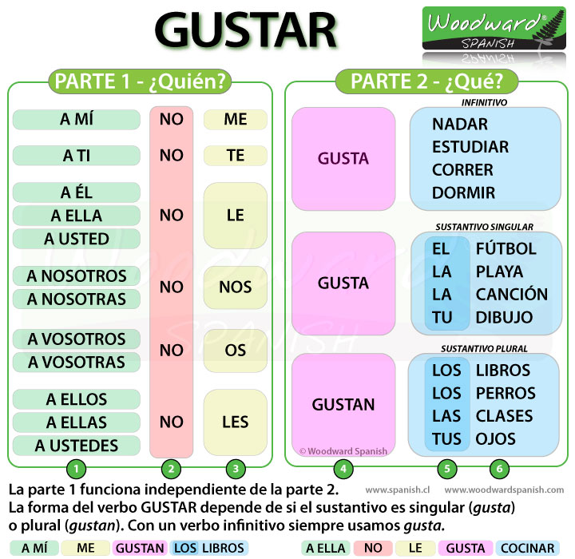

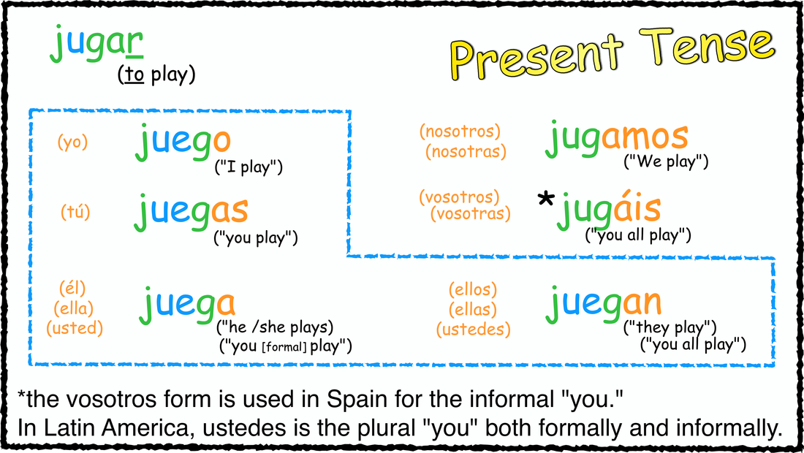

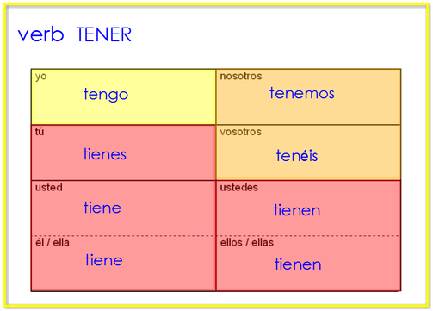
Present Indicative: Regular -AR verbs
tocar: to touch or to play an instrument
yo toco | nosotros tocamos
tú tocas | (vosotros tocáis)
él/ella/Ud. toca | ellos/ellas/Uds. tocan

Present Indicative: Regular -AR verbs
DESCANSAR: to rest
yo descanso | nosotros descansamos
tú descansas | (vosotros descansáis)
él/ella/Ud. descansa | ellos/ellas/Uds. descansan

Present Indicative: Regular -AR verbs
Bailar: to dance
yo bailo | nosotros bailamos
tú bailas | (vosotros bailáis)
él/ella/Ud. baila | ellos/ellas/Uds. bailan

Present Indicative: Regular -AR verbs
Caminar: to walk
yo camino | nosotros caminamos
tú caminas | (vosotros camináis)
él/ella/Ud. camina | ellos/ellas/Uds. caminan

Dibujar: To draw
yo dibujo | nosotros  dibujamos
tú dibujas | (vosotros  dibujáis)
él/ella/Ud. dibuja | ellos/ellas/Uds.  dibujan
Present Indicative: Regular -AR verbs
ESCHUCHAR: To listen
yo  escucho | nosotros  escuchamos
tú  escuchas | (vosotros  escucháis)
él/ella/Ud.  escucha | ellos/ellas/Uds.  escuchan
ESTUDIAR: TO STUDY
yo  estudio | nosotros  estudiamos
tú estudias | (vosotros  estudiáis)
él/ella/Ud.  estudia | ellos/ellas/Uds.  Estudian
DIBUJAR: TO DRAW
yo  DIBUJo | nosotros  DIBUJamos
tú  DIBUJas | (vosotros  DIBUJáis)
él/ella/Ud.  DIBUJa | ellos/ellas/Uds.  DIBUJan
Present Indicative: Regular -AR verbs
Hablar: to talk
yo  Hablo | nosotros  Hablamos
tú  Hablas | (vosotros  Habláis)
él/ella/Ud.  Habla | ellos/ellas/Uds.  Hablan
Present Indicative: Regular -AR verbs
Lavar: to wash
yo lavo | nosotros lavamos
tú lavas | (vosotros laváis)
él/ella/usted lava | ellos/ellas/Ustedes lavan
Present Indicative: Regular -AR verbs
Mirar: to watch, to look at

yo miro | nosotros miramos
tú miras | (vosotros miráis)
él/ella/Ud. mira | ellos/ellas/Uds. Miran
Present Indicative: Regular -AR verbs
Montar: to ride
yo Monto | nosotros Montamos
tú Montas | (vosotros Montáis)
él/ella/Ud. Monta | ellos/ellas/Uds. Montan
Present Indicative: Regular -AR verbs
Nadar: to swim
Yo Nad o | nosotros Nadamos
tú Nadas | (vosotros Nadáis)
él/ella/Ud. Nada | ellos/ellas/Uds. Nadan
Present Indicative: Regular -AR verbs
Pasar (el rato con amigos): to spend time with friends
yo Paso | nosotros Pasamos
tú Pasas | (vosotros Pasáis)
él/ella/Ud. Pasa | ellos/ellas/Uds. Pasan
Present Indicative: Regular -AR verbs
Pintar: to paint
yo Pinto | nosotros Pintamos
tú Pintas | (vosotros Pintáis)
él/ella/Ud. Pinta | ellos/ellas/Uds. Pintan
Present Indicative: Regular -AR verbs
Practicar: to practice
yo practico | nosotros practicamos
tú practicas | (vosotros practicáis)
él/ella/Ud. practica | ellos/ellas/Uds. practican
Present Indicative: Regular -AR verbs
Preparar: to prepare
yo Preparo | nosotros Preparamos
Tú Preparas | (vosotrosPreparáis)
él/ella/Ud. Prepara | ellos/ellas/Uds. PreparAn
Present Indicative: Regular -AR verbs
Regresar: to return

yo Regreso | nosotrosRegres amos
tú Regresas | (vosotros Regresáis)
él/ella/Ud. Regresa | ellos/ellas/Uds. Regresan
Present Indicative: Regular -AR verbs
Sacar: to take out sacar la basura take out the trash
Sacar fotos take pictures
Sacar buenas notas earn good grades
yo Saco | nosotros Sacamos
tú Sacas | (vosotros Sacáis)
él/ella/Ud. Saca | ellos/ellas/Uds. Sacan
Present Indicative: Regular -AR verbs
Tomar: to take or to drink
yo Tomo | nosotros Tomamos
tú Tomas | (vosotros Tomáis)
él/ella/Ud. Toma | ellos/ellas/Uds. Toman
Present Indicative: Regular -AR verbs
Trabajar: to work
yo Trabajo | nosotros Trabajamos
tú Trabajas | (vosotros Trabajáis)
él/ella/Ud. Trabaja | ellos/ellas/Uds. Trabajan

GRAMMAR:
To talk about doing things with someone else, con is used with a pronoun like the following chart:
Conmigo | With me | Con nosotros/as | With us
Contigo | With you | Con vosotros/as | With you (plural)
Con usted | With you | Con ustedes | With you (plural)
Con él | With him | Con ellos | With Them

Examples:
I talk with you. Yo hablo contigo.
You talk with me. Usted habla conmigo.

Written Project

Due dates/fecha __
Video/presentation
http://spanish.typeit.org/

Describe yourself, talk about activities you do, talk about things you really like and the things you really dislike.
Writing

- Write or type your final copy. Please use google docs. You must use technology. If you don’t have access to a computer please let me know so I can arrange for you to have a computer available to you.

- Only as a last resort you should write the last copy. If so please double space it so I can write in my corrections. Use black or blue pen if you are hand-writing the composition

- Do not use a translator to write your composition. I will know if you do you will earn a ZERO if you use a tranlator.

- You must use the following in your composition

- 10 –ar verbs
- These verbs –er verbs like comer to eat, to drink beber, tener to haver and querer to want, and there is/there are

- Use at least 3 Transitional Words

Para empezar to begin with
Para comenzar to begin with
Primero First
Segundo Second
Tercero Third
A Continuación Following
También Also
Después Afterwards
Luego Later
Por último At last
Finalmente Finally

- Grading Written work 25 pts. http://education.ohio.gov/getattachment/Topics/Ohios-Learning-Standards/Foreign-Language/World-Languages-Model-Curriculum/World-Languages-Model-Curriculum-Framework/Instructional-Strategies/Scoring-Guidelines-for-World-Languages/2-Presentational-Writing-Rubric_unit_august_2015.pdf.aspx

Video Project

Video/presentation

Make a 1 minute and half video describing your life. You can also do a class presentation if you don’t have access to technology to do this project.

You will be graded on the following:
- REFLEXIVE verbs usage 4. VOCABULARY
- CREATIVITY 5. Pronunciation
- Volume 6. Eye contact

I will be showing videos done by students from North during class to show every day so you know what you need to get done!

THIS PROJECT IS WORTH 25 POINTS ¡Buena suerte!

Oral presentation/video 25 pts. http://education.ohio.gov/getattachment/Topics/Ohios-Learning-Standards/Foreign-Language/World-Languages-Model-Curriculum/World-Languages-Model-Curriculum-Framework/Instructional-Strategies/Scoring-Guidelines-for-World-Languages/1-Presentational-Speaking-Rubric_unit_august_2015.pdf.aspx

Examples:

Good

https://www.youtube.com/watch?v=TNMDQ-vEuWU
So so video
https://www.youtube.com/watch?v=A62mmiGRo7E
https://www.youtube.com/watch?v=PbHISNqHprI

Bad video

https://www.youtube.com/watch?v=CFn_n3Oswhs

Written project EXAMPLE:

Mi vida
Primero, yo soy Kattya. Segundo, Yo hago muchas cosas. También, a mí me gustan muchas cosas. Finalmente, a mí encanta mi vida.

Primero, yo soy Kattya. Yo soy de Los Estados Unidos. Yo tengo quince años. Yo estoy bien. Mi dirección es la Calle Bonita Número dos mil dos. Mi número de teléfono es doce quince veinte y dos cien. Yo soy bella, inteligente y buena. Yo como mucha comida mexicana. Yo bebo mucho café. Yo miro mucha televisión con mis padres. Yo compro muchas cosas con mis padres en el centro comercial. Yo nado en la piscina con mis padres.

Segundo, yo hago muchas cosas en mi colegio y en mi casa. Yo estudio en el Colegio del Norte. Mi horario es muy interesante. Mi primera clase es a las 7:45 de la mañana. Mi última clase es a las 2:20 de la tarde. Yo hablo con amigos en el colegio. Yo paso el tiempo con mis amigos. Yo como en la cafetería del colegio. Yo canto con el coro del colegio. Yo estudio siete clases. Yo escucho a mis profesores en el colegio. En mi casa yo lavo nuestro carro. Mis amigos hablan conmigo y yo hablo con ellos por teléfono. Mi familia hace muchas cosas con mis amigos. Mis amigos hacen muchas cosas con nosotros porque mi familia es divertida.

También, a mí me encanta bailar en los bailes del colegio. A mí me encanta pintar y dibujar en la calse de arte. A mí me encanta pasar el tiempo con mis amigos en el colegio. A no me encanta caminar con mi perro antes del colegio. A no me encanta sacar la basura en mi casa. A no me encanta preparar la comida en mi casa. A no me encanta tomar a mi hermano a la clase de baile pop. A no me encanta cuidar a mi hermano.

Finalmente, a mí me encanta mi vida porque soy Kattya y hago muchas cosas con mis amigos pero a mí no me encanta cuidar a mi hermano.

