Chapter 7.1/7.2/7.3
Useful websites
http://www.purposegames.com/game/spanish-know-your-preterite-vsimperfect
http://www.classtools.net/widgets/dustbin_6/2lGi5.htm

Quizlet 3 quizlets=5 points per chapter
http://quizlet.com/3806647/ven-conmigo-level-2-71-flash-cards/
http://quizlet.com/33129807/ven-conmigo-level-ii-capitulo-73-vocabulario-flash-cards/
https://quizlet.com/5405624/ven-conmigo-2-chapter-7-section-1-flash-cards/
https://quizlet.com/12079959/ven-conmigo-chapter-7-section-2-flash-cards/

Videos:
https://www.youtube.com/watch?v=Pwgzcll54kA
https://www.youtube.com/watch?v=Pwgzcll54kA
https://www.youtube.com/watch?v=wPRDovbiYg4
Comparison of equality and inequality
https://www.youtube.com/watch?v=iMaWF2bdJzk
https://www.youtube.com/watch?v=gHYUjQZhtSk
Songs:
https://www.youtube.com/watch?v=5x0huHYBpCQ&feature=iv&src_vid=6pNZ-BopVhs&annotation_id=annotation_1474926747

Websites that explain and provide quizzes to study Imperfect vs Preterit:

http://www.rocketlanguages.com/spanish/learn/spanish-imperfect-past-tense/
http://www.spanishdict.com/topics/show/59

USEFUL WEBSITES
https://www.youtube.com/watch?v=xMoIZomZG0Q
http://www.slideshare.net/sraellner/preterite-vs-imperfectppt?ref=https://www.pinterest.com/
http://www.slideshare.net/mcpeg/preterit-of-regular-verbs-presentation?ref=https://www.pinterest.com/
https://www.youtube.com/watch?time_continue=65&v=SfYzrCTfwJE
http://languagelinks2006.wikispaces.com/file/view/Imp%20vs%20Pret%20Review.ppt/193333864/Imp%20vs%20Pret%20Review.ppt
Power Point

http://languagelinks2006.wikispaces.com/file/view/Caperucita%20Roja-%20WebEd.ppt/117601527/Caperucita%20Roja-%20WebEd.ppt
History in Spanish Video
https://www.youtube.com/watch?v=x0IiBh843Us
https://www.youtube.com/watch?v=TStZvZ__JLA

Listening exercises
https://www.youtube.com/watch?v=bQaF9NMuCX0
https://www.youtube.com/watch?v=3pmwWsqYiIA

Cinco de Mayo History Lesson
https://www.youtube.com/watch?v=QIICWQyK72Y

THE PRETERITE AND THE IMPERFECT CONTRASTED
THREE POWERPOINTS TO REVIEW AND TAKE NOTES
EL PRETERITO POWERPOINT
http://www.slideshare.net/wordynerdy365/preterito-6983945
EL IMPERFECTO POWERPOINT
http://www.slideshare.net/csdegocobachi/imperfecto-conjugation-and-uses
EL PRETERITO E IMPERFECTO POWERPOINT
https://www.slideshare.net/Booze1kr/preterite-and-imperfect-verbs-2337260
ACTIVITIES: Pretérito o Imperfecto
1) http://www.colby.edu/~bknelson/SLC/preterite.php
2)http://www.columbia.edu/~fms5/himp.htmlhttp://www.trinity.edu/mstroud/grammar/pret3.htm
3) http://www.colby.edu/~bknelson/SLC/pret_irregtrans.php
4) http://www.colby.edu/~bknelson/SLC/pret_imp.php

Review demonstrative pronouns:
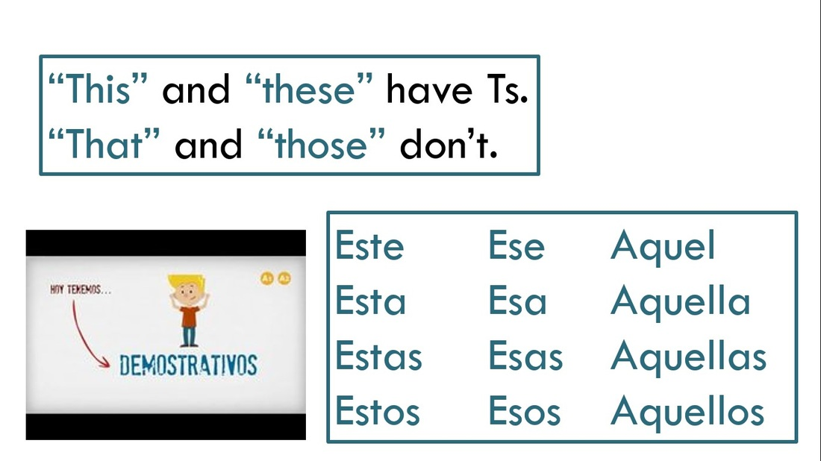

LEARNING TARGET Capítulo 7
1. Preterit vs Imperfect
2. Present
3. Adverbs
4. Comparisons of Equality

5. Comparisons of Inequality

CORNELL NOTES  SHEET | Name: KattyaRomero  Class: Spanish I  Topic: Spanish  Date: Hoy es del dos mil diez y seis  Period primero, tercero,
PREGUNTAS | APUNTES
WHAT ARE WE LEARNING? | Imperfect vs Preterite
WHY ARE WE LEARNING THIS? | TO BE ABLE TO COMMUNICATE IN SPANISH
When to use the imperfect (indicative) tense  Verbs that are irregular in the imperfect indicative | The imperfect tense is used to talk about something that was ongoing in the past, as well as something that happened continuously or repeatedly in the past. It also sets the scene with background information about time, conditions, feelings, or personality. Specifically, it is used for:  Description  Used to (ongoing, continual, repeated, or habitual past actions)  Was + -ing and were + -ing  Internal (mental) processes (feeling, knowing, needing, thinking, wanting)  Time (always expressed with the verb ser)  There are NO stem-changing verbs or verbs with spelling changes in the imperfect tense. In fact, only three verbs at all irregular in the imperfect tense. They are  ir (to go) ser ver  iba íbamos era éramos veía veíamos  ibas ibais eras erais veías veíais  iba iban era eran veía veían
Comparisons of equality | - Comparing things with adjectives  - Formula: más + adjective + que  - Menos + adjective + que  - Examples:  - Un escritorio es más grande que una silla.  - El chico es más alto que la chica.  - We need to be careful because in English, we use “er” to compare short adjectives such as “bigger”, “taller”, and “faster”. However, we use “more than” or “less than” for longer adjectives such as “more delicate than” or “more expensive than”.  - But in Spanish, we use the same equivalent “more than/less than” for both.  - Examples:  - Alfredo hace la tarea más frecuentemente que Miguel.  - Pero Miguel trabaja más que Alfredo  - Here we have a verb. Therefore, just like in English, the verb goes before “más que” or “menos que”  - Have the students do some examples:  - I eat more than my friends  - I like to go to the library more than the gym  - I like hamburgers less than tacos  - My grandma is more fun than my grandpa  - Science class is less fun than English class  - Irregulars  - Regular form Irregular form  Más Bueno (bien) Mejor  Más malo (mal) Peor  Más Viejo Mayor (que)  Más joven Menor (que)  - The irregulars “mayor que” and “menor que” are only used for people. When you have inanimate objects however, the regular form is used.  - Mi coche es más viejo que tu coche.  - Be very careful to match these irregulars with the people they are referring to.  - Mi padre es mayor que mi madre  - Mis tíos son mayores que mis primos
General Preterit Uses  Useful Phrases that Trigger the Preterit. | Generally, the preterit is used for actions considered completed, actions that have definite beginning and end points. These can be actions that can be viewed as single events, actions that were part of a chain of events, actions that were repeated a very specific number of times, or actions that specifically state the beginning and end of an action.  • Fui al baile anoche. (I went to the dance last night.)  • Caminé al mercado, compré unos plátanos, y regresé a casa. (I walked to the market, bought some bananas, and returned home.)  • Te llamó tres veces. (He called you three times.)  • Hablé con mi madre de las dos hasta las tres. (I spoke with my mother from two o’clock until three o’clock.)  a esa hora at that time  ayer por la tard eyesterday afternoon  en ese momento at that moment  anoche last night  ayer por la noche last night  hace (dos) años/días (two) years/days ago  ante anoche the night before last  el año pasado last year  hoy por la mañana this morning  ante ayer the day before yesterday  el (lunes) pasado last (Monday)  la semana pasada last week  ayer al mediodía yesterday at noon  el mes pasado last month  una vez one time/once
SUMMARY: Write 4 or more sentences describing specific learning from these notes.

This is how you should start your notes eve

The vocabulary in red is the vocabulary for 7.1 and 7.3

VOCABULARY LIST

Language: | Spanish
Title: | Ven Conmigo 2: Capítulo 7

ENGLISH |  |  | SPANISH
1. to get scared |  |  | 1. asustarse
2. to share |  |  | 2. compartir
3. to build |  |  | 3. construir
4. to tell jokes |  |  | 4. contar chistes
5. when I was young... |  |  | 5. cuando era joven
6. as a small child |  |  | 6. de chiquito
7. as a child |  |  | 7. de niño/de pequeño
8. to play tricks |  |  | 8. hacer travesuras
9. to fight |  |  | 9. pelear
10. to dream about |  |  | 10. soñar con
11. to climb trees |  |  | 11. trepar a los árboles
12. to like someone |  |  | 12. caer bien
13. to think (something) is great |  |  | 13. encontrar genial
14. fresh air |  |  | 14. aire puro
15. adventurous |  |  | 15. aventurero/aventurera
16. kind |  |  | 16. bondadoso/bondadosa
17. spoiled |  |  | 17. consentido/consentida
18. pollution |  |  | 18. contaminación
19. talkative |  |  | 19. conversador/conversadora
20. selfish |  |  | 20. egoísta
21. back then |  |  | 21. en aquel entonces
22. in those days |  |  | 22. en aquella época
23. in those times |  |  | 23. en aquellos tiempos
24. in my time |  |  | 24. en mis tiempos
25. factory |  |  | 25. fábrica
26. gigantic |  |  | 26. gigantesco/gigantesca
27. impatient |  |  | 27. impaciente
28. dangerous |  |  | 28. peligroso/peligrosa
29. noise |  |  | 29. ruido
30. noisy |  |  | 30. ruidoso/ruidosa
31. simple |  |  | 31. sencillo/sencilla
32. lonely |  |  | 32. solitario/solitaria
33. traffic |  |  | 33. tránsito
34. running water |  |  | 34. agua corriente
35. air conditining |  |  | 35. aire acondicionado
36. heat |  |  | 36. calefacción
37. electricity |  |  | 37. electricidad
38. stove |  |  | 38. estufa
39. streetlight |  |  | 39. lámpara de la calle
40. firewood |  |  | 40. leña
41. well |  |  | 41. pozo
42. to sleep like a baby |  |  | 42. dormir tan bien como un lirón
43. to be a terrible bore |  |  | 43. ser tan aburrido como un pato
44. to be as good as a saint |  |  | 44. ser tan bueno como un ángel
45. to be as happy as a lark |  |  | 45. ser tan feliz como una lombriz
46. to be as strong as an ox |  |  | 46. ser tan fuerte como un toro
47. to be as noble as a lion |  |  | 47. ser tan noble como un perro

Written exercises Preterit vs Imperfect

Preterite vs. Imperfect
Click on the link below to practice choosing between Preterite and Imperfect when telling a story.
Practice #1: Ricitos de oro y los tres ositos (Goldilocks and the Three Little Bears)

http://personal.colby.edu/personal/b/bknelson/SLC/ricitos1.php
In this practice, choose between the preterite and imperfect conjugation of the verb according to the context of the sentence. They will tell you whether or not you chose correctly, and why.
Click Here for Practice #1

Practice #2: Ricitos de oro y los tres ositos (Goldilocks and the Three Little Bears)
In this practice, you will have to conjugate the verb. As you conjugate, you will have to decide, according to the context of the sentence, whether to conjugate the verb in the imperfect or preterite tense. After filling out all the verbs in the paragraph, click "Correct" and find out your score.
Click here for Practice #2

http://personal.colby.edu/personal/b/bknelson/SLC/ricitos2.php

When to use the preterit (indicative) tense

The preterit tense is used to talk about completed, past actions and events, as well as to focus on a specific point in time in the past.

Formation of the preterit

-ar -er/-ir ser/ir

-é -amos -í -imos -e -imos fui fuimos
-aste -asteis -iste -isteis -iste -isteis fuiste fuisteis
-ó -aron -ió -ieron -o -(i)eron fue fueron

When to use the imperfect (indicative) tense

The imperfect tense is used to talk about something that was ongoing in the past, as well as something that happened continuously or repeatedly in the past. It also sets the scene with background information about time, conditions, feelings, or personality. Specifically, it is used for:

Description
Used to (ongoing, continual, repeated, or habitual past actions)
Was + -ing and were + -ing
Internal (mental) processes (feeling, knowing, needing, thinking, wanting)
Time (always expressed with the verb ser)

Formation of the imperfect
-ar -er/-ir ir ser

-aba -ábamos -ía -íamos iba íbamos era éramos
-abas -abáis -ías -íais ibas ibaís eras eráis
-aba -aban -ía -ían iba iban era eran

The meanings of the following verbs change depending upon the tense that is used:

Verb | Meaning | IMPERFECT | PRETERIT | NEGATIVE P.
conocer | to be familiar with | was familiar with | met | X
poder | to be able to | was not able | managed | was not able & didn’t
querer | to want | wanted | tried | refused
saber | to know | knew | found out | X

General Preterit Uses
Generally, the preterit is used for actions considered completed, actions that have definite beginning and end points. These can be actions that can be viewed as single events, actions that were part of a chain of events, actions that were repeated a very specific number of times, or actions that specifically state the beginning and end of an action.

- Fui al baile anoche. (I went to the dance last night.)
- Caminé al mercado, compré unos plátanos, y regresé a casa. (I walked to the market, bought some bananas, and returned home.)
- Te llamó tres veces. (He called you three times.)
- Hablé con mi madre de las dos hasta las tres. (I spoke with my mother from two o’clock until three o’clock.)

Useful Phrases that Trigger the Preterit. Some words and phrases are very helpful in indicating specific time frames and therefore signal the use of the preterit.
a esa hora at that time
ayer por la tard eyesterday afternoon
en ese momento at that moment
anoche last night
ayer por la noche last night
hace (dos) años/días (two) years/days ago
ante anoche the night before last
el año pasado last year
hoy por la mañana this morning
ante ayer the day before yesterday
el (lunes) pasado last (Monday)
la semana pasada last week
ayer al mediodía yesterday at noon
el mes pasado last month
una vez one time/once
...
[Message clipped] View entire message
Attachments area
Preview YouTube video Spanish Regular Verbs (Imperfect Tense)
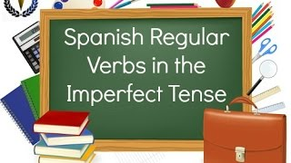
Spanish Regular Verbs (Imperfect Tense)
Preview YouTube video 02 Spanish Lesson - Imperfect - Regular -ER and -IR verbs
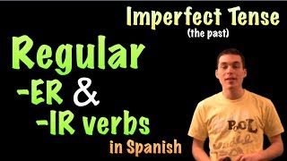
02 Spanish Lesson - Imperfect - Regular -ER and -IR verbs
Preview YouTube video Regular AR verbs in Imperfect Song!
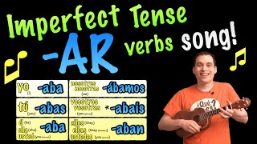
Regular AR verbs in Imperfect Song!
Preview YouTube video Pretérito v. Imperfecto
Pretérito v. Imperfecto
Preview YouTube video Preterit vs. Imperfect
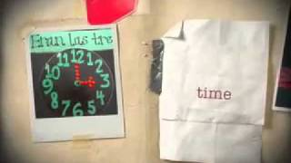
Preterit vs. Imperfect
Preview YouTube video 'Cuando ella me amaba' - Toy Story 2 ❪Cover Latino❫
'Cuando ella me amaba' - Toy Story 2 ❪Cover Latino❫
Preview YouTube video Habia una vez - Ricitos de oro y los tres osos
Habia una vez - Ricitos de oro y los tres osos
Preview YouTube video Mi pretérito imperfecto | Cortometraje
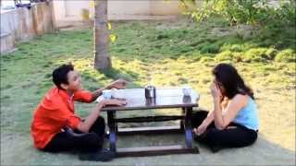
Mi pretérito imperfecto | Cortometraje
Preview YouTube video Cuando era pequeña... Nivel A2
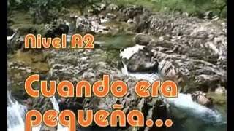
Cuando era pequeña... Nivel A2
Program Policies

http://personal.colby.edu/~bknelson/SLC/pret_repaso.php#pret1
Home > El Pretérito
Repasos de verbos en el pretérito
Preterite Tense Review

Verbos regulares (bailar, comer, vivir, etc.)
Verbos irregulares (ser, ir, ver, dar)
Verbos con cambios ortográficos (-gar, -car, -zar, etc.)
Verbos con raíces irregulares (hacer, decir, poner, etc.)
Verbos con cambios de raíz (mentir, dormir, seguir, pedir, etc.)

Video
https://www.youtube.com/watch?v=QPSc7kfUX9Q

Kevin, Karla y La Banda canta

https://www.youtube.com/watch?v=i83DToXgVLc

Kevin y Karla son hermanos de Santiago, Chile. ¿Dónde está Chile?
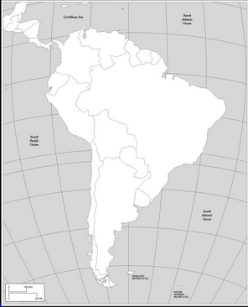

Ellos hacen covers en español de los más sonados éxitos de cantantes de la escena juvenil mundial como Justin Bieber, Katy Perry, Demi Lovato, Rihanna y mucho más.
¿Cuál canción sugieres que Kevin y Karla canten?
______________________________________________________________________________

En esta canción hay muchos verbos en el pretérito porque se trata de una relación que no funcionó.
¿Cuáles son los finales del pretérito?
AR ER/IR

I Knew You Were Trouble por Taylor Swift
Versión Española por Kevin, Karla y La Banda

Hace tiempo atrás, errores cometí
mirabas sin parar, tratando de fingir
me hallaaaaste, me hallaaaaste, me hallaaaaste
eh, eh, eh, eih

Luego no te importé, pero eso me gustó
cuando me enamoré, huiste con mi amor
me heriiiiste, me heriiiiste, me heriiiiiste
eh, eh, eh, eih

Me di cuenta que yo, nada soy para ti
me di cuando amor, que un tonto yo fui

Siempre supe desde que te conocí, que un problema eras
me enseñaste lugares donde nunca fui, y aún así me humillas

Siempre supe desde que te conocí, que un problema eras
me enseñaste lugares donde nunca fui, he despertado y ahora en el suelo estoy
ahh! ahh! en el suelo, suelo, sueloooo
ahh! ahh! en el suelo, suelo, sueloooo

No sé disculpará, no me verá llorar
él sólo fingirá, que no tuvo la culpa
alguuuuna, alguuuuuna, alguuuuna
ahh, ahh, ahh, ayayie

Rumores escuché, confirman la verdad
al fin pude entender, que sólo fui una más
no hay duuuuuda, no hay duuuuuda, no hay duuuuuuda
ahh, ahh, ahh, ayayie

Me di cuenta que yo, nada soy para ti
me di cuando amor, que un tonto yo fui

CORO

Cuando el miedo está, empiezo a preguntar
¿si me pudiste amar?, quizás
¿a alguien más?
di la verdad

CORO

He despertado y ahora en el suelo estoy
ahh! ahh! en el suelo, suelo, sueloooo
He despertado y ahora en el suelo estoy
ahh! ahh! en el suelo, suelo, sueloooo

