|  |  |
| --- | --- |
| **Spanish I**  **Chapter 3.3**  <https://www.youtube.com/watch?v=w_D08ltoOns&list=PL81D49AFE2942F3F4> |  |
|  |  |

Hoy es de noviembre del dos mil quince.

¿Cuánto estudias?   Yo estudio..... minutos

|  |
| --- |
| **LEARNING TARGET** Spanish I |
| 1. **Review SER vs ESTAR** 2. **Uses of SER and ESTAR** 3. **Adjectivies** 4. **GUSTAR** |

|  |  |
| --- | --- |
| **CORNELL NOTES**  **SHEET** | **Name: KattyaRomero Class: Spanish I**  **Topic: Spanish**  **Date: Hoy es del dos mil quince Period primero, tercero** |
| **PREGUNTAS** | **APUNTES** |
| **What are we studying?** | 1. **Review SER vs ESTAR** 2. **Uses of SER and ESTAR** 3. **Adjectivies** 4. **GUSTAR** |
| **What is our focus?** | **Gender and # agreement**  **Singular vs Plural**  **plural of vowel A E I O U 🡪-S**  **plural of consonants VDF🡪 -ES**  **EXCEPTION Z🡪 CES**  **SER VS ESTAR** |
| **What are we reviewing?** | **All of the above and ADJECTIVIES** |
| **What’s an irregular verb?**  **What’s a regular verb?**  **What the endings for ALL verbs in Spanish?** | **The root has changes.**  **The root does not change.**  **-AR, -ER,-IR** |
| **What is the vocabulary we are reviewing?** | **ADJECTIVES/PREPOSITION** |
| **SUMMARY: Write 4 or more sentences describing specific learning from these notes.**  **We are learning to describe THINGS AND PEOPLE.** | |

**Useful Websites**

[**https://quizlet.com/4702862/ch-3-ven-conmigo-tercer-paso-part-1-flash-cards/**](https://quizlet.com/4702862/ch-3-ven-conmigo-tercer-paso-part-1-flash-cards/)

[**https://quizlet.com/19160289/spanish-1chapter-3-tercer-paso-flash-cards/**](https://quizlet.com/19160289/spanish-1chapter-3-tercer-paso-flash-cards/)

[**https://quizlet.com/64186423/vc1-chapter-3-tercer-paso-flash-cards/**](https://quizlet.com/64186423/vc1-chapter-3-tercer-paso-flash-cards/)

[**https://www.youtube.com/watch?v=6QzEmSJvHPw**](https://www.youtube.com/watch?v=6QzEmSJvHPw)

[**https://www.youtube.com/watch?v=w6TjefGxfPY**](https://www.youtube.com/watch?v=w6TjefGxfPY)

[**https://www.youtube.com/watch?v=Yi8VW4xKciQ**](https://www.youtube.com/watch?v=Yi8VW4xKciQ)

[**https://www.youtube.com/watch?v=O45wjys1Cu0**](https://www.youtube.com/watch?v=O45wjys1Cu0)

**http://www.cram.com/flashcards/ven-conmigo-level-1-ch-33-1460320**

<http://quizlet.com/20277455/learn>

<http://quizlet.com/22987153/spanish-adjectives-with-pictures-flash-cards/>

<http://www.spanish.cl/Grammar/Games/Adjetivos.htm>

<http://www.spanish.cl/Grammar/Games/Adjetivos.htm>

<http://www.softschools.com/matching_games/spanish/spanish_adjectives/855/>

**HOW to use Adjectives and the Verb ser**

<https://www.youtube.com/watch?v=1x7VDs_8c0s>

[**https://www.youtube.com/watch?v=v2ALpg1HaYs**](https://www.youtube.com/watch?v=v2ALpg1HaYs)

**http://conjuguemos.com/print_vocabulary_list.php?id=136&source=public**

**VOCABULARIO CHAPTER 3 STEP 3**

|  |  |
| --- | --- |
| 41. boring | 41. aburrido |
| 42. tall | 42. alto |
| 43. disagreeable | 43. antipático |
| 44. short | 44. bajo |
| 45. pretty | 45. bonito |
| 46. good | 46. bueno |
| 47. funny | 47. cómico |
| 48. What is he like? | 48. ¿Cómo es él? |
| 49. What are they (masc.) like? | 49. ¿Cómo son ellos? |
| 50. friend, pal | 50. el compañero |
| 51. difficult | 51. difícil |
| 52. fun, amusing | 52. divertido |
| 53. they (masc.) | 53. ellos |
| 54. You are (fam.) | 54. Tú eres |
| 55. He is... | 55. Él es... |
| 56. strict | 56. estricto |
| 57. easy | 57. fácil |
| 58. ugly | 58. feo |
| 59. big | 59. grande |
| 60. good-looking | 60. guapo |
| 61. intelligent | 61. inteligente |
| 62. interesting | 62. interesante |
| 63. bad | 63. malo |
| 64. dark haired, dark skinned | 64. moreno |
| 65. Do not worry | 65. No te preocupes |
| 66. new | 66. nuevo |
| 67. small | 67. pequeño |
| 68. teacher (masc.) | 68. el profesor |
| 69. blond | 69. rubio |
| 70. nice | 70. simpático |
| 71. We are | 71. Somos |
| 72. the dance | 72. el baile |
| 73. the concert | 73. el concierto |
| 74. Which? | 74. ¿Cuál? |
| 75. the sports | 75. los deportes |
| 76. the exam | 76. el examen |
| 77. the exams | 77. los exámenes |
| 78. favorite | 78. favorito |
| 79. the party | 79. la fiesta |
| 80. teacher (fem.) | 80. la profesora |
| 81. the novel | 81. la novela |
| 82. the game | 82. el partido |
| 83. Why? | 83. ¿Por qué? |
| 84. because | 84. porque |
| 85. the videogame | 85. el videojuego |
| 86. the videogames | 86. los videojuegos |
| 87. the (fem. / pl.) | 87. las |

Adjectives – **adjetivos**

Adjective – a word that describes a noun or distinguishes it from a group of other nouns.

In English an adjective comes before the word it is describing and has one form.

Ex: the red car the red cars

Before car it has the same form even though there are more cars

In Spanish, an adjective comes after the noun and must agree with it in number and gender. So each adjective that ends in an “o” has four forms: masculine, feminine, singular and plural. Adjectives that end in an “e” or a consonant have two forms: singular and plural. Use these charts to help:

Adj. that end in “O” have four forms. Let’s look at the word for “tall”

|  |  |  |
| --- | --- | --- |
|  | **Singular** | **Plural** |
| Masculine | Alt**o** | Alt**os** |
| Feminine | Alt**a** | Alt**as** |

Examples: The tall boy = **el** muchach**o** alt**o**

The tall girl = **la** muchach**a** alt**a**

The tall boys = **los** muchach**os** alt**os**

The tall girls = **las** muchach**as** alt**as**

Notice that the article, noun, and adjective must match in gender and number.

**Don’t forget that the adjective comes after the noun in Spanish!**

Adjectives that end in “e” or a consonant have only two forms.

|  |  |  |
| --- | --- | --- |
|  | **Singular** | **Plural** |
| Adjective that end in “e” | Inteligent**e** | Inteligente**s** |
| Consonant | Popular | Popular**es** |

If an adjective ends in a vowel, simply add an “s” to make if plural. If it ends in a consonant, you add an “es”. Examples:

The popular boy = **el** muchach**o** popular

The popular girl = **la** muchach**a** popular

The poplar boys = **los** muchach**os** popular**es**

The popular girls = **las** muchach**as** popular**es**

The intelligent boy = **el** muchach**o** inteligent**e**

**Possessive Adjectives**

**Useful videos explaining the possessive adjectives**

[**https://www.youtube.com/watch?v=rUaX5OqTEzE**](https://www.youtube.com/watch?v=rUaX5OqTEzE)

**https://www.youtube.com/watch?v=9-TFyxNwWQM**

[**https://www.youtube.com/watch?v=zT1kIpCRBqM**](https://www.youtube.com/watch?v=zT1kIpCRBqM)

## [Possessive Adjectives and "De"](http://hamiltonspanish.weebly.com/blog-2014-2015/studying-for-the-14-grammar-assessment-part-2-possessive-adjectives-and-de)

Your assessment on **Possessive Adjectives** and **"De"**

You can show relationship or possession in two ways:

"De" (of/from)              Ella es la hermana **de** Ariana.  (She is the sister **of** Ariana.)  
  Es el libro de Miguel.                (It is Miguel's book. / It is the book **of** Miguel.)

**Adjectives and Ser**

1. **Quizlet  
   1.  Click on the link below to practice adjectives with ser.**

[**http://quizlet.com/6709178/adjectives-ser-flash-cards/**](http://quizlet.com/6709178/adjectives-ser-flash-cards/)

1. Possessive adjectives

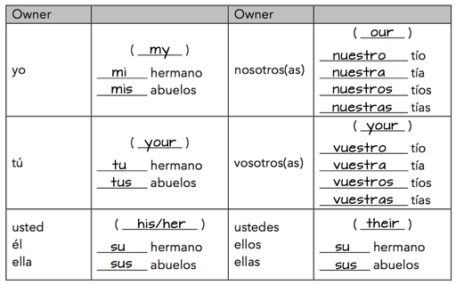

**Conjugation and Uses of SER**

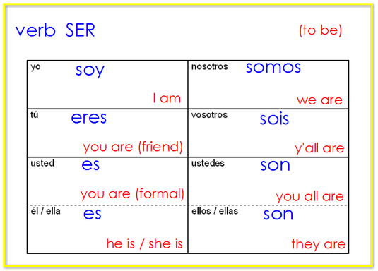

You know the correct form of ser to use based on the subject pronoun. You can also infer the subject pronoun based on the form of ser if the subject pronoun is missing.   
1.  Click here to hear all the forms of ser

<http://quizlet.com/8892022/ser-flash-cards/>

2.  Click here to practice spelling the subject pronouns and forms of ser: <https://quizlet.com/8892022/spacerace>

3.  Click here to take a practice test in ENGLISH AND SPANISH.  Start with English, next select Spanish, and create a new test: <http://quizlet.com/8892022/test>

**Short practice assessment: Formative  Escritura**

**The quiz for ser and subject pronouns is very similar to the activity below. Fill in the correct subject pronoun or the correct form of ser.  
Answer these on the back of your handout.   
1.       ____ soy inteligente.  
2.       Señor Anaya ____ profesor.  
3.       Usted ____ alto.  
4.       ____ eres guapo.  
5.       Andres y Diego ____ locos.   
6.       ____ somos de Texas.   
7.       Ella ____ bonita.  
8.       Nosotros ____ estudiantes buenos.   
9.       _____ sois de España.  
10.   Yo ____ especial.**

**GUSTAR**

https://www.youtube.com/watch?v=masuGwmv9q0

<https://www.youtube.com/watch?v=P7RP3Mw5mNM>

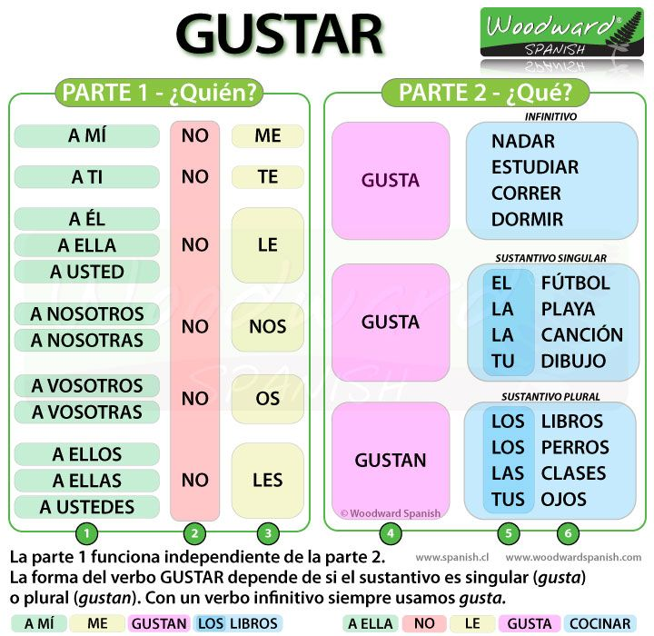

**Listening**

**Listening activity**

[**http://faubionspanish.weebly.com/lab-5---ser.html**](http://faubionspanish.weebly.com/lab-5---ser.html)

[**https://miclaseessuclase.wordpress.com/2014/11/07/cancion-de-la-semana-soy-guapo-por-senor-wooly/**](https://miclaseessuclase.wordpress.com/2014/11/07/cancion-de-la-semana-soy-guapo-por-senor-wooly/)

**¿Cómo es el señor Wooly?**

**¿Qué piensa el Sr. Wooly de él mismo?**

**¿Cómo es el otro hombre?**

**¿Por qué es feo el otro hombre?**

[**https://www.pinterest.com/pin/123145371032411511/**](https://www.pinterest.com/pin/123145371032411511/)

**¿Cómo son los jeans del chico?**

**¿Qué adjetivos usa la niña/chica/mujer?**

<https://video.search.yahoo.com/search/video;_ylt=AwrBTztcq1xWJCIAIupXNyoA;_ylu=X3oDMTEyYjUwMmQzBGNvbG8DYmYxBHBvcwMxBHZ0aWQDQjExNzlfMQRzZWMDc2M-?p=Webbly+Lesons+On+Ser+Spanish&fr=mcafee#id=25&vid=d9593de5a5bfa03b8d676f15ca988e8e&action=view>

¿Cómo y cúando se usa el verbo ser?

**a1qkywj3[1]Due date Written work: 12/07/15 25 points**

**Due date Video: 12/16/15 25 points**

PROYECTO- DESCRIBIÉNDOTE TU MISMO/A

***TASK:*** Describe yourself and others in Spanish, including physical and personality descriptions. In clude likes and dislikes. For this assignment you will work in pairs or alone. Please introduce yourself in Spanish.

***PROCESS:***

1. WRITE WHAT YOU ARE LIKE, WHAT YOU LIKE TO DO, AND WHAT YOU DON’T LIKE TO DO.
2. WRITE WHAT ANOTHER OR OTHERS YOU KNOW ARE LIKE (FRIENDS OR FAMILY), AND WHAT THEY LIKE AND DON’T LIKE TO DO.
3. BE CREATIVE

***REQUIREMENTS:***

1. Use at least 4 adjectives to describe EACH person including yourself.
2. Use at least 2 activities EACH person likes to do, including your self.
3. Use at least 1 activity EACH person doesn’t like to do, including yourself.
4. Use the following expressions at least one time:
5. “I am…” “Yo soy”
6. “I am not…” “Yo no soy”
7. “is…” or “are…” “Ella es” o “Ellas son”
8. “isn’t…” or “aren’t…” “ Ella no es” Ella no son”
9. “ I like…” “A mí No me gusta…”
10. “I don’t like …” “A mí No me gusta…”
11. “He or she likes …” …” “A ella le gusta…”
12. “He or she does not like” “ A ellos no les gusta…”
13. “He or she really likes …” “A ella le encanta…”
14. “They do not really like it” “ A ellas no les encantan…”
15. “He or she does not really like …” “A ella No le encanta…”
16. “They do not really like it” “ A ellas No les encantan…”
17. Include the following words:

* los videojuegos VIDEOGAMES
* centro comercial MALL
* las novelas NOVELS
* los partidos GAMES
* ¿No? ¿ verdad? Isn’t it? Don’t you?
* La fiesta PARTY
* el concierto THE CONCERTS

1. Include the follwing verbs:

* Encontrar TO FIND
* Comprar TO BUY
* Organizar TO ORGANIZE
* Comer TO EAT
* Beber TO DRINK
* Ir a (al, a los) TO GO TO
* Jugar a(al, a los) TO PLAY
* Dormir TO SLEEP
* Hacer TO DO

This project will be worth **50 points**. It will be graded on the required elements, creativity/ originality, use of language (grammar and vocabulary), pronunciation, and clarity and total presentation. Please use the vocabulary from the chapter vocabulary and what you already know. You should be able to do this activity without a dictionary.

Project: DO NOT READ. Memorize your presentation. No points will be given if you read your presentation.

PROJECT:

Script:

* + **Send it via- email to** [**Kattya.Romeromora@WESChools.org**](mailto:Kattya.Romeromora@WESChools.org)**.**
  + **No late or read work will be accepted.** Don’t wait till the last minute to do the assignment. If you have problems sending it. You should bring it to me in a flash drive or in a CD at 7:30 a.m. of the due date.
* **If you don’t have technology available please let me know so you can use my computer to do your work.**

**** Keep your game school appropriate, including anything on the tape after your presentation. Inappropriate material could result in a failing grade and/or a disciplinary action.****

**Some ideas of videos...**

**This is my first time doing this project so I don’t have many examples though I have plenty with songs… You don’t have to sing….**

**Video examples:**

<https://www.youtube.com/watch?v=rwWzMvPyVXA>

<https://www.youtube.com/watch?v=TxWugQUw2us>

Example for the project:

**¿Cómo soy yo?  ¿Quién soy yo?**

Yo soy Natalia. yo tengo catorce años. Yo soy de los Estados Unidos de America. Yo soy bella, alta, morena y cómica. Yo no soy mala, rubia, baja y no soy pelirroja. A mí me gusta **comprar** la comida. A mí no me gusta **encontrar** la comida en mi cama. A mí me encanta dormir en mi cama. A mí no me encantan mi teléfono o mi televisión.

A mí me encanta organizar mi cuarto. A mí no me gusta ir al centro comercial. A mí me encanta encontrar comida en cama. Pero a mí me **comer y beber** en mi cama.

A mí me encanta comprar libros y A mí me encantan los videojuegos americanos como Mario Brother y Pac Mac.

**¿Cómo es él?  ¿Quién es  él?**

Mi compañero es  Sam. Sam es moreno, bajo, delgado y simpático. Él es de los Estados Unidos de Am**é**rica. **é**l tiene quince años. A él le gusta organizar la ropa en su cuarto. A él no le gusta comer la comida china. A él le encanta ir al colegio de Norte pero A él no le encanta  hacer la tarea.

A él le encanta organizar  sus libros. A  él no le gusta ir al colegio después de clases.A él le encanta jugar muchos deportes.  A  él no le gusta  ir al  centro comercial.

Project Steps: **Fill out this page completely, thank you**

**If you have problems meeting with your partner you need to resolve the situation amongst yourselves. If the person does not show up them do the presentation alone.**

1. Pick a partner.

Our group members are: __________________________________

1. Arrange a meeting time and place outside of class to complete the project: When:_________________________ Where:________________________
2. Decide on a type of project: We are doing a ____________ presentation
3. Compose a script (use the script page) Done!
4. Gather graphics (plan out video shots, take pictures, find clip art) Done!
5. Rehearse lines and actions before your presentation – or – put poster together Done
6. Rehearse live presentation until it is smooth with good pronunciation Done!
7. Turn it in!

OPTIONAL Write your outline statements here:

1. ____________________________________________________________________________________________________________________________________
2. ____________________________________________________________________________________________________________________________________
3. ____________________________________________________________________________________________________________________________________
4. ____________________________________________________________________________________________________________________________________
5. ____________________________________________________________________________________________________________________________________
6. ____________________________________________________________________________________________________________________________________
7. ____________________________________________________________________________________________________________________________________

USES de SER vs ESTAR

|  |  |
| --- | --- |
| Los usos de **SER**  DESCRIBE THE **ESSENCE**  **(Example: ice=cold)**  (Paco & Pablo Have Never Cooked Insect Oatmeal 4 ME.) | Los usos de **ESTAR**  DESCRIBE A **CHANGE**  in state, condition, or motion  (Example: was happy, now is sad)  (Santa Clause Loves Pizza.) |
| Características  Personalidad/Profesión  Posesión  1. (las entradas) son de él | Sentimientos   1. está muy triste 2. estamos muy emocionados |
| Nacionalidad  Soy estadounidense  Soy costarricense | Condiciones y Salud |
| Origen  Soy de Costa Rica | Lugar   1. está en NY 2. está en NY |
| Time  Es la una  Son las dos | Presente Progresivo   1. está visitando 2. estamos contando |
| Evento   1. es en Los Angeles 2. es a las 7:30 |  |

Conjugation of ESTAR

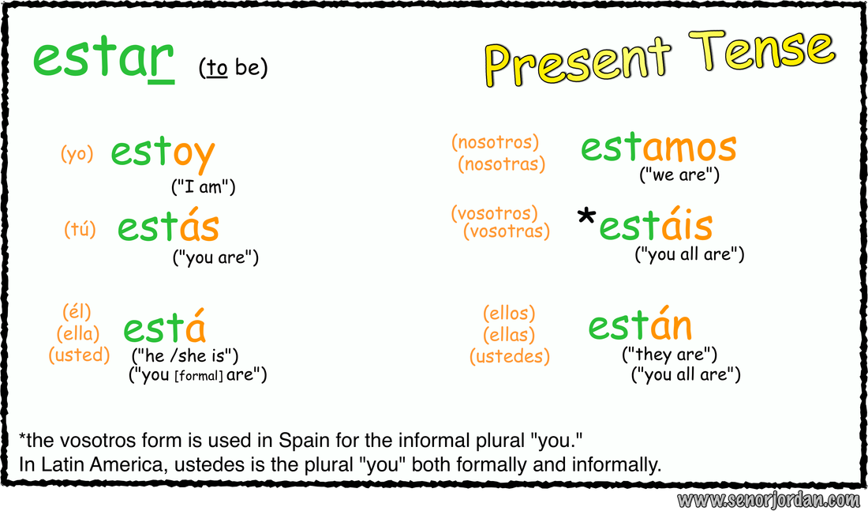

Conjugation SER



**LAS FRASES DEL TIEMPO**

**Weather Expressions with “Hace…”**

**Hace buen tiempo** *It’s nice weather*

**Hace mal tiempo** *It’s bad weather*

**Hace fresco** *It’s cool*

**Hace (*mucho)* frío** *It’s (really/ very) cold*

**Hace (*un poco*)calor** *It’s (a little/a bit) hot*

**Hace viento**                                        *It’s windy*

**Hace sol** *It’s sunny*

**Weather Expressions with “Está…”**

**Está nublado***It’s cloudy*

**Está lloviendo***It’s raining  (right now)*

**Está nevando***It’s snowing (right now)*

**Other Expressions**

**Llueve** *It rains/ is raining*

**Nieva** *It snows/ is snowing*