**Spanish Video Project -**

rr_2tseh[1]Estar + PREPOSITIONS Project

a1qkywj3[1]**Due date/fecha 1/30/17**

**Written 1/25/17**

For this assignment you will work in pairs and produce estar + prepositions project. This presentation should be no more than 5 minutes long.

**This project will be worth 25 points. It will be graded on the required elements, creativity/ originality, use of language (grammar and vocabulary), pronunciation, and clarity and total presentation.**

**Please use the vocabulary from the chapter vocabulary and what you already know. You should be able to do this activity without a dictionary.**

**Project: DO NOT READ. Memorize your presentation. No points will be given if you read your presentation.**

**Script:**

* + **Send it via- email to** [**Kattya.Romeromora@WESChools.org**](mailto:Kattya.Romeromora@WESChools.org)**.**
  + **No late or read work will be accepted. Don’t wait till the last minute to do the assignment. If you have problems sending it. You should bring it to me in a flash drive or in a CD at 7:30 a.m. of the due date.**
* **If you don’t have technology available, please let me know so you can use my computer to do your work. Or presented in class.**

**\*\*\*\* Keep your game school appropriate, including anything on the tape after your presentation. Inappropriate material could result in a failing grade and/or a disciplinary action. \*\*\*\***

**Written work 25 pts.** [**http://education.ohio.gov/getattachment/Topics/Ohios-Learning-Standards/Foreign-Language/World-Languages-Model-Curriculum/World-Languages-Model-Curriculum-Framework/Instructional-Strategies/Scoring-Guidelines-for-World-Languages/2-Presentational-Writing-Rubric\_unit\_august\_2015.pdf.aspx**](http://education.ohio.gov/getattachment/Topics/Ohios-Learning-Standards/Foreign-Language/World-Languages-Model-Curriculum/World-Languages-Model-Curriculum-Framework/Instructional-Strategies/Scoring-Guidelines-for-World-Languages/2-Presentational-Writing-Rubric_unit_august_2015.pdf.aspx)

**Oral presentation/video 25 pts.** [**http://education.ohio.gov/getattachment/Topics/Ohios-Learning-Standards/Foreign-Language/World-Languages-Model-Curriculum/World-Languages-Model-Curriculum-Framework/Instructional-Strategies/Scoring-Guidelines-for-World-Languages/1-Presentational-Speaking-Rubric\_unit\_august\_2015.pdf.aspx**](http://education.ohio.gov/getattachment/Topics/Ohios-Learning-Standards/Foreign-Language/World-Languages-Model-Curriculum/World-Languages-Model-Curriculum-Framework/Instructional-Strategies/Scoring-Guidelines-for-World-Languages/1-Presentational-Speaking-Rubric_unit_august_2015.pdf.aspx)

**Do no use these examples. Make up your own!**

**Example of games:**

**Fun games**

[**https://www.youtube.com/watch?v=Vxfj1Db27PA**](https://www.youtube.com/watch?v=Vxfj1Db27PA)

**Plaza Sesamo**

[**https://www.youtube.com/watch?v=JNkZALxekl8**](https://www.youtube.com/watch?v=JNkZALxekl8)

**Lesson teaching prepositions**

**https://www.youtube.com/watch?v=Vmn1-g0wyNo**

**Dance**

**https://www.youtube.com/watch?v=txsazO4UH\_U**

**Song using prepositions and clothes**

[**https://www.youtube.com/watch?v=4uzfwLKevUU**](https://www.youtube.com/watch?v=4uzfwLKevUU)

**Bad video use English**

**https://www.youtube.com/watch?v=Ng3hnlduaOc**

**https://www.youtube.com/watch?v=BZsV5PUIJEA**

Game example:

Videos using this activity:

<https://www.youtube.com/watch?v=wZGoSkQ2bLI>

<https://www.youtube.com/watch?v=eYeqUetm6fY>

<https://www.youtube.com/watch?v=Sj03_PagWp4>

English video but you can do it in Spanish

<https://www.youtube.com/watch?v=oKhz6H4SFX0>

FUNNY

https://www.youtube.com/watch?v=BZsV5PUIJEA

Here are some words that might help you do your project:

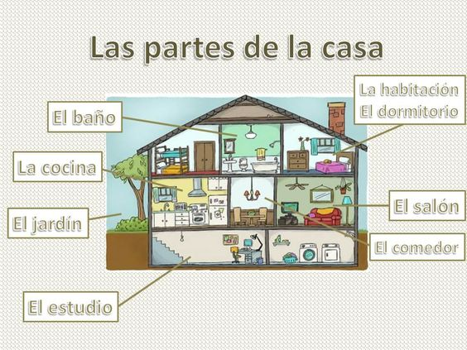

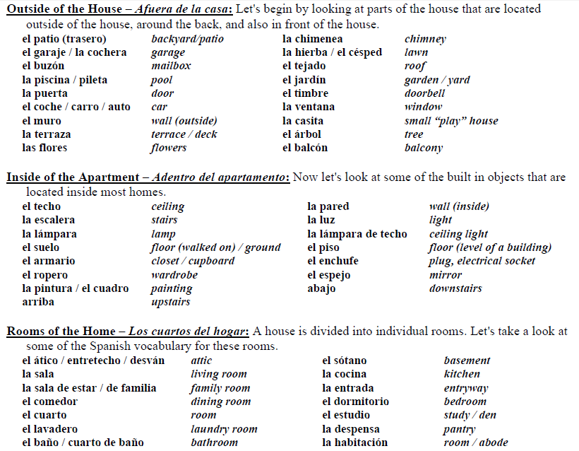

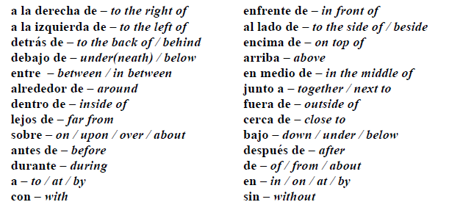

Example of the written part due on 1/25/17 due at 7:30 a.m.

¡Hola!  ¡Yo estoy muy bien!

¿Quién soy yo?

Yo soy Kattya. Yo me llamo Kattya. Yo tengo quince años. Yo soy baja, cómica, fuerte y atlética. Yo soy de Los Estados Unidos. Yo soy una estudiante del Colegio del Norte.

¿Dónde estoy yo?

Hoy estoy en mi casa. Yo voy afuera. Yo estoy enfrente de mi casa. Yo voy alrededor de mi carro. Ahora (now) estoy entre mi casa y mi carro. Ahora voy al lado del jardín.  Ahora estoy cerca de las flores.

¿Quién es él?

Él es Brad. Brad es de México. Brad tiene catorce  años. Brad es débil, delgado, guapo y bueno.

¿Dónde está él?

Él está en mi casa. Él está debajo de la mesa. Él está ahora cerca de mí. Él está  a la derecha del baño y lejos de mi garaje.

¿Quién son ellos?

Ellos se llaman Ana y  Brad. Brad es de México y Ana es de Colombia. Ellos tienen catorce  años. Ellos son morenos, activos, serios, interesantes y  simpáticos.

¿Dónde están ellos?

Ellos están en mi garaje.  Ellos están a la izquierda de la puerta.  Ellos están al lado de mi bicicleta. Ellos están atrás de mi carro y enfrente de mí.