Chapter 6.1 and 6.2
LEARNING TARGET Spanish I
-Vocabulary: Family
-Review regular and irregular verbs in the present indicative
-Possessive adjectives
CORNELL NOTES  SHEET | Name: KattyaRomero  Class: Spanish I  Topic: Spanish  Date: Hoy es del dos mil diez y seis  Period
PREGUNTAS | APUNTES
What are we studying? | -Vocabulary: Family  -Review regular and irregular verbs in the present indicative  -Possessive adjectives
What is our focus? | Present Indicative regular and irregular verbs  Possessive Adjectives
What are we reviewing? | We are reviewing conjugation of -ar, -er and -ir verbs.  We are reviewing regular and irregular verbs.
What’s an irregular verb?  What’s a regular verb?  What the endings for ALL verbs in Spanish? | Irregular verbs have a change in the root  Regular verb keeps the same root of the verb  All verbs in Spanish end in –ar, -er and –ir.
What is the vocabulary we are reviewing? | Family, food, sports, weather, months of the year, and days of the week.
SUMMARY: Write 4 or more sentences describing specific learning from these notes.
I can describe my family and I can write about our family activities together.

Extra credit: 3 quizlets (5 points)

https://quizlet.com/38356216/cehs-ven-conmigo-1-chapter-6-paso-1-flash-cards/

https://quizlet.com/43461038/ven-conmigo-1-chapter-6-segundo-paso-flash-cards/

https://quizlet.com/43461399/ven-conmigo-1-chapter-6-tercer-paso-flash-cards/

https://quizlet.com/263477/household-chores-in-spanish-flash-cards/

Useful websites

Do you need to review how to express the age of your family members, let's watch this video:

https://www.youtube.com/watch?v=42ZY_chZ_fc

You tube FAMILY:

https://www.youtube.com/watch?v=DjCzY4BsmFI

https://www.youtube.com/watch?v=X_v5cBtqpOM
https://www.youtube.com/watch?v=DuhvGnHD0TE

Listening exercises
http://www.laits.utexas.edu/spe/beg13.html
https://www.youtube.com/watch?v=Bj-fAlHK2rM
https://www.youtube.com/watch?v=SDhSMrVm2yo
https://www.youtube.com/watch?v=15j45byNa8Y
https://www.youtube.com/watch?v=MzcqgcU4PoU
https://www.youtube.com/watch?v=p2BBUQJx6r8
https://www.youtube.com/watch?v=Q5EotVQc2QU

Lesson: La Familia

Introducción
Spanish 1 Talking about Your Immediate Family PREASSESSMENT
https://app.activateinstruction.org/playlist/resource-sview/rid/51cb661307121cb457677481/id/51ca6f0f07121c37209e2daf/bc0/explore/bc1/playlist

Identificar Miembros de la Familia 1 (Identify family members correctly)

Lesson: La Familia https://www.youtube.com/watch?v=X_v5cBtqpOM
Immediate Family Pre-Assessment Quiz
http://www.softschools.com/quizzes/spanish/los_miembros_de_la_familia_en_espanol/quiz1743.html

Describir a la familia (Describe family in general terms)
Video: Tengo una familia grande
https://www.youtube.com/watch?v=s9iUXEhEMh8
Song: description of a few key family members
https://www.youtube.com/watch?v=1iDlAd1L9FM

Expresar relaciones entre los miembros de la familia (express basic family relationships)
Family Tree Video and Actual Interactive tree
https://www.youtube.com/watch?v=HrL7pQsL6Lk

Quizlet: Family Members and Relationships
https://quizlet.com/6145765/family-relationships-flash-cards/

Family Relationships Practice quiz

http://www.123teachme.com/spanish_sentence_quiz/category/family

Usar los Posesivos: mi, mis, tu, tus (Use first and second person possessives appropriately)
Expressing Possession in Spanish http://www.elearnspanishlanguage.com/grammar/possession.html

Video Explanantion of Possessive adjectives Part 1
https://www.youtube.com/watch?v=rUaX5OqTEzE
Posesivos (possessives Spanish)
http://www.spanishdict.com/answers/100031/possessive-adjectives#.VtRN0Pn4_Gh
Video Explanation of Possessive Adjectives 2
https://www.youtube.com/watch?v=yaK-wFTMC6c
Skills Practice: Talking about your Immediate family
Authentic Videos: Describing one's Family
http://www.laits.utexas.edu/spe/beg13.html

Ven Conmigo 1: Chapter 61.-6.3 Vocabulary
https://conjuguemos.com/print_vocabulary_list.php?id=323&source=public

ENGLISH |  |  | SPANISH
1. grandmother |  |  | 1. la abuela
2. grandfather |  |  | 2. el abuelo
3. grandparents |  |  | 3. los abuelos
4. What is your family like? |  |  | 4. ¿Cómo es tu familia?
5. How many people are there in your family |  |  | 5. ¿Cuántas personas hay en tu familia?
6. wife |  |  | 6. la esposa
7. husband |  |  | 7. el esposo
8. these (feminine |  |  | 8. éstas
9. these (masculine, masculine and feminine |  |  | 9. éstos
10. family |  |  | 10. la familia
11. cat |  |  | 11. el gato
12. sister |  |  | 12. la hermana
13. stepsister |  |  | 13. la hermanastra
14. stepbrother |  |  | 14. el hermanastro
15. brother |  |  | 15. el hermano
16. brothers, brothers and sisters |  |  | 16. los hermanos
17. daughter |  |  | 17. la hija
18. son |  |  | 18. el hijo
19. children |  |  | 19. los hijos
20. stepmother |  |  | 20. la madrastra
21. mother |  |  | 21. la madre
22. mom |  |  | 22. la mamá
23. half sister |  |  | 23. la media hermana
24. half brother |  |  | 24. el medio hermano
25. my (singular) |  |  | 25. mi
26. my (plural) |  |  | 26. mis
27. our |  |  | 27. nuestro
28. stepfather |  |  | 28. el padrastro
29. father |  |  | 29. el padre
30. dad |  |  | 30. el papá
31. parents |  |  | 31. los padres
32. female cousin |  |  | 32. la prima
33. male cousin |  |  | 33. el primo
34. cousins |  |  | 34. los primos
35. to be close-knit |  |  | 35. ser unido
36. There are five of us. |  |  | 36. Somos cinco.
37. his, her, (you formal) |  |  | 37. su
38. their |  |  | 38. su
39. aunt |  |  | 39. la tía
40. uncle |  |  | 40. el tío
41. to live |  |  | 41. vivir
42. your (familiar sigular) |  |  | 42. tu
43. your (familiar plural) |  |  | 43. tus
44. close-knit |  |  | 44. unido
45. your (plural, Spain) |  |  | 45. vuestro
46. blue |  |  | 46. azul
47. affectionate |  |  | 47. cariñoso
48. brown |  |  | 48. de color café
49. thin |  |  | 49. delgado
50. smart |  |  | 50. listo
51. older |  |  | 51. mayor
52. younger |  |  | 52. menor
53. black |  |  | 53. negro/a
54. eyes |  |  | 54. los ojos
55. redheaded |  |  | 55. pelirrojo/a
56. hair |  |  | 56. el pelo
57. a little overweight |  |  | 57. un poco gordo
58. He/she looks young. |  |  | 58. Se ve joven.
59. He/she has gray hair. |  |  | 59. Tiene canas.
60. He/she has green eyes. |  |  | 60. Tiene los ojos verdes.
61. He/she has blue eyes. |  |  | 61. Tiene los ojos azules.
62. mischievous |  |  | 62. travieso
63. green |  |  | 63. verde
64. old |  |  | 64. viejo
65. something |  |  | 65. algo
66. almost always |  |  | 66. casi siempre
67. to eat dinner |  |  | 67. cenar
68. to take a trip |  |  | 68. hacer un viaje
69. What do you do on weekends? |  |  | 69. ¿Qué hacen ustedes los fines de semana?
70. to go out, to leave |  |  | 70. salir
71. to visit |  |  | 71. visitar
72. to cut the grass |  |  | 72. cortar el césped
73. to take care of the cat |  |  | 73. cuidar al gato
74. should, ought to |  |  | 74. deber
75. You should... |  |  | 75. Debes...
76. too much |  |  | 76. demasiado
77. he/she says that |  |  | 77. dice que
78. to make the bed |  |  | 78. hacer la cama
79. to clean the kitchen |  |  | 79. limpiar la cocina
80. less |  |  | 80. menos
81. It's not true. |  |  | 81. No es cierto.
82. to vacuum |  |  | 82. pasar la aspiradora
83. to iron |  |  | 83. planchar
84. to set the table |  |  | 84. poner la mesa
85. a problem |  |  | 85. un problema
86. What should I do? |  |  | 86. ¿Qué debo hacer?
87. household chores |  |  | 87. los quehaceres domésticos
88. living room |  |  | 88. la sala
89. to work in the garden |  |  | 89. trabajar en el jardín
90. horse |  |  | 90. el caballo
91. rabbit |  |  | 91. el conejo
92. playful |  |  | 92. juguetón
93. pet |  |  | 93. la mascota
94. affectionate |  |  | 94. mimoso
95. bites |  |  | 95. muerde
96. bird |  |  | 96. pájaro
97. goldfish |  |  | 97. el pez de colores
98. selfish |  |  | 98. egoísta
99. lazy |  |  | 99. perezoso
100. hard-working |  |  | 100. trabajador

February 24 through March 8th lesson plan will focus on this information:

Descubre Lección 6:
La familia
La familia | Family
el abuelo  la abuela | Grandfather  Grandmother
el apellido | last name
el bisabuelo  la bisabuela | Great-grandfather  Great-grandmother
el cuñado  la cuñada | Brother-in-law  Sister-in-law
el esposo  la esposa | Husband  Wife
la familia | Family
el gemelo  la gemela | Twin (male)  Twin (female)
el hermanastro  la hermanastra | Step-brother  Step-sister
el hermano  la hermana | Brother  Sister
el hijastro  la hijastra | Step-son  Step-daughter
el hijo  la hija | Son  Daughter
el hijo único  la hija única | Only child (male)  Only child (female)
los hijos | Children
la madrastra | Step-mother
la madre | Mother
el medio hermano  la media hermana | Half-brother  Half-sister
el nieto  la nieta | Grandson  Granddaughter
la nuera | Daughter-in-law
el padrastro | Step-father
el padre | Father
los padres | Parents
los parientes | Relatives
el primo  la prima | Cousin (male)  Cousin (female)
el sobrino  la sobrina | Nephew  Niece
el suegro  la suegra | Father-in-law  Sister-in-law
el tío  la tía | Uncle  Aunt
el yerno | Son-in-law
Otras personas | Other people
el amigo  la amiga | Friend (male)  Friend (female)
la gente | People
el muchacho  la muchacha | Boy  Girl
el niño  la niña | Young boy  Young girl
el novio  la novia | Boyfriend  Girlfriend
la persona | Person
Profesiones | Professions
el artista  la artista | Artist (male)  Artist (female)
el doctor, el médico  la doctora, la médica | Doctor (male)  Doctor (female)
el ingeniero  la ingeniera | Engineer (male)  Engineer (female)
el periodista  la periodista | Journalist (male)  Journalist (female)
el programador  la programadora | Programmer (male)  Programmer (female)
Adjetivos | Adjectives
alto/a | Tall
antipático/a | Mean
bajo/a | Short
bonito/a | Beautiful, pretty
buen, bueno/a | Good
delgado/a | Skinny, thin
difícil | Difficult
fácil | Easy
feo/a | Ugly
gordo/a | Fat
gran, grande | Big
guapo/a | Handsome
importante | Important
inteligente | Smart
interesante | Interesting
joven  jóvenes | Young (singular)  Young (plural)
mal, malo/a | Bad
mismo/a | Same
moreno/a | Dark-haired, brunette
mucho/a
muchos/as

POSSESSIVE ADJECTIVES
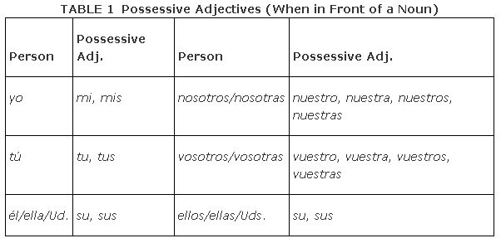

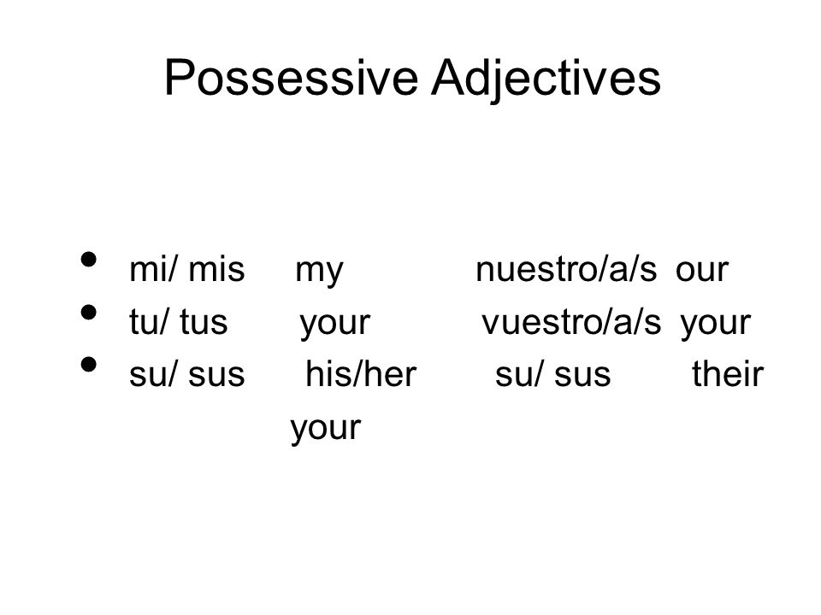

VERBS that we are studying

DEBER : |  | OUGHT TO
Yo: | Debo | Nosotros: | Debemos
Tú: | Debes | Vosotros: | Debéis
Ella: | Debe | Ellos: | Deben

viviR : |  | To live
Yo: | vivo | Nosotros: | vivimos
Tú: | vives | Vosotros: | vivís
Ella: | vive | Ellos: | viven

SALIR : |  | TO GO OUT
Yo: | Salgo | Nosotros: | salimos
Tú: | sales | Vosotros: | salís
Ella: | sale | Ellos: | salen

haceR : |  | TODO/to make
Yo: | Hago | Nosotros: | hacemos
Tú: | haces | Vosotros: | hacéis
Ella: | hace | Ellos: | hacen

poneR : |  | To put/to set
Yo: | pongo | Nosotros: | ponemos
Tú: | pones | Vosotros: | ponéis
Ella: | pone | Ellos: | ponen

visitAR : |  | to visit
Yo: | visito | Nosotros: | visitamos
Tú: | visitas | Vosotros: | visitáis
Ella: | visita | Ellos: | visitan

cenAR : |  | to have dinner
Yo: | ceno | Nosotros: | cenamos
Tú: | cenas | Vosotros: | cenáis
Ella: | cena | Ellos: | cenan

cortAR : |  | to cut
Yo: | corto | Nosotros: | cortamos
Tú: | cortas | Vosotros: | cortáis
Ella: | corta | Ellos: | cortan

cuidAR (a pet or people) (No A for things): |  | to take care of
Yo: | cuido | Nosotros: | cuidamos
Tú: | cuidas | Vosotros: | cuidáis
Ella: | cuida | Ellos: | cuidan

limpiar: |  | to clean
Yo: | limpio | Nosotros: | limpiamos
Tú: | limpias | Vosotros: | limpiáis
Ella: | limpia | Ellos: | limpian

planchar: |  | to iron
Yo: | plancho | Nosotros: | planchamos
Tú: | planchas | Vosotros: | plancháis
Ella: | plancha | Ellos: | plachan

lavAR : |  | To wash
Yo: | lavo | Nosotros: | lavamos
Tú: | lavas | Vosotros: | laváis
Ella: | lava | Ellos: | lavan

trabajar : |  | To work
Yo: | trabajo | Nosotros: | trabajamos
Tú: | trabajas | Vosotros: | trabajáis
Ella: | trabaja | Ellos: | trabajan

preparAR : |  | To prepare
Yo: | preparo | Nosotros: | preparamos
Tú: | preparas | Vosotros: | preparáis
Ella: | prepara | Ellos: | preparan

sacAR : |  | To take out
Yo: | saco | Nosotros: | sacamos
Tú: | sacas | Vosotros: | sacáis
Ella: | saca | Ellos: | sacan

cocinAR : |  | To cook
Yo: | cocino | Nosotros: | cocinamos
Tú: | cocinas | Vosotros: | cocináis
Ella: | cocina | Ellos: | cocinan

ayudAR : |  | To help
Yo: | ayudo | Nosotros: | ayudamos
Tú: | ayudas | Vosotros: | ayudáis
Ella: | ayuda | Ellos: | ayudan

pasar el rato con amigos:  pasar la aspiradora |  | to spend time with friends  to vacuum
Yo: | paso | Nosotros: | pasamos
Tú: | pasas | Vosotros: | pasáis
Ella: | pasa | Ellos: | pasan

http://users.ipfw.edu/jehle/courses/PRESENT1.HTM

Present Tense
Before we begin...
Reminders:
- Most present tense verb forms have several equivalents in English. For example, the form hablo may be translated in numerous ways:
 |  | I speak |  | (customary action)
 |  | I am speaking |  | (action in progress)
hablo |  | I do speak |  | (emphatic form)
 |  | I will speak |  | (near future action)
 |  | do I speak |  | (interrogative form)
 |  | I have been speaking |  | (action started in the past but still in progrerss)
- The subject pronouns that accompany these verbs are:
singular |  |  |  | plural
yo | I |  |  | nosotros, nosotras | we
tú | you | (familiar) |  | vosotros, vosotras | you | (familiar pl., Spain)
usted | you | (formal) |  | ustedes | you | (formal)
él | he |  |  | ellos | they | (masculine or mixed)
ella | she |  |  | ellas | they | (feminine)
- The formal second-person forms (usted and ustedes) take third-person forms of a verb:
Ustedes hablan bien. |  |  | You (plural) speak very well.
Usted es norteamericana, no? |  |  | You (sing.) are an American, right?
The formal study of the various moods and tenses of Spanish verbs will be be spread out over several weeks of the semester, and the individual exercises will normally concentrate on the tense/mood being studied. Nevertheless, it is assumed that you do already know all the tenses. Furthermore, you will be required to produce many of the forms before their introduction, including subjunctive forms.
Present Indicative of Verbs - Review of Forms
- Regular verbs. To form the present indicative of regular verbs, drop the infinitive ending (-ar, -er, or -ir) and add the endings given below:
-ar |  |  | -er |  |  | -ir
hablar (to speak) |  |  | comer (to eat) |  |  | vivir (to live)
hablo | hablamos |  | como | comemos |  | vivo | vivimos
hablas | habláis |  | comes | coméis |  | vives | vivís
habla | hablan |  | come | comen |  | vive | viven
- In the above examples, note that the endings for the -er and -ir verbs are identical except for the nosotros and vosotros forms.
- Stem changing verbs. These verbs are also referred to as “radical changing verbs”; the word radical in Spanish means “stem” or “root”. The stem vowel undergoes a change when it is stressed in the present tense. [These verbs do not so change in any other tense —except for -ir verbs, which experience a stem change in the -ndo form, in the present subjunctive and in the preterit.]
  - o > ue (the stem vowel o changes to ue when stressed)
acostar | (put to bed) | acuesto, acuestas, acuesta, acostamos, acostáis, acuestan
volver | (return, go back) | vuelvo, vuelves, vuelve, volvemos, volvéis, vuelven
dormir | (sleep) | duermo, duermes, duerme, dormimos, dormís, duermen
  - Similar verbs: acordarse (remember), almorzar (eat lunch), apostar (bet), contar (count, relate), costar (cost), encontrar (find), llover (rain), morir (die), mover (move), oler(smell), poder (be able), probar (try, prove), recordar (remember), rogar (beg), sonar (sound), soñar (dream), volar (fly).
  - e > ie (the stem vowel e changes to ie when stressed):
empezar | (begin) | empiezo, empiezas, empieza, empezamos, empezáis, empiezan
querer | (want) | quiero, quieres, quiere, queremos, queréis, quieren
sentir | (feel) | siento, sientes, siente, sentimos, sentís, sienten
  - Similar verbs: advertir (notice), atravesar (cross), calentar (heat), cerrar (close), comenzar (begin), convertir (convert), defender (defend), despertar (awaken), divertir(amuse), empezar (begin), gobernar (govern), herir (injure), pensar (think), perder (lose) querer (want), sentir (feel, regret), tropezar (stumble).
  - e > i (the stem vowel e changes to i when stressed; -ir verbs only):
pedir | (request, ask for) | pido, pides, pide, pedimos, pedís, piden
  - Similar verbs: competir (compete), conseguir (get), corregir (correct), derretir (melt), despedir (fire, say goodbye), elegir (elect), medir (measure), reír (laugh), servir (serve),seguir (follow, continue), sonreír (smile), repetir (repeat), vestir (dress).
  - u > ue (the stem vowel u changes to ue when stressed [in the verb jugar only]):
jugar | (play [a game or sport]) | juego, juegas, juega, jugamos, jugáis, juegan
- Verbs with an irregular first person singular (yo) form. [Note that all of these verbs will also have special forms for the present subjunctive, since present subjunctive forms are based on the first person singular.]
  - c > zc in the yo form:
conocer | (know, be aquainted with [people or places]) | conozco, conoces, conoce, conocemos, conocéis, conocen
  - This is the usual pattern for verbs whose infinitive ends in -cer or -cir: acontecer (happen), agradecer (thank), amanecer (dawn), aparecer (appear), conducir (drive, conduct),crecer (grow), enflaquecerse (get thin), enriquecerse (get rich), envejecerse (get older), establecer (establish), merecer(deserve), nacer (be born), obedecer (obey), ofrecer(offer), padecer (suffer), parecer (seem), permanecer (remain), producir (produce), reducir (reduce), and traducir (translate).
  - appearance of g in the yo form:
caer | (fall) | caigo, caes, cae, caemos, caéis, caen
traer | (bring) | traigo, traes, trae, traemos, traéis, traen
decir | (say, tell) | *digo, dices, dice, decimos, decís, dicen
hacer | (do, make) | hago, haces, hace, hacemos, hacéis, hacen
poner | (put, set) | pongo, pones, pone, ponemos, ponéis, ponen
salir | (leave, go out) | salgo, sales, sale, salimos, salís, salen
tener | (have) | *tengo, tienes, tiene, tenemos, tenéis, tienen
valer | (be worth) | valgo, vales, vale, valemos, valéis, valen
venir | (come) | *vengo, vienes, viene, venimos, venís, vienen
  - *These are also stem changing verbs.
  - other types of yo form changes:
caber | (fit [in something]) | quepo, cabes, cabe, cabemos, cabéis, caben
dar | (give) | doy, das, da, damos, dais, dan
saber | (know [facts]) | sé, sabes, sabe, sabemos, sabéis, saben
ver | (see) | veo, ves, ve, vemos, veis, ven
- Verbs which add an accent over a final weak vowel. The vowels i and u are “weak vowels” in contrast to the “strong vowels” a, e, and o. When they come in contact with any other vowel they normally form a diphthong; the addition of a written accent keeps this diphthonization from occurring. Such accents are necessary for some verbs because the i and u are the stem vowels:
continuar | continúo, continúas, continúa, continuamos, continuáis, continúan  (“I continue, you continue”, etc. Note that the unaccented words continuo and continua, are adjectives meaning “continuous”.)
enviar | envío, envías, envía, enviamos, enviáis, envían  (“I send, you send”, etc.)
- Similar verbs: actuar (act), efectuar (bring about), graduar (graduate), confiar (trust), criar (raise, bring up), esquiar (ski), vaciar (empty).
- With most other verbs the i and u are not stem vowels, and thus form diphthongs:
copiar | copio, copias, copia, copiamos, copiáis, copian  (forms of the verb “to copy”; the i is not stressed)
- Similar verbs: anunciar (announce), apreciar (appreciate), asociar (associate), cambiar (change), divorciar (divorce), ensuciar (dirty), estudiar (study), iniciar (initiate), limpiar(clean), negociar (negociate), renunciar (renounce).
- Verbs like huir. Verbs whose infinitive ends in -uir (but not -guir) insert a y in present tense endings whenever the ending does not contain the sound “i”, that is, in all forms except fornosotros and vosotros.
huir | (flee) | huyo, huyes, huye, huimos, huís, huyen
- Verbs conjugated like huir: construir (construct), contribuir, (contribute), disminuir, (diminish), incluir (include), influir (influence).
- Irregular verbs. The following verbs are completely irregular (usually because of the way they evolved from Latin) or display characteristics so rare as to be considered “irregular” for our purposes.
estar | (to be) | estoy, estás, está, estamos, estáis, están
ser | (to be) | soy, eres, es, somos, sois, son
ir | (go) | voy, vas, va, vamos, vais, van
oler | (smell) | huelo, hueles, huele, olemos, oléis, huelen  [Oler is a stem changing verb; however, no word can begin with ue in Spanish, so an initial h is added.]
- Orthographic changes. Some verbs exhibit orthographic or spelling changes to maintain the same pronunciation of the final stem consonant:
  - g > j: Verbs whose infinitive form ends in -gir change the g to j before an a or an o.
dirigir | (direct) | dirijo, diriges, dirige, dirigimos, dirigís, dirigen
elegir | (elect) | elijo, eliges, elige, elegimos, elegís, eligen  [Elegir is also a stem changing verb, where the e changes to i.]
  - More verbs in this category: corregir (correct), exigir (require), fingir (pretend), and surgir (arise).
  - gu > g: Verbs whose infinitive form ends in -guir drop the u before an a or an o.
distinguir | (distinguish) | distingo, distingues, distingue, distinguimos...
  - Other verbs like this include seguir (follow, continue; e>i) and its compounds: conseguir (get, obtain) and perseguir (pursue).
- Invariable. There is one verb which never changes in the present tense. Hay (“there is”, “there are”, from the infinitive haber) has only one form in the present indicative. The same form is used for both singular and plural subjects (or complements):
Hay muchos españoles en tu clase? |  | Are there many Spaniards in your class?
No, sólo hay uno. |  | No, there is only one.
- Note: This carries over to the other tenses as well: it is only used in a singular form, even when used with plural subjects/complements:
Había tres chicas en la esquina. |  | There were three girls on the corner.
Hubo dos accidentes aquí ayer. |  | There were 2 accidents here yesterday.

Usage of the present tense
Special case: The present tense with hacer in expressions of time. As indicated at the beginning, the present tense is used to indicate an action in progress, and this is true even if the action began in past time but the emphasis is on the present time. This is frequently seen with the hacer + expression of time construction:
Hace un mes que busco una casa nueva. |  | I've been looking for a new house for a month.
or:
Busco una casa nueva desde hace un mes.
Note that if the hace clause may be used either before or after the main verb; if used afterwards, desde is inserted before ha

