Spanish II CHAPTER 7.1, 7,2, 7,3

Chapter 7.1/7.3

Extra credit 3 Quizlets= 5 points:
http://quizlet.com/3806647/ven-conmigo-level-2-71-flash-cards/
https://quizlet.com/182648246/ven-conmigo-2-chapter-7-primer-paso-flash-cards/
https://quizlet.com/136929932/ven-conmigo-level-2-chapter-7-primer-paso-flash-cards/
http://quizlet.com/33129807/ven-conmigo-level-ii-capitulo-73-vocabulario-flash-cards/
https://quizlet.com/139457779/ven-conmigo-2-chapter-7-tercer-paso-flash-cards/
https://quizlet.com/120784588/ven-conmigo-2-chapter-7-tercer-paso-flash-cards/
https://quizlet.com/80933698/ven-conmigo-level-2-chapter-7-tercer-paso-flash-cards/

Videos:
https://www.youtube.com/watch?v=Pwgzcll54kA
https://www.youtube.com/watch?v=Pwgzcll54kA
https://www.youtube.com/watch?v=wPRDovbiYg4

Songs:
https://www.youtube.com/watch?v=5x0huHYBpCQ&feature=iv&src_vid=6pNZ-BopVhs&annotation_id=annotation_1474926747

The vocabulary in red is the vocabulary for 7.1 and 7.3

CHAPTER 7

ENGLISH |  |  | SPANISH
1. to get scared |  |  | 1. asustarse
2. to share |  |  | 2. compartir
3. to build |  |  | 3. construir
4. to tell jokes |  |  | 4. contar chistes
5. when I was young... |  |  | 5. cuando era joven
6. as a small child |  |  | 6. de chiquito
7. as a child |  |  | 7. de niño/de pequeño
8. to play tricks |  |  | 8. hacer travesuras
9. to fight |  |  | 9. pelear
10. to dream about |  |  | 10. soñar con
11. to climb trees |  |  | 11. trepar a los árboles
12. to like someone |  |  | 12. caer bien
13. to think (something) is great |  |  | 13. encontrar genial
14. fresh air |  |  | 14. aire puro
15. adventurous |  |  | 15. aventurero/aventurera
16. kind |  |  | 16. bondadoso/bondadosa
17. spoiled |  |  | 17. consentido/consentida
18. pollution |  |  | 18. contaminación
19. talkative |  |  | 19. conversador/conversadora
20. selfish |  |  | 20. egoísta
21. back then |  |  | 21. en aquel entonces
22. in those days |  |  | 22. en aquella época
23. in those times |  |  | 23. en aquellos tiempos
24. in my time |  |  | 24. en mis tiempos
25. factory |  |  | 25. fábrica
26. gigantic |  |  | 26. gigantesco/gigantesca
27. impatient |  |  | 27. impaciente
28. dangerous |  |  | 28. peligroso/peligrosa
29. noise |  |  | 29. ruido
30. noisy |  |  | 30. ruidoso/ruidosa
31. simple |  |  | 31. sencillo/sencilla
32. lonely |  |  | 32. solitario/solitaria
33. traffic |  |  | 33. tránsito
34. running water |  |  | 34. agua corriente
35. air conditining |  |  | 35. aire acondicionado
36. heat |  |  | 36. calefacción
37. electricity |  |  | 37. electricidad
38. stove |  |  | 38. estufa
39. streetlight |  |  | 39. lámpara de la calle
40. firewood |  |  | 40. leña
41. well |  |  | 41. pozo
42. to sleep like a baby |  |  | 42. dormir tan bien como un lirón
43. to be a terrible bore |  |  | 43. ser tan aburrido como un pato
44. to be as good as a saint |  |  | 44. ser tan bueno como un ángel
45. to be as happy as a lark |  |  | 45. ser tan feliz como una lombriz
46. to be as strong as an ox |  |  | 46. ser tan fuerte como un toro
47. to be as noble as a lion |  |  | 47. ser tan noble como un perro

Websites that explain and provide quizzes to study Imperfect vs Preterit:

http://www.rocketlanguages.com/spanish/learn/spanish-imperfect-past-tense/
http://www.spanishdict.com/topics/show/59

USEFUL WEBSITES
https://www.youtube.com/watch?v=xMoIZomZG0Q
http://www.slideshare.net/sraellner/preterite-vs-imperfectppt?ref=https://www.pinterest.com/
http://www.slideshare.net/mcpeg/preterit-of-regular-verbs-presentation?ref=https://www.pinterest.com/
https://www.youtube.com/watch?time_continue=65&v=SfYzrCTfwJE
http://languagelinks2006.wikispaces.com/file/view/Imp%20vs%20Pret%20Review.ppt/193333864/Imp%20vs%20Pret%20Review.ppt
Power Point
http://languagelinks2006.wikispaces.com/file/view/Caperucita%20Roja-%20WebEd.ppt/117601527/Caperucita%20Roja-%20WebEd.ppt
History in Spanish Video
https://www.youtube.com/watch?v=x0IiBh843Us
https://www.youtube.com/watch?v=TStZvZ__JLA

Listening exercises
https://www.youtube.com/watch?v=bQaF9NMuCX0
https://www.youtube.com/watch?v=3pmwWsqYiIA

Written exercises Preterit vs Imperfect

Preterite vs. Imperfect
Click on the link below to practice choosing between Preterite and Imperfect when telling a story.
Practice #1: Ricitos de oro y los tres ositos (Goldilocks and the Three Little Bears)

http://personal.colby.edu/personal/b/bknelson/SLC/ricitos1.php
In this practice, choose between the preterite and imperfect conjugation of the verb according to the context of the sentence. They will tell you whether or not you chose correctly, and why.
Click Here for Practice #1

Practice #2: Ricitos de oro y los tres ositos (Goldilocks and the Three Little Bears)
In this practice, you will have to conjugate the verb. As you conjugate, you will have to decide, according to the context of the sentence, whether to conjugate the verb in the imperfect or preterite tense. After filling out all the verbs in the paragraph, click "Correct" and find out your score.
Click here for Practice #2

http://personal.colby.edu/personal/b/bknelson/SLC/ricitos2.php

When to use the preterit (indicative) tense

The preterit tense is used to talk about completed, past actions and events, as well as to focus on a specific point in time in the past.

!

When to use the imperfect (indicative) tense

The imperfect tense is used to talk about something that was ongoing in the past, as well as something that happened continuously or repeatedly in the past. It also sets the scene with background information about time, conditions, feelings, or personality. Specifically, it is used for:

Description
Used to (ongoing, continual, repeated, or habitual past actions)
Was + -ing and were + -ing
Internal (mental) processes (feeling, knowing, needing, thinking, wanting)
Time (always expressed with the verb ser)

Formation of the imperfect
-ar -er/-ir ir ser

-aba -ábamos -ía -íamos iba íbamos era éramos
-abas -abáis -ías -íais ibas ibaís eras eráis
-aba -aban -ía -ían iba iban era eran

The meanings of the following verbs change depending upon the tense that is used:

Verb | Meaning | IMPERFECT | PRETERIT | NEGATIVE P.
conocer | to be familiar with | was familiar with | met | X
poder | to be able to | was not able | managed | was not able & didn’t
querer | to want | wanted | tried | refused
saber | to know | knew | found out | X

Function of the imperfect indicative tense

The imperfect tense is used to talk about ongoing, past actions and events.

Formation of the imperfect indicative

To form the imperfect tense of a verb, simply find the stem of the verb (by removing the -ar,
-er, or -ir ending) and add the appropriate ending from the chart below.
Example: hablar - -ar = habl THEREFORE habl + -ábamos
(the infinitive) (the ending) (the stem) (we were talking/we used to talk)

-ar -er/-ir

-aba -ábamos -ía -íamos
-abas -abais -ías -íais
-aba -aban -ía -ían

Verbs that are irregular in the imperfect indicative

There are NO stem-changing verbs or verbs with spelling changes in the imperfect tense. In fact, only three verbs at all irregular in the imperfect tense. They are:
ir (to go) ser ver No super
y—due
iba íbamos era éramos veía veíamos to the
ibas ibais eras erais veías veíais accent
iba iban era eran veía veían

Había = “there was” and “there were”

General Preterit Uses
Generally, the preterit is used for actions considered completed, actions that have definite beginning and end points. These can be actions that can be viewed as single events, actions that were part of a chain of events, actions that were repeated a very specific number of times, or actions that specifically state the beginning and end of an action.
· Fui al baile anoche. (I went to the dance last night.)
· Caminé al mercado, compré unos plátanos, y regresé a casa. (I walked to the market, bought some bananas, and returned home.)
· Te llamó tres veces. (He called you three times.)
· Hablé con mi madre de las dos hasta las tres. (I spoke with my mother from two o’clock until three o’clock.)
Useful Phrases that Trigger the Preterit. Some words and phrases are very helpful in indicating specific time frames and therefore signal the use of the preterit.
a esa hora at that time
ayer por la tard eyesterday afternoon
en ese momento at that moment
anoche last night
ayer por la noche last night
hace (dos) años/días (two) years/days ago
ante anoche the night before last
el año pasado last year
hoy por la mañana this morning
ante ayer the day before yesterday
el (lunes) pasado last (Monday)
la semana pasada last week
ayer al mediodía yesterday at noon
el mes pasado last month
una vez
...

Helful videos:

Video:
http://www.senorjordan.com/2009/02/02-imperfect-regular-erir-verbs/

Songs:

https://www.youtube.com/watch?v=xA3YRCcoTr4

Verb conjugations:
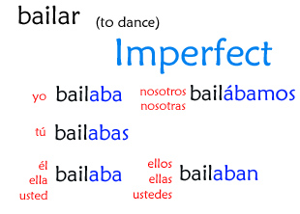
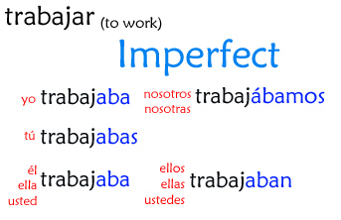

Verb charts:

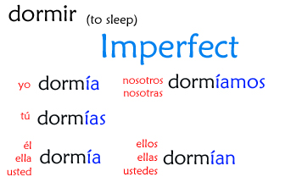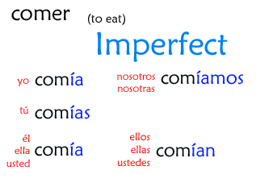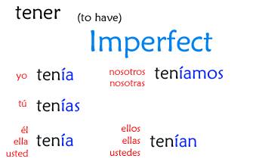

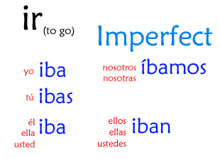
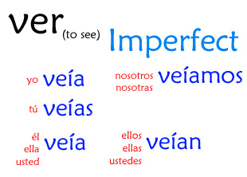
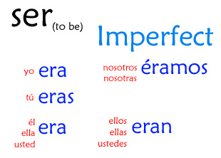

Nombre: Fecha:

Tercer Paso

- You are at a family reunion, listening to everyone describe relatives from their childhood. Write down the sayings we studied in class that best fits each description.

- A mí abuela le encantaba ir al teatro. Todos los días soñaba con ser actriz.

- Cuando mi hermana Jazmín era un niña, a ella le fascinaba contar chistes malísimos.

- Cuando yo tenía problemas mi madre me ayudaba.

- Mi tío Devono era como un oso. Él era fuerte y musculoso como un oso.

- Mi hermana trabajaba siempre dormía profundamente.

- De niña yo tenía muchos amigos y me gustaba trabajar y ayudar a mis padres.

B. Raimundo made a chart comparing his new school in Texas with his old school in Ohio. Write a sentence about each item in the chart, making a comparison of equality between the two schools.

COLEGIO | TEXAS | Ohio
6. El colegio | Me parece pequeño | No es grande
8. Los profesores | Son torpes | Son torpes también
9. La clase de español | Es aburrida | No es interesante
10. El director | Es estricto | Es difícil
11. Los exámenes | Son muy fáciles | No son muy difíciles
12. La Comida en el colegio | Es muy rica | Es deliciosa
13. Los estudiantes | Son muy aplicados | Son muy estudiosos, también

6.____________________________________________________________________________
7.____________________________________________________________________________
8.___________________________________________________________________________
9.____________________________________________________________________________
10.___________________________________________________________________________
11.___________________________________________________________________________
12.___________________________________________________________________________
13.___________________________________________________________________________

C. Marcos y Kattya were very competitive when they were growing up. Write comparisons explaining comparisons of equality.

14. travesura (hacer)

15. árboles (trepar)

16. Arañas (soñar con)

17. Juguetes(compartir)

18. Océano (nadar)

19. Edificios (Construir)

D. Listening

Listening exercises to review with scripts
http://www.laits.utexas.edu/spe/adv04.html

Escucha a los padres de Joaquín mientras hablan de cómo era él de pequeño.
- ______________
- ______________
- ______________
- ______________
- ______________
- ______________
- ______________
- ______________
- ______________

E. Write 8 sentences describing yourself when you were younger.
As a child……….
_______________________________________________________________________________________________________________________________________________________________________________________________________________________________________________________________________________________________________________________________________________________________________________________________________________________________________________________________________________________________________________________________________________________________________________________________________________________________________________

F. Please fill the blanks with the correct conjugation:
You can find the answer in this website
https://conjuguemos.com/grammar/homework/229

Cuando era joven

Cuando yo (ser) joven, yo siempre (visitar) a mis abuelos en la costa oeste de Puerto Rico. Mis abuelos (vivir) en una pequeña casa que (estar) enfrente de una de las playas más bonitas en la isla. Cada vez que yo (llegar) mis abuelos (hacer) lo mismo:
(preparar) una comida grande y me (preguntar) como las cosas me
(ir) en la escuela. Yo (ir) a su casa por siete veranos consecutivos, hasta que ellos
(decidir) mudarse a otra parte de la isla porque le (tener) miedo a las olas que a veces (ser) un poco grandes.

