"Striving for excellence today, preparing students for the challenges of tomorrow"

BIENVENIDOS A LA CLASE DE ESPAÑOL DE LA SEÑORA ROMERO
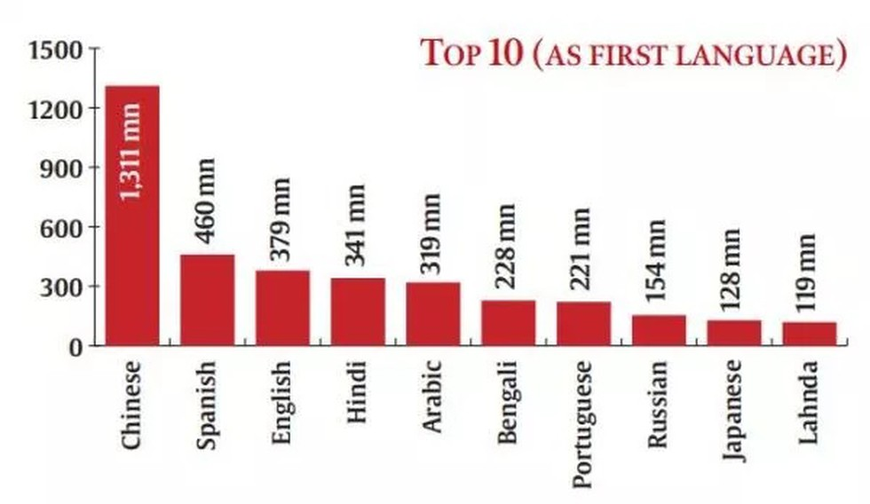

Course Description and Requirements Objectives:

This course is based on authentic materials. The course is designed to teach students beginning Spanish grammar and culture through reading, writing, listening, and speaking activities. Communication in Spanish is the ultimate goal of all activities through an understanding of language and cultural practices. The text is supplemented with additional materials such as newspapers, magazines, and children's books. Students will be able to read, write, converse, and comprehend, as well as understand the present and future tenses by the end of the year.

Attendance:

This course is of prime importance in the learning of a foreign language. To be successful, Spanish must be practiced daily, not merely studied at home from a textbook. Regarding absence, school board policy (5210) will be enforced. Students with excessive unexcused absences as stated in the handbook should not expect to pass this course. Records of tardiness will be kept, with the standard detention procedures applied. Students will hopefully recognize the value of class time and will not abuse it.

Class procedures:
- Participation: Students must be at their assigned seat as soon as they enter the class. Materials should be on each student’s desk and the textbook must be on the vocabulary section we are covering. The points in participation include active involvement in class, i.e. raising his/her hand to answer, going to board, offering to read, etc.

- Make-up Work: Students that are absent from a class will receive the same number of days to make-up the work. The teacher will post one to two weeks in advance the dates of a quiz and/or a test, therefore if a student is absent he or she should be preparing for the quiz and/or test. It is the student’s responsibility to see me as to the specifications of the assignment or assessment after the class is over. Please contact me to request work during an extended absence.

- Daily Work: Students will have homework every day. This consists of reading, reviewing, writing exercises or vocabulary memorization. Written work may be assigned and is due in completion on the day expected at the beginning of the period. No late work will be accepted. Written homework assignments as well as all written work must be complete and turned in using schoology. All work should have the student’s name. The grade is determined from total number of questions given and the difficulty of the assignment.

- Cheating/Copying: Students should never have to resort to this if they prepare and participate as outlined. In the event they are compelled to cheat they will most likely be caught and the following consequences will occur: a “0” on test or assignment, notification to parent and/or administrator for possible consequences.

- Students will be allowed to retake 2 failing tests per quarter. The students would need to schedule the retake test after they have meet with the teacher for tutoring. The student have one day after he/she has taken the test to schedule for a tutoring session. The student will not be allowed to retake any test without being tutored by the teacher before hand. The student will retake the test no later that one day after he/she has been tutored.

- ENRICHMENT: The students will have the opportunity to engage in one or two enrichment opportunities per quarter. The teacher will announce them each quarter and the teacher will send via e-mail the guidelines of each activity. The student will be required to submit their enrichment activity via e-mail and at times it may involve the collaboration of a parent to do this activity.

Behavior: A positive attitude is important to meet the challenges of a foreign language. The students must feel free to experiment within the classroom, yet must not infringe upon the rights of others. Respect for the instructor and fellow students should be fostered. Students should not eat, drink, nor chew gum unless given special permission. In the event of the teacher’s absence, all students should follow the class rules. Morning detentions will be given for class misbehavior and tardies. Please note that after three tardies a referral will be issued. Disruptions will be dealt with according to the rules and regulations of this class as well as school regulations.

Phones/Electronics/Earbud/s: NO ELECTRONIC DEVICES OR USING APPS FOR PERSONAL USE DURING CLASS (Includes Music, ear bud/s in ears, & Checking PowerSchool without teacher permission) Phones and devices will not be allowed without permission from the teacher. From time to time phones and devices will be used for academic purposes in class. If you do not have a phone, the teacher will accommodate the student.
Consequences per semester to be recorded:
- First time--Warning to stop using the device.
- Second time--Phone removed for the class period.
- Third time--Phone call home
- Fourth time--Office referral

Class Evaluation: A point system will be used to determine grades. Students will take both written and oral quizzes and exams. Class participation is essential for the language acquisition. Homework is reviewed in class as part of the class activity. Credit will be given if the assignment is entirely complete at the beginning of the period. All test, quizzes and homework are returned within four days. There will not be extra credit allotted to replenish poor performance.

Grading Policy:
A 100-90 D 69-60
B 89-80 E 59-0
C 79-70
Basic Materials:
- Ven Conmigo Level 1. Holt, Rinehart and Winston
- 2 Notebooks
- One pocket folder
- Pencils
- Black or blue pen for TESTS

Spanish Sources:

https://quizlet.com
www.wordreference.com
www.studyspanish.com/tutorial.htm
http://www.uni.edu/becker/Spanish2.html
www.notesinspanish.com (beginner’s level)

"Striving for excellence today, preparing students for the challenges
of tomorrow"

BIENVENIDOS A LA CLASE DE ESPAÑOL DE LA Señora ROMERO

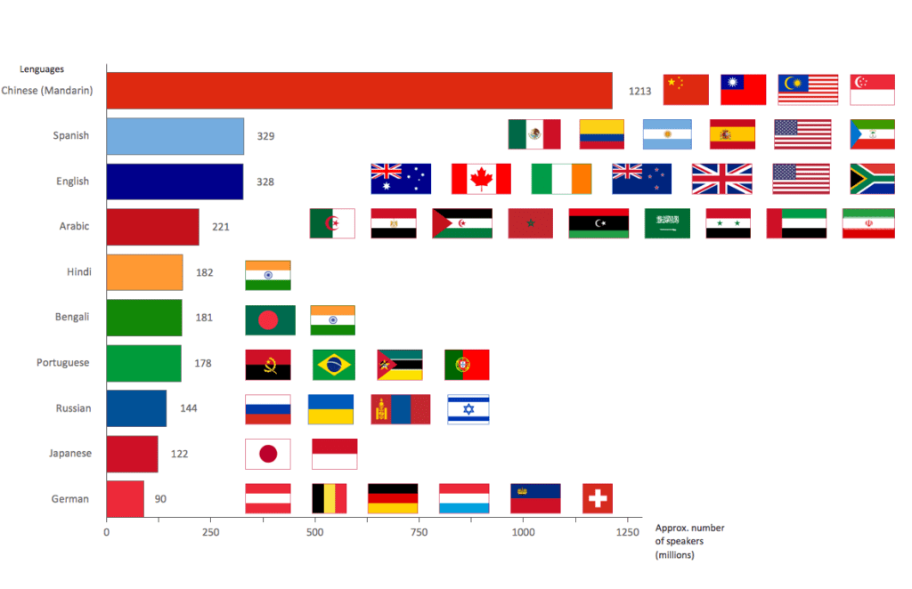
Willoughby-Eastlake City Schools
August 19th, 2020

Dear Parent/Guardian:

My name is Mrs. Romero. For the past twenty-one years, I have been teaching high school Spanish courses. My goal has been to assist my students in achieving competence in the Spanish language as well as to gain full awareness and appreciation of the range of Spanish-speaking cultures around the world.

Students will be reading, writing and memorizing vocabulary. There is homework every day. You can help with the task of memorization of vocabulary. You should encourage daily reading or speaking. Practice varies, but generally 20 minutes a day, every day is needed. Memorization requires patience and oral reinforcement. Also, ask for notes, practice sheets, and online resources such as quizlets. All quizzes, tests and homework assignments will be posted on Schoology and in the Grade Book in Power School so you can check your students’ progress.

Please complete the attached form and return it to school with your son/daughter by August 31th, 2020. This will be an indication to me that you have read the attached syllabus and are aware of what is expected in my class. Also, all supplies should be obtained by August 31st, if possible. If you need to reach me for a conference, please call North High School extension 4631 and leave a message. I will get back to you at my earliest convenience. You can also reach me via e-mail at Kattya.Romeromora@WESchools.org.

Thank you in advance for allowing me the pleasure to teach your son/daughter Spanish this year and for your support in keeping your son/daughter well-equipped, organized and on-track this year!

Sincerely,

Kattia Romero Mora

Señora Kattya Romero Mora
Kattia.Romeromora@WESchools.org

"Striving for excellence today, preparing students for the challenges
of tomorrow"
The classroom operates most successfully with parent involvement. Please send me an email informing me that you have read the syllabus, have been able to access my website, and have seen the materials needed for this class. I will keep these emails on file as a quick form of contact. Please place your son/daughter’s name and class period in the subject heading of the email.
In responding by email, you do not need to sign and return this letter. If you do not have internet access, please indicate this on the back of this letter by giving me another form of contact and return a signed copy to me.
Students and Parents: Please complete the biographical information form and have your parents sign the syllabus and computer/lab forms. These are attached to the back of the syllabus. Return these to me on the following day. Thank you.
Students and Parents: Please complete the biographical information form and have your parents sign the syllabus and computer/lab forms. These are attached to the back of the syllabus. Return these to me on the following day. Thank you.

Personal Information

Nombre:____________________________________________Grade: 9 10 11 12
last name name

Address:__________________________City________Zip Code__________

Father’s name:_____________________________________________________
E-mail:__________________________Phone Number:____________________

Mother’s name:______________________________________________________
E-mail:____________________________Phone Number:____________________

Briefly tell why you chose to learn Spanish:

1. List three personal characteristics/qualities that you like about yourself or are proud of:
1.
2.
3.
2. Mention one characteristic about yourself that you would like to improve:

3. What kind of learner are you? (Visual, auditory, hands-on, etc.)

_____________________________________________________________________

4. List anything you think I need to know about you that may affect your performance in the classroom (i.e. visual and auditory problems, diabetes, anxiety, medications, etc.)

Phones/Electronics/Earbud/s: NO ELECTRONIC DEVICES OR USING APPS FOR PERSONAL USE DURING CLASS (Includes Music, ear bud/s in ears, & Checking Powerschool without teacher permission) Phones and devices will not be allowed without permission from the teacher. From time to time phones and devices will be used for academic purposes in class. If you do not have a phone, the teacher will accommodate the student.
Consequences per semester to be recorded:
            - First time--Warning to stop using the device.
            - Second time--Phone removed for the class period.
            - Third time--Phone call home
            - Fourth time--Office referral

