Spanish 2
Chapter 5.3 LEARNING TARGET
-Vocabulary: Body parts
-Verbs to express pain or injury
-Reflexives
-Commands
CORNELL NOTES  SHEET | Name: KattyaRomero  Class: Spanish II  Topic: Spanish  Date: Hoy es del dos mil diez y nueve  Period
PREGUNTAS | APUNTES
What are we studying? | - Vocabulary: Body parts  -Verbs to express pain or injury  -Reflexives  -Commands
What is our focus? | -Present and Preterite Indicative regular and irregular verbs  -Verbs to express pain or injury  -Reflexives  -Commands
What are we reviewing? | We are reviewing conjugation of -ar, -er and -ir verbs.  We are reviewing regular and irregular verbs.
What’s an irregular verb?  What’s a regular verb?  What the endings for ALL verbs in Spanish? | Irregular verbs have a change in the root  Regular verb keeps the same root of the verb  All verbs in Spanish end in –ar, -er and –ir.
What is the vocabulary we are reviewing? | Body parts, commands, preterit and present.
SUMMARY: Write 4 or more sentences describing specific learning from these notes.
I can describe injuries and body parts.

Quizlet:
http://quizlet.com/28374578/u1-5th-gr-body-parts-flash-cards/
Vocabulary with pictures:
http://quizlet.com/16664138/spanish-body-parts-with-pictures-flash-cards/

Video Body Parts:
https://www.youtube.com/watch?v=ct_VPIH0ObM&list=RDct_VPIH0ObM#t=0
kids songs to learn body parts:
http://www.rockalingua.com/videos/parts-body
http://www.videoele.com/A1_El_cuerpo.html
https://www.youtube.com/watch?v=kQm_6ZKKyGA
Song:
https://www.youtube.com/watch?v=qMaJ1_eZDos
PRACTICE/game body parts:
http://www.spanishspanish.com/body/body.html
http://www.spanishspanish.com/body/face.html
http://www.trentu.ca/academic/modernlanguages/spanish/masarriba/body2.html
http://www.123teachme.com/games/drag_n_match?cat=8

Listening exercises:
https://www.youtube.com/watch?v=ffmAFP1MoAM
https://www.youtube.com/watch?v=LRkRczALHoE
Students videos: https://www.youtube.com/watch?v=4x4CuEytBwE

Language: | Spanish
Title: | Ven Conmigo 2: Capítulo 5

ENGLISH |  |  | SPANISH
1. I already know |  |  | 1. ya lo sé
2. I was going to... but I wasn't able |  |  | 2. iba a... pero no pude
3. ankle |  |  | 3. el tobillo
4. balanced |  |  | 4. balanceado/balanceado a
5. be careful |  |  | 5. ten cuidado
6. calf (of the leg) |  |  | 6. el muslo
7. competition |  |  | 7. la competencia
8. cycling |  |  | 8. el ciclismo
9. deeply |  |  | 9. profundamente
10. diet |  |  | 10. la dieta
11. don't add salt |  |  | 11. no añadas sal
12. don't be... |  |  | 12. no seas...
13. elbow |  |  | 13. el codo
14. enough |  |  | 14. suficiente
15. fat |  |  | 15. la grasa
16. for (a period of time) |  |  | 16. por
17. get into shape |  |  | 17. ponte en forma
18. habit |  |  | 18. el hábito
19. health |  |  | 19. la salud
20. healthy |  |  | 20. sano/sano a
21. hiking |  |  | 21. el senderismo
22. it's just that... |  |  | 22. es que...
23. it's necessary |  |  | 23. es preciso
24. knee |  |  | 24. la rodilla
25. martial arts |  |  | 25. las artes marciales
26. mountain climbing |  |  | 26. el montañismo
27. neck |  |  | 27. el cuello
28. rowing |  |  | 28. remar
29. shoulder |  |  | 29. el hombro
30. stop smoking |  |  | 30. deja de fumar
31. stress |  |  | 31. el estrés
32. swimming |  |  | 32. la natación
33. thigh |  |  | 33. el muslo
34. to ache/to hurt |  |  | 34. doler
35. to avoid |  |  | 35. evitar
36. to be in good shape |  |  | 36. estar en plena forma
37. to be on a diet |  |  | 37. hacer régimen
38. to become ill |  |  | 38. enfermarse
39. to breathe |  |  | 39. respirar
40. to complain |  |  | 40. quejarse
41. to dedicate |  |  | 41. dedicar
42. to do sit-ups |  |  | 42. hacer abdominales
43. to enroll |  |  | 43. inscribirse
44. to forget (about) |  |  | 44. olvidarse (de)
45. to get tired |  |  | 45. cansarse
46. to give permission |  |  | 46. dar permiso
47. to go mountain climbing |  |  | 47. escalar montañas
48. to have a cramp |  |  | 48. tener calambre
49. to have fun |  |  | 49. divertirse
50. to hurt (oneself) |  |  | 50. hacerse daño
51. to injure (oneself) |  |  | 51. lastimarse
52. to jump rope |  |  | 52. saltar a la cuerda
53. to lift weights |  |  | 53. levantar pesas
54. to lose weight |  |  | 54. bajar de peso
55. to move |  |  | 55. moverse
56. to put on weight |  |  | 56. aumentar de peso
57. to relax |  |  | 57. relajarse
58. to remember |  |  | 58. acordarse de
59. to row |  |  | 59. remar
60. to sprain |  |  | 60. torcerse
61. to stay in shape |  |  | 61. mantenerse en forma
62. to stretch |  |  | 62. estirarse
63. to sweat |  |  | 63. sudar
64. to train |  |  | 64. entrenarse
65. track and field |  |  | 65. el atletísmo
66. well-being |  |  | 66. el bienestar
67. wrist |  |  | 67. la muñeca
2000-2016 CONJUGUEMOS (Yegros Educational LLC)

Las partes del cuerpo

(PARTS OF THE BODY)
el cuerpo__________________________
la mano__________________________
el codo__________________________
la cintura__________________________
la cabeza__________________________
el brazo__________________________
el dedo__________________________
el cuello__________________________
la espalda__________________________
el tobillo__________________________
el pie__________________________
la pierna__________________________
la rodilla__________________________
el hombro__________________________
la cara__________________________
el ojo__________________________
la nariz__________________________
la boca__________________________
la lengua__________________________
el pompis__________________________
la oreja__________________________
los dientes__________________________
el pelo__________________________
la garganta__________________________
el pecho__________________________
el dedo del pie__________________________
el estómago__________________________

The verb doler
http://www.123teachme.com/learn_spanish/quizzes_verb_doler
The verb doler (to hurt) is similar to the verb "gustar". It is always accompanied by (IOP) indirect object pronouns (me, te, le, nos, os, les).When you hurt you use the phrase: me duele me dolió (singular) or me duelen me dolieron (plural).
Fill in the blank with the correct form of the verb doler. Say the sentence.
Example: Nos _____ los dedos. - Our fingers hurt. Answer : Nos duelen los dedos.
1. Me _____ el diente.
2. Les _____ las manos.
3. A mi hijo le _____ la garganta.
4. ¿Te _____ la cabeza?
5. Me _____ las piernas.
6. ¿Dónde le _____ ?
7. Me _____ la espalda.
8. A Juan le _____ el brazo.
9. A nosotros nos _____ la cabeza.
10. Me _____ los ojos cuando leo.
11. Me _____ la cabeza y el pie derecho.
12. A ella le _____ los dientes.
13. Le _____ los brazos.
14. Nos _____ las manos y las rodillas.
15. Te _____ las orejas.

Verbs we need to know how to conjugate in present and preterit:
PRACTICE CONJUGATING THESE VERBS IN THIS WEBSITES:
http://go.hrw.com/hrw.nd/arbiter/pRedirect?project=hrwonline&siteId=593&pageId=4254
http://quizlet.com/12589707/spanish-200-verbs-flash-cards/

Partes del cuerpo
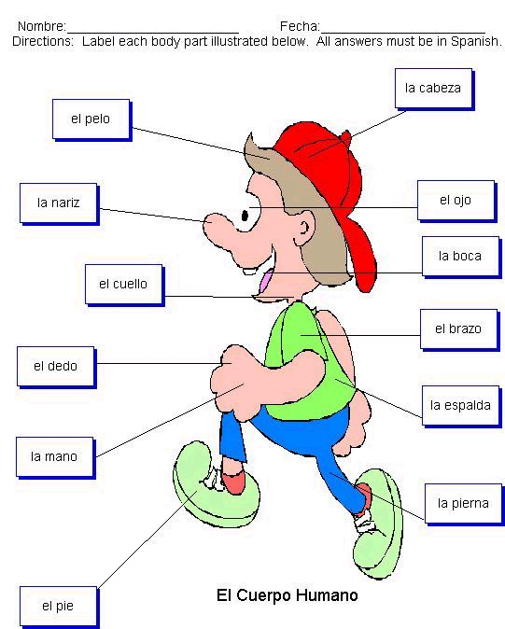
https://www.youtube.com/watch?v=qbMApcnzLDk

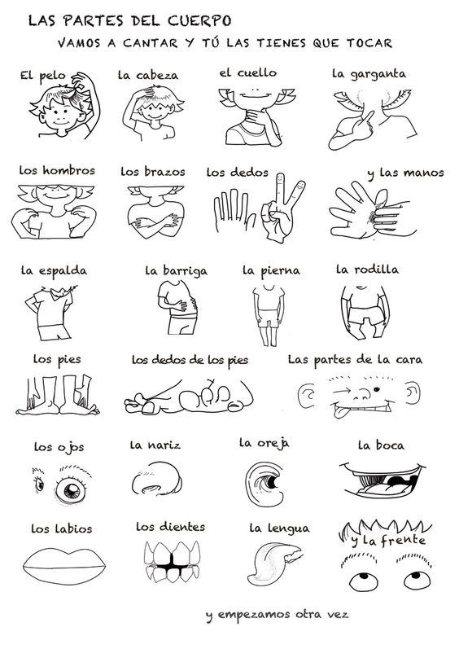

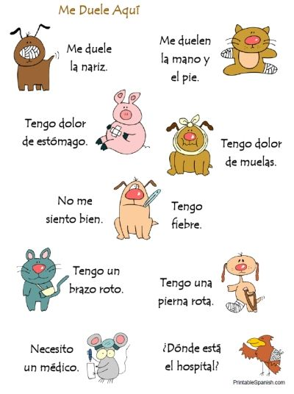

Mandatos (commands) – Commands are used to tell others what to do. They can be used in many things such as recipes, direction giving, advertisements, or any situation in which you need to tell someone what to do or what not to do.
- Positive tú commands –
*Positive tú commands are formed by using the _3rd_ person singular form of the present tense.
*Any pronouns (IOP, DOP, or reflexive) must be ATTACHED to the END of the command!
Practice: Write the following to + tú commands in Spanish:
1.Run __corre__ 2. Talk__habla__ 3. Wake up!___despiértate___

*There are 8 irregular tú commands that you will just have to memorize.
List them below:
- Say/tell = _di___ 5. Go = __ve____
- Do/make=_haz__ 6. Have = _ten___
- Come=_ ven___ 7. Leave=_sal__
- Put=__pon____ 8. Be = __sé____
What is the phrase we learned to help you remember these irregulars?
__VenDiSal____ __Haz___ __Ten___ __VePonSé____

- Negative tú commands –
To form a negative tú command, do the following:
- Put the verb in the present tense __Yo__ form
- __Drop the “o”___
- Add opposite endings (-ar verbs add __-es__ / -er/-ir verbs add __-as___)

*Where do you place a pronoun with NEGATIVE commands?____BEFORE the verb(command)________
*Verbs that end in –gar, -car, and –zar will have spelling changes with negative tú commands.
*What are those changes? –gar g>gu__ -car c>qu__ -zar z>c__
*There are only 4 irregular verbs for negative tú commands:
1. Don’t give _no des_
2. Don’t be _no seas
3. Don’t go_no vayas
4. Don’t be___no estés (condition/state/emotion) (description)
Practice –
Write the negative commands in Spanish:
1. Don’t leave __no salgas_____ 4. Don’t get up __no te levantes__________
2. Don’t go _ no vayas___ 5. Don’t start ___no empieces___________
3. Don’t talk _____no hables_________ 6. Don’t eat them (French fries)__no las comas___
- Positive and Negative Ud./Uds. Commands
They follow the same pattern as negative tú commands, but let’s recap just to make sure you know…
1. Yo form (present tense)
2. Drop the “o”
3. opposite endings: –ar verbs add –e/-en and –ir/-er verbs add –a/-an
*This 3-step pattern is followed for BOTH NEGATIVE and POSITIVE Ud./Uds. commands.
*-gar,-car, and –zar will also change with Ud/Uds. Commands
*formal commands also have 4 irregulars (same whether neg. or pos.)
Ud. Uds.
1. dé den
2. sea sean
3. vaya vayan
4. esté estén
Practice writing the correct Ud./Uds. commands.
- Estudiantes, no __se vayan___ (irse)
- Dr. Bitterman, __siéntese____ (sentarse) aquí, por favor.
- Juan y Eva, __almuercen______ (almorzar) conmigo (with me).
- Amigos, __escuchen______ (escuchar) la música del conjunto.
- Señor, __lea_____ (leer) el poema otra vez.
- Elena y Jaime, __díganme____ (decirme) la verdad.

VERB CONJUGATIONS
acordarse to remember Present Indicative
Yo me acuerdo | Nosotros nos acordamos
Tú te acuerdas | Vosotros os acordáis
Él se acuerda | Ellos se acuerdan
acordarse Preterite Indicative
Yo me acordé | Nosotros nos acordamos
Tú te acordaste | Vosotros os acordasteis
Él se acordó | Ellos se acordaron
Cansarse Present Indicative to get tired
Yo me canso | Nosotros nos cansamos
Tú te cansas | Vosotros os cansáis
Él se cansa | Ellos se cansan
Preterite cansarse
Yo me cansé | Nosotros nos cansamos
Tú te cansaste | Vosotros os cansasteis
Él se cansó | Ellos se cansaron
Lastimarse to injure oneself Present Indicative
Yo me lastimo | Nosotros nos lastimamos
Tú te lastimas | Vosotros os lastimáis
Él se lastima | Ellos se lastiman
Lastimarse Preterite Indicative
Yo me lastimé | Nosotros nos lastimamos
Tú te lastimas te | Vosotros os lastimasteis
Él se lastimó | Ellos se lastimaron

Enfermarse to get sick to become ill Present Indicative
Yo me enfermo | Nosotros nos enfermamos
Tú te enfermas | Vosotros os enfermáis
Él se enferma | Ellos se enferman
Preterite Indicative
Yo me enfermé | Nosotros nos enfermamos
Tú te enfermaste | Vosotros os enfermasteis
Él se enfermó | Ellos se enfermaron

Quejarse Present Indicative
Yo me quejo | Nosotros nos quejamos
Tú te quejas | Vosotros os quejáis
Él se queja | Ellos se quejan
Quejarse Preterite Indicative
Yo me quejé | Nosotros nos quejamos
Tú te quejaste | Vosotros os quejasteis
Él se quejó | Ellos se quejaron

Olvidarse to forget Present Indicative
Yo me olvido | Nosotros nos olvidamos
Tú te olvidas | Vosotros os olvidáis
Él se olvida | Ellos se olvidan

Olvidarse to forget Preterite Indicative
Yo me olvidé | Nosotros nos olvidamos
Tú te olvidaste | Vosotros os olvidasteis
Él se olvidó | Ellos se olvidaron

Divertirse to have fun Present Indicative SHOE VERB
Yo me divierto | Nosotros nos divertimos
Tú te diviertes | Vosotros os divertís
Él se diviertió | Ellos se diviertieron

Divertirse to have fun Preterite Indicative SANDAL
Yo me divertí | Nosotros nos divertimos
Tú te divertiste | Vosotros os divertisteis
Él se divIrtió | Ellos se divIrtieron

IRREGULAR VERBS

Hacerse daño to hurt oneself Present indicative
Yo me hago daño | Nosotros nos hacemos
Tú te haces daño | Vosotros os hacéis
Él se hace daño | Ellos se hacen

Hacerse daño Preterite Indicative
Yo me hice daño | Nosotros nos enfermamos
Tú te hiciste daño | Vosotros os enfermáis
Él se hizo daño | Ellos se enferman

Torcerse to sprain Present Indicative

Yo me tuerzo | Nosotros nos torcimos
Tú te tuerces | Vosotros os torcéis
Él se tuerce | Ellos se tuercen

Torcerse to sprain Preterite Indicative

Yo me torcí | Nosotros nos torcimos
Tú te torciste | Vosotros os torcisteis
Él se torció | Ellos se torcieron

This verb NOT reflexive

Tener calambre to have a cramp Present indicative

Yo tengo un calambre | Nosotros tenemos un calambre
Tú te tienes un calambre | Vosotros os tenéis un calambre
Él se tiene un calambre | Ellos se tienen un calambre

Tener un calambre
Yo tuve un calambre | Nosotros tuvimos un calambre
Tú te tuviste un calambre | Vosotros os tuvisteis un calambre
Él se tuvo un calambre | Ellos se tuvieron un calambre

Romperse Present indicative

Yo me rompo | nosotros nos rompimos
Tú te rompes | vosotros os rompéis
él se rompe | ellos se rompen

Romperse en Preterit

Yo me rompí | nosotros nos rompimos
Tú te rompiste | vosotros os rompisteis
él se rompió | ellos se rompieron

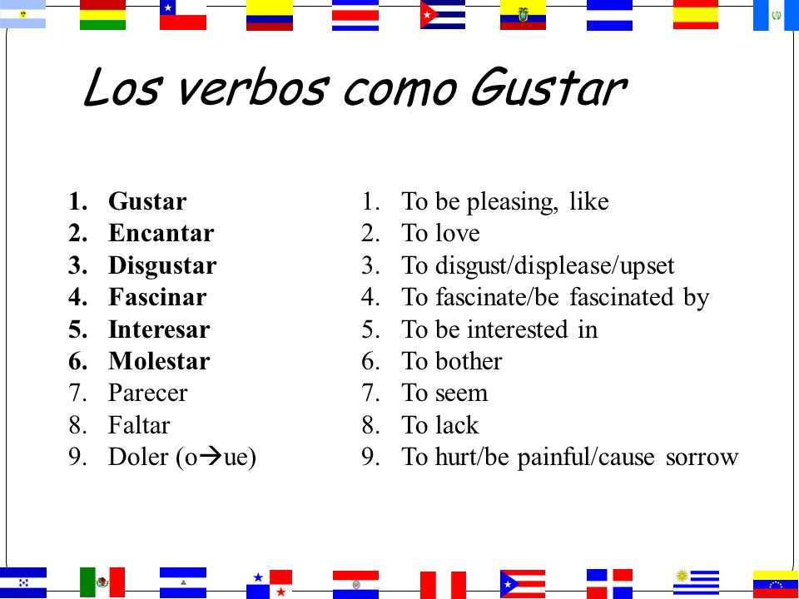

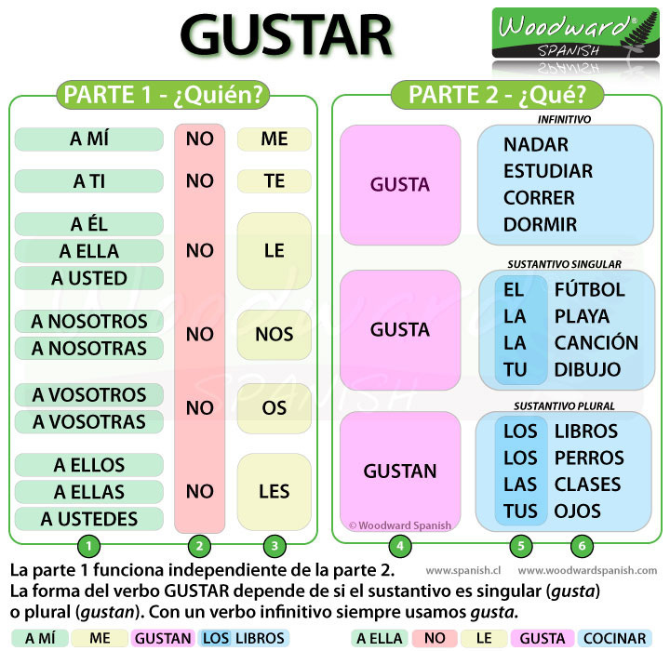

El verbo DOLER (o → ue) ● Literally, it means to cause pain, but in English we use it in translating sentences with hurt.
SLIDES EXPLANING DOLER: http://slideplayer.es/slide/4633867/

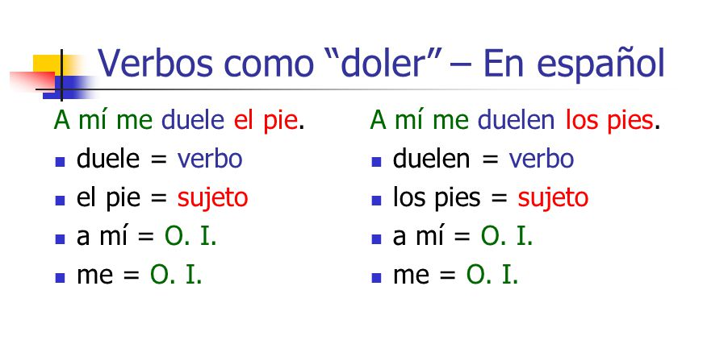
DOLER

DOLER
Pretérito
A mí me Dolió Singular
A ti te Dolió Verbs
A él le
A nosotros Dolieron Plural
A vosotros Dolieron NO VERBS
A ellos

