|  |  |
| --- | --- |
| **Spanish I**  **Chapter 3.3**  <https://www.youtube.com/watch?v=w_D08ltoOns&list=PL81D49AFE2942F3F4> |  |
|  |  |

Hoy es de enero del dos mil diez y siete.

¿Cuánto estudias?   Yo estudio..... minutos

|  |
| --- |
| **LEARNING TARGET** Spanish I |
| 1. **Review SER vs ESTAR** 2. **Uses of SER and ESTAR** 3. **Adjectivies** 4. **GUSTAR** |

|  |  |
| --- | --- |
| **CORNELL NOTES**  **SHEET** | **Name: KattyaRomero Class: Spanish I**  **Topic: Spanish**  **Date: Hoy es del dos mil quince Period primero, tercero** |
| **PREGUNTAS** | **APUNTES** |
| **What are we studying?** | 1. **Review SER vs ESTAR** 2. **Uses of SER and ESTAR** 3. **Adjectivies** 4. **GUSTAR** |
| **What is our focus?** | **Gender and # agreement**  **Singular vs Plural**  **plural of vowel A E I O U 🡪-S**  **plural of consonants VDF🡪 -ES**  **EXCEPTION Z🡪 CES**  **SER VS ESTAR** |
| **What are we reviewing?** | **All of the above and ADJECTIVIES** |
| **What’s an irregular verb?**  **What’s a regular verb?**  **What the endings for ALL verbs in Spanish?** | **The root has changes.**  **The root does not change.**  **-AR, -ER,-IR** |
| **What is the vocabulary we are reviewing?** | **ADJECTIVES/PREPOSITION** |
| **SUMMARY: Write 4 or more sentences describing specific learning from these notes.**  **We are learning to describe THINGS AND PEOPLE.** | |

**Useful Websites**

**Extra credit 3 quizlets = 5 points due on test day**

[**https://quizlet.com/4702862/ch-3-ven-conmigo-tercer-paso-part-1-flash-cards/**](https://quizlet.com/4702862/ch-3-ven-conmigo-tercer-paso-part-1-flash-cards/)

[**https://quizlet.com/19160289/spanish-1chapter-3-tercer-paso-flash-cards/**](https://quizlet.com/19160289/spanish-1chapter-3-tercer-paso-flash-cards/)

[**https://quizlet.com/64186423/vc1-chapter-3-tercer-paso-flash-cards/**](https://quizlet.com/64186423/vc1-chapter-3-tercer-paso-flash-cards/)

[**https://www.youtube.com/watch?v=6QzEmSJvHPw**](https://www.youtube.com/watch?v=6QzEmSJvHPw)

[**https://www.youtube.com/watch?v=w6TjefGxfPY**](https://www.youtube.com/watch?v=w6TjefGxfPY)

[**https://www.youtube.com/watch?v=Yi8VW4xKciQ**](https://www.youtube.com/watch?v=Yi8VW4xKciQ)

[**https://www.youtube.com/watch?v=O45wjys1Cu0**](https://www.youtube.com/watch?v=O45wjys1Cu0)

**http://www.cram.com/flashcards/ven-conmigo-level-1-ch-33-1460320**

<http://quizlet.com/20277455/learn>

<http://quizlet.com/22987153/spanish-adjectives-with-pictures-flash-cards/>

<http://www.spanish.cl/Grammar/Games/Adjetivos.htm>

<http://www.spanish.cl/Grammar/Games/Adjetivos.htm>

<http://www.softschools.com/matching_games/spanish/spanish_adjectives/855/>

**HOW to use Adjectives and the Verb ser**

<https://www.youtube.com/watch?v=1x7VDs_8c0s>

[**https://www.youtube.com/watch?v=v2ALpg1HaYs**](https://www.youtube.com/watch?v=v2ALpg1HaYs)

**Listening**

**Listening activity**

[**http://faubionspanish.weebly.com/lab-5---ser.html**](http://faubionspanish.weebly.com/lab-5---ser.html)

[**https://miclaseessuclase.wordpress.com/2014/11/07/cancion-de-la-semana-soy-guapo-por-senor-wooly/**](https://miclaseessuclase.wordpress.com/2014/11/07/cancion-de-la-semana-soy-guapo-por-senor-wooly/)

**¿Cómo es el señor Wooly?**

**¿Qué piensa el Sr. Wooly de él mismo?**

**¿Cómo es el otro hombre?**

**¿Por qué es feo el otro hombre?**

[**https://www.pinterest.com/pin/123145371032411511/**](https://www.pinterest.com/pin/123145371032411511/)

**¿Cómo son los jeans del chico?**

**¿Qué adjetivos usa la niña/chica/mujer?**

**GREAT VIDEOS AND EXPLANATIONS:**

<https://video.search.yahoo.com/search/video;_ylt=AwrBTztcq1xWJCIAIupXNyoA;_ylu=X3oDMTEyYjUwMmQzBGNvbG8DYmYxBHBvcwMxBHZ0aWQDQjExNzlfMQRzZWMDc2M-?p=Webbly+Lesons+On+Ser+Spanish&fr=mcafee#id=25&vid=d9593de5a5bfa03b8d676f15ca988e8e&action=view>

**http://conjuguemos.com/print\_vocabulary\_list.php?id=136&source=public**

**VOCABULARIO CHAPTER 3 STEP 3**

|  |  |
| --- | --- |
| 41. boring | 41. aburrido |
| 42. tall | 42. alto |
| 43. disagreeable | 43. antipático |
| 44. short | 44. bajo |
| 45. pretty | 45. bonito |
| 46. good | 46. bueno |
| 47. funny | 47. cómico |
| 48. What is he like? | 48. ¿Cómo es él? |
| 49. What are they (masc.) like? | 49. ¿Cómo son ellos? |
| 50. friend, pal | 50. el compañero |
| 51. difficult | 51. difícil |
| 52. fun, amusing | 52. divertido |
| 53. they (masc.) | 53. ellos |
| 54. You are (fam.) | 54. Tú eres |
| 55. He is... | 55. Él es... |
| 56. strict | 56. estricto |
| 57. easy | 57. fácil |
| 58. ugly | 58. feo |
| 59. big | 59. grande |
| 60. good-looking | 60. guapo |
| 61. intelligent | 61. inteligente |
| 62. interesting | 62. interesante |
| 63. bad | 63. malo |
| 64. dark haired, dark skinned | 64. moreno |
| 65. Do not worry | 65. No te preocupes |
| 66. new | 66. nuevo |
| 67. small | 67. pequeño |
| 68. teacher (masc.) | 68. el profesor |
| 69. blond | 69. rubio |
| 70. nice | 70. simpático |
| 71. We are | 71. Somos |
| 72. the dance | 72. el baile |
| 73. the concert | 73. el concierto |
| 74. Which? | 74. ¿Cuál? |
| 75. the sports | 75. los deportes |
| 76. the exam | 76. el examen |
| 77. the exams | 77. los exámenes |
| 78. favorite | 78. favorito |
| 79. the party | 79. la fiesta |
| 80. teacher (fem.) | 80. la profesora |
| 81. the novel | 81. la novela |
| 82. the game | 82. el partido |
| 83. Why? | 83. ¿Por qué? |
| 84. because | 84. porque |
| 85. the videogame | 85. el videojuego |
| 86. the videogames | 86. los videojuegos |
| 87. the (fem. / pl.) | 87. las |

Adjectives – **adjetivos**

Adjective – a word that describes a noun or distinguishes it from a group of other nouns.

In English an adjective comes before the word it is describing and has one form.

Ex: the red car the red cars

Before car it has the same form even though there are more cars

In Spanish, an adjective comes after the noun and must agree with it in number and gender. So each adjective that ends in an “o” has four forms: masculine, feminine, singular and plural. Adjectives that end in an “e” or a consonant have two forms: singular and plural. Use these charts to help:

Adj. that end in “O” have four forms. Let’s look at the word for “tall”

|  |  |  |
| --- | --- | --- |
|  | **Singular** | **Plural** |
| Masculine | Alt**o** | Alt**os** |
| Feminine | Alt**a** | Alt**as** |

Examples: The tall boy = **el** muchach**o** alt**o**

The tall girl = **la** muchach**a** alt**a**

The tall boys = **los** muchach**os** alt**os**

The tall girls = **las** muchach**as** alt**as**

Notice that the article, noun, and adjective must match in gender and number.

**Don’t forget that the adjective comes after the noun in Spanish!**

Adjectives that end in “e” or a consonant have only two forms.

|  |  |  |
| --- | --- | --- |
|  | **Singular** | **Plural** |
| Adjective that end in “e” | Inteligent**e** | Inteligente**s** |
| Consonant | Popular | Popular**es** |

If an adjective ends in a vowel, simply add an “s” to make if plural. If it ends in a consonant, you add an “es”. Examples:

The popular boy = **el** muchach**o** popular

The popular girl = **la** muchach**a** popular

The poplar boys = **los** muchach**os** popular**es**

The popular girls = **las** muchach**as** popular**es**

The intelligent boy = **el** muchach**o** inteligent**e**

**Possessive Adjectives**

**Useful videos explaining the possessive adjectives**

[**https://www.youtube.com/watch?v=rUaX5OqTEzE**](https://www.youtube.com/watch?v=rUaX5OqTEzE)

**https://www.youtube.com/watch?v=9-TFyxNwWQM**

[**https://www.youtube.com/watch?v=zT1kIpCRBqM**](https://www.youtube.com/watch?v=zT1kIpCRBqM)

## [Possessive Adjectives and "De"](http://hamiltonspanish.weebly.com/blog-2014-2015/studying-for-the-14-grammar-assessment-part-2-possessive-adjectives-and-de)

Your assessment on **Possessive Adjectives** and **"De"**

You can show relationship or possession in two ways:

"De" (of/from)              Ella es la hermana **de** Ariana.  (She is the sister **of** Ariana.)  
  Es el libro de Miguel.                (It is Miguel's book. / It is the book **of** Miguel.)

**Adjectives and Ser**

1. **Quizlet  
   1.  Click on the link below to practice adjectives with ser.**

[**http://quizlet.com/6709178/adjectives-ser-flash-cards/**](http://quizlet.com/6709178/adjectives-ser-flash-cards/)

1. Possessive adjectives

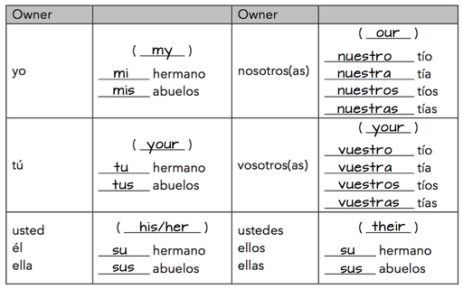

**Conjugation and Uses of SER**

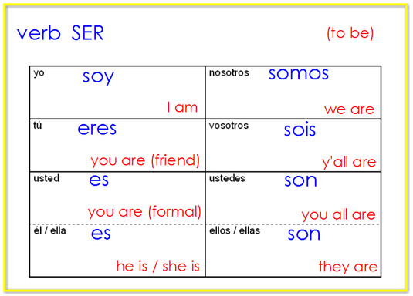

You know the correct form of ser to use based on the subject pronoun. You can also infer the subject pronoun based on the form of ser if the subject pronoun is missing.   
1.  Click here to hear all the forms of ser

<http://quizlet.com/8892022/ser-flash-cards/>

2.  Click here to practice spelling the subject pronouns and forms of ser: <https://quizlet.com/8892022/spacerace>

3.  Click here to take a practice test in ENGLISH AND SPANISH.  Start with English, next select Spanish, and create a new test: <http://quizlet.com/8892022/test>

**Short practice assessment: Formative  Escritura**

**The quiz for ser and subject pronouns is very similar to the activity below. Fill in the correct subject pronoun or the correct form of ser.**

**Answer these on the back of your handout.**

**1.       \_\_\_\_ soy inteligente.  
2.       Señor Anaya \_\_\_\_ profesor.  
3.       Usted \_\_\_\_ alto.  
4.       \_\_\_\_ eres guapo.  
5.       Andres y Diego \_\_\_\_ locos.   
6.       \_\_\_\_ somos de Texas.   
7.       Ella \_\_\_\_ bonita.  
8.       Nosotros \_\_\_\_ estudiantes buenos.   
9.       \_\_\_\_\_ sois de España.  
10.   Yo \_\_\_\_ especial.**

**REVIEW OF ALL VERBS LEARNED UP TO KNOW**

**GUSTAR**

https://www.youtube.com/watch?v=masuGwmv9q0

<https://www.youtube.com/watch?v=P7RP3Mw5mNM>

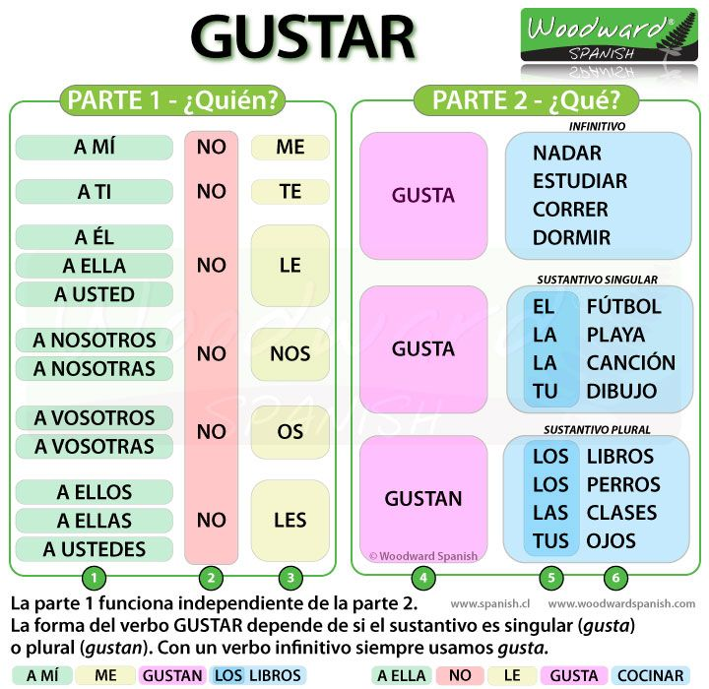

<http://users.ipfw.edu/jehle/VERBLIST.HTM>

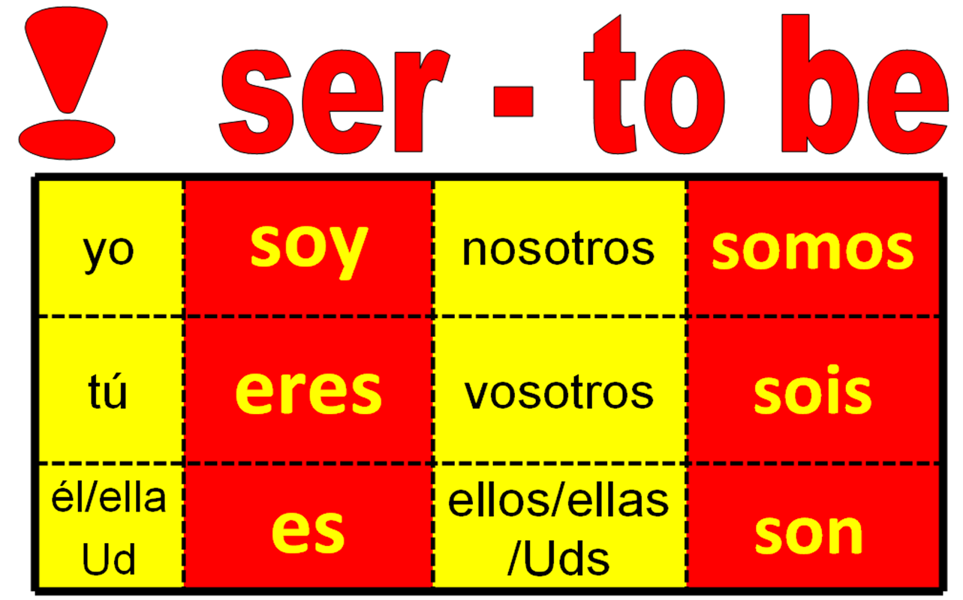

**Uses of ser: descriptions**

**http://www.spanishdict.com/topics/show/42**

**Overview**

Ser and Estar can be confusing since they both can mean “to be;” however, there are some simple generalizations that can help you remember when to use one or the other. In general, Ser is used for Descriptions, Origins, and Time, or D.O.T. This article covers Descriptions.

**Descriptions with Ser**

Ser is used for all permanent/long-term and personal descriptions. You would use ser to answer the question, “How would you describe \_\_\_\_?”. Ser is used with the essential qualities  that define a person or thing and that are not likely to change in the near future. These can be:

**physical descriptions**  
 **Soy** alta y delgada. - *I****am****tall and thin.*

* Silvia **es** pelirroja y baja. - *Silvia****is****red-headed and short.*

**names**  
 **Soy** Raúl. - *I****am****Raúl.*

* **Son** Adela y Amalia. -*They****are****Adela and Amalia.*

**the job a person has**  
**Soy** profesora de español. - *I****am****a Spanish teacher.*

* **Son** jardineros. - *They****are****gardeners.*

**the relationship a person has with someone else**

* Anita **es** mi hermana. - *Anita****is****my sister.*
* Aaron **es** su prometido. -*Aaron****is****her fiancé.*

**a person’s religion**

* Andrés **es** católico. -*Andres****is****Catholic.*
* Mis padres **son** budistas. -*My parents****are****Buddhists.*

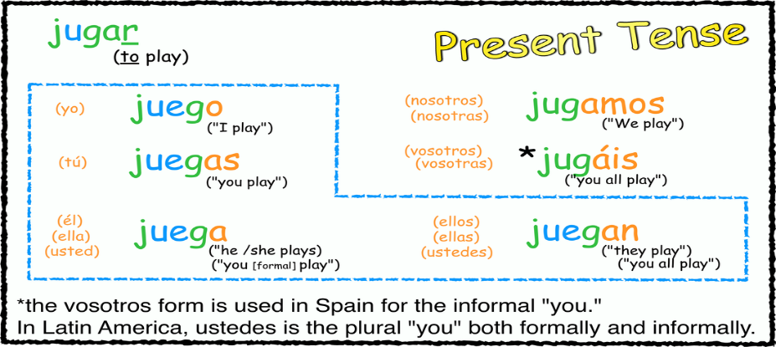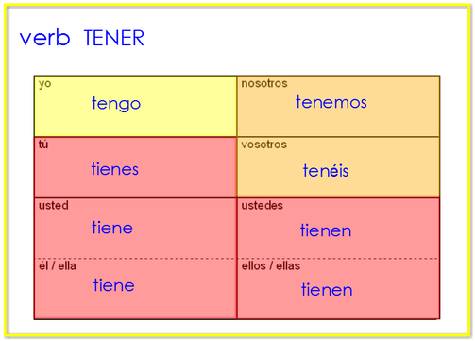

All verbs learned so far:

|  |  |
| --- | --- |
| ***Present Indicative: Regular -AR verbs*** | |
| tocar: to touch or to play an instrument | |
| **yo toco** | **nosotros tocamos** |
| **tú tocas** | **(vosotros tocáis)** |
| **él/ella/Ud. toca** | **ellos/ellas/Uds. tocan** |

|  |  |
| --- | --- |
| ***Present Indicative: Regular -AR verbs*** | |
| DESCANSAR: to rest | |
| **yo descanso** | **nosotros descansamos** |
| **tú descansas** | **(vosotros descansáis)** |
| **él/ella/Ud. descansa** | **ellos/ellas/Uds. descansan** |

|  |  |
| --- | --- |
| ***Present Indicative: Regular -AR verbs*** | |
| Bailar: to dance | |
| **yo bailo** | **nosotros bailamos** |
| **tú bailas** | **(vosotros bailáis)** |
| **él/ella/Ud. baila** | **ellos/ellas/Uds. bailan** |

|  |  |
| --- | --- |
| ***Present Indicative: Regular -AR verbs*** | |
| Caminar: to walk | |
| **yo camino** | **nosotros caminamos** |
| **tú caminas** | **(vosotros camináis)** |
| **él/ella/Ud. camina** | **ellos/ellas/Uds. caminan** |

|  |  |
| --- | --- |
| **Dibujar: To draw** | |
| **yo dibujo** | **nosotros**  **dibujamos** |
| **tú dibujas** | **(vosotros**  **dibujáis)** |
| **él/ella/Ud. dibuja** | **ellos/ellas/Uds.**  **dibujan** |
| ***Present Indicative: Regular -AR verbs*** | |
| **ESCHUCHAR: To listen** | |
| **yo**  **escucho** | **nosotros**  **escuchamos** |
| **tú**  **escuchas** | **(vosotros**  **escucháis)** |
| **él/ella/Ud.**  **escucha** | **ellos/ellas/Uds.**  **escuchan** |
| **ESTUDIAR: TO STUDY** | |
| **yo**  **estudio** | **nosotros**  **estudiamos** |
| **tú estudias** | **(vosotros**  **estudiáis)** |
| **él/ella/Ud.**  **estudia** | **ellos/ellas/Uds.**  **Estudian** |
| **DIBUJAR: TO DRAW** | |
| **yo**  **DIBUJo** | **nosotros**  **DIBUJamos** |
| **tú**  **DIBUJas** | **(vosotros**  **DIBUJáis)** |
| **él/ella/Ud.**  **DIBUJa** | **ellos/ellas/Uds.**  **DIBUJan** |
| ***Present Indicative: Regular -AR verbs*** | |
| **Hablar: to talk** | |
| **yo**  **Hablo** | **nosotros**  **Hablamos** |
| **tú**  **Hablas** | **(vosotros**  **Habláis)** |
| **él/ella/Ud.**  **Habla** | **ellos/ellas/Uds.**  **Hablan** |
| ***Present Indicative: Regular -AR verbs*** | |
| **Lavar: to wash** | |
| **yo lavo** | **nosotros lavamos** |
| **tú lavas** | **(vosotros laváis)** |
| **él/ella/usted lava** | **ellos/ellas/Ustedes lavan** |
| ***Present Indicative: Regular -AR verbs*** | |
| **Mirar: to watch, to look at** | |
| **yo miro** | **nosotros miramos** |
| **tú miras** | **(vosotros miráis)** |
| **él/ella/Ud. mira** | **ellos/ellas/Uds. Miran** |
| ***Present Indicative: Regular -AR verbs*** | |
| **Montar: to ride** | |
| **yo Monto** | **nosotros Montamos** |
| **tú Montas** | **(vosotros Montáis)** |
| **él/ella/Ud. Monta** | **ellos/ellas/Uds. Montan** |
| ***Present Indicative: Regular -AR verbs*** | |
| **Nadar: to swim** | |
| **Yo Nad o** | **nosotros Nadamos** |
| **tú Nadas** | **(vosotros Nadáis)** |
| **él/ella/Ud. Nada** | **ellos/ellas/Uds. Nadan** |
| ***Present Indicative: Regular -AR verbs*** | |
| **Pasar (el rato con amigos): to spend time with friends** | |
| **yo Paso** | **nosotros Pasamos** |
| **tú Pasas** | **(vosotros Pasáis)** |
| **él/ella/Ud. Pasa** | **ellos/ellas/Uds. Pasan** |
| ***Present Indicative: Regular -AR verbs*** | |
| **Pintar: to paint** | |
| **yo Pinto** | **nosotros Pintamos** |
| **tú Pintas** | **(vosotros Pintáis)** |
| **él/ella/Ud. Pinta** | **ellos/ellas/Uds. Pintan** |
| ***Present Indicative: Regular -AR verbs*** | |
| **Practicar: to practice** | |
| **yo practico** | **nosotros practicamos** |
| **tú practicas** | **(vosotros practicáis)** |
| **él/ella/Ud. practica** | **ellos/ellas/Uds. practican** |
| ***Present Indicative: Regular -AR verbs*** | |
| **Preparar: to prepare** | |
| **yo Preparo** | **nosotros Preparamos** |
| **Tú Preparas** | **(vosotrosPreparáis)** |
| **él/ella/Ud. Prepara** | **ellos/ellas/Uds. PreparAn** |
| ***Present Indicative: Regular -AR verbs*** | |
| **Regresar: to return** | |
| **yo Regreso** | **nosotrosRegres amos** |
| **tú Regresas** | **(vosotros Regresáis)** |
| **él/ella/Ud. Regresa** | **ellos/ellas/Uds. Regresan** |
| ***Present Indicative: Regular -AR verbs*** | |
| **Sacar: to take out sacar la basura take out the trash**  **Sacar fotos take pictures**  **Sacar buenas notas earn good grades** | |
| **yo Saco** | **nosotros Sacamos** |
| **tú Sacas** | **(vosotros Sacáis)** |
| **él/ella/Ud. Saca** | **ellos/ellas/Uds. Sacan** |
| ***Present Indicative: Regular -AR verbs*** | |
| **Tomar: to take or to drink** | |
| **yo Tomo** | **nosotros Tomamos** |
| **tú Tomas** | **(vosotros Tomáis)** |
| **él/ella/Ud. Toma** | **ellos/ellas/Uds. Toman** |
| ***Present Indicative: Regular -AR verbs*** | |
| **Trabajar: to work** | |
| **yo Trabajo** | **nosotros Trabajamos** |
| **tú Trabajas** | **(vosotros Trabajáis)** |
| **él/ella/Ud. Trabaja** | **ellos/ellas/Uds. Trabajan** |

**GRAMMAR:**

To talk about doing things with someone else, **con** is used with a pronoun like the following chart:

|  |  |  |  |
| --- | --- | --- | --- |
| **Conmigo** | *With me* | **Con nosotros/as** | *With us* |
| **Contigo** | *With you* | **Con vosotros/as** | *With you (plural)* |
| **Con usted** | *With you* | **Con ustedes** | *With you (plural)* |
| **Con él** | *With him* | **Con ellos** | *With Them* |

Examples:

I talk with you. Yo hablo contigo.

You talk with me. Usted habla conmigo.

USES de SER CNOTE vs

ESTAR LOCATION AND CONDITION

|  |  |
| --- | --- |
| Los usos de **SER**  DESCRIBE THE **ESSENCE**  **(Example: ice=cold)**  (Paco & Pablo Have Never Cooked Insect Oatmeal 4 ME.) | Los usos de **ESTAR**  DESCRIBE A **CHANGE**  in state, condition, or motion  (Example: was happy, now is sad)  (Santa Clause Loves Pizza.) |
| Características  Personalidad/Profesión  Posesión  1. (las entradas) son de él | Sentimientos   1. está muy triste 2. estamos muy emocionados |
| Nacionalidad  Soy estadounidense  Soy costarricense | Condiciones y Salud |
| Origen  Soy de Costa Rica | Lugar   1. está en NY 2. está en NY |
| Time  Es la una  Son las dos | Presente Progresivo   1. está visitando 2. estamos contando |
| Evento   1. es en Los Angeles 2. es a las 7:30 |  |

Conjugation of ESTAR

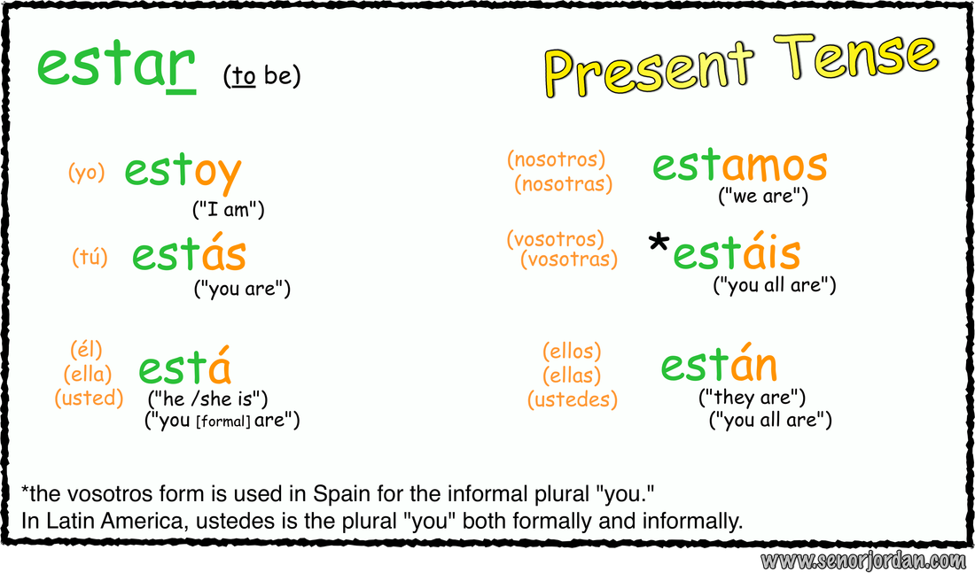

CONJUGATION OF SER:



**LAS FRASES DEL TIEMPO**

**Weather Expressions with “Hace…”**

**Hace buen tiempo** *It’s nice weather*

**Hace mal tiempo** *It’s bad weather*

**Hace fresco** *It’s cool*

**Hace (*mucho)* frío** *It’s (really/ very) cold*

**Hace (*un poco*)calor** *It’s (a little/a bit) hot*

**Hace viento**                                        *It’s windy*

**Hace sol** *It’s sunny*

**Weather Expressions with “Está…”**

**Está nublado***It’s cloudy*

**Está lloviendo***It’s raining  (right now)*

**Está nevando***It’s snowing (right now)*

**Other Expressions**

**Llueve** *It rains/ is raining*

**Nieva** *It snows/ is snowing*

**Spanish Video Project -**

rr_2tseh[1]Estar + PREPOSITIONS Project

a1qkywj3[1]**Due date/fecha 1/16/19**

**Written 1/21/19**

For this assignment you will work in pairs and produce estar + prepositions project. This presentation should be no more than 5 minutes long.

**This project will be worth 25 points. It will be graded on the required elements, creativity/ originality, use of language (grammar and vocabulary), pronunciation, and clarity and total presentation.**

**Please use the vocabulary from the chapter vocabulary and what you already know. You should be able to do this activity without a dictionary.**

**Project: DO NOT READ. Memorize your presentation. No points will be given if you read your presentation.**

**Script:**

* + **Send it via- email to** [**Kattya.Romeromora@WESChools.org**](mailto:Kattya.Romeromora@WESChools.org)**.**
  + **No late or read work will be accepted. Don’t wait till the last minute to do the assignment. If you have problems sending it. You should bring it to me in a flash drive or in a CD at 7:30 a.m. of the due date.**
* **If you don’t have technology available, please let me know so you can use my computer to do your work. Or presented in class.**

**\*\*\*\* Keep your game school appropriate, including anything on the tape after your presentation. Inappropriate material could result in a failing grade and/or a disciplinary action. \*\*\*\***

**Written work 25 pts.** [**http://education.ohio.gov/getattachment/Topics/Ohios-Learning-Standards/Foreign-Language/World-Languages-Model-Curriculum/World-Languages-Model-Curriculum-Framework/Instructional-Strategies/Scoring-Guidelines-for-World-Languages/2-Presentational-Writing-Rubric\_unit\_august\_2015.pdf.aspx**](http://education.ohio.gov/getattachment/Topics/Ohios-Learning-Standards/Foreign-Language/World-Languages-Model-Curriculum/World-Languages-Model-Curriculum-Framework/Instructional-Strategies/Scoring-Guidelines-for-World-Languages/2-Presentational-Writing-Rubric_unit_august_2015.pdf.aspx)

**Oral presentation/video 25 pts.** [**http://education.ohio.gov/getattachment/Topics/Ohios-Learning-Standards/Foreign-Language/World-Languages-Model-Curriculum/World-Languages-Model-Curriculum-Framework/Instructional-Strategies/Scoring-Guidelines-for-World-Languages/1-Presentational-Speaking-Rubric\_unit\_august\_2015.pdf.aspx**](http://education.ohio.gov/getattachment/Topics/Ohios-Learning-Standards/Foreign-Language/World-Languages-Model-Curriculum/World-Languages-Model-Curriculum-Framework/Instructional-Strategies/Scoring-Guidelines-for-World-Languages/1-Presentational-Speaking-Rubric_unit_august_2015.pdf.aspx)

**Do no use these examples. Make up your own!**

**Example of games:**

**Fun games**

[**https://www.youtube.com/watch?v=Vxfj1Db27PA**](https://www.youtube.com/watch?v=Vxfj1Db27PA)

**Plaza Sesamo**

[**https://www.youtube.com/watch?v=JNkZALxekl8**](https://www.youtube.com/watch?v=JNkZALxekl8)

**Lesson teaching prepositions**

**https://www.youtube.com/watch?v=Vmn1-g0wyNo**

**Dance**

**https://www.youtube.com/watch?v=txsazO4UH\_U**

**Song using prepositions and clothes**

[**https://www.youtube.com/watch?v=4uzfwLKevUU**](https://www.youtube.com/watch?v=4uzfwLKevUU)

**Bad video use English**

**https://www.youtube.com/watch?v=Ng3hnlduaOc**

**https://www.youtube.com/watch?v=BZsV5PUIJEA**

Game example:

Videos using this activity:

<https://www.youtube.com/watch?v=wZGoSkQ2bLI>

<https://www.youtube.com/watch?v=eYeqUetm6fY>

<https://www.youtube.com/watch?v=Sj03_PagWp4>

English video but you can do it in Spanish

<https://www.youtube.com/watch?v=oKhz6H4SFX0>

FUNNY

https://www.youtube.com/watch?v=BZsV5PUIJEA

Here are some words that might help you do your project:

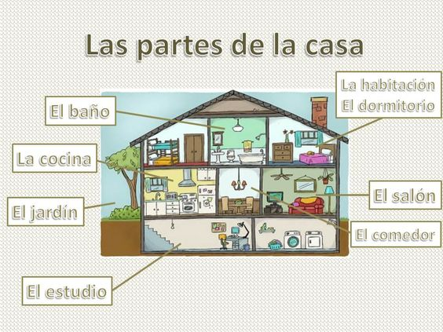

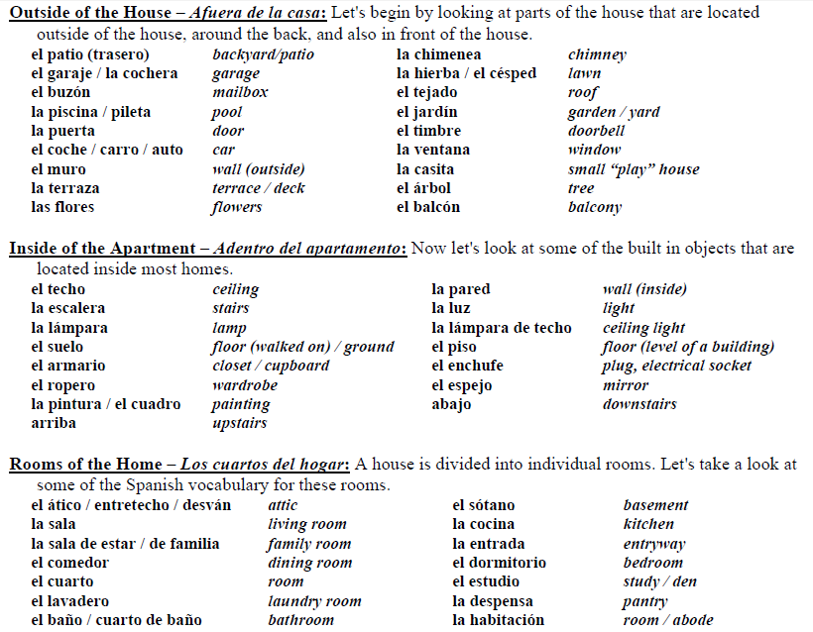

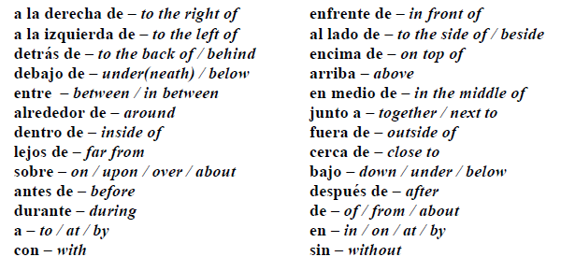

<https://www.thoughtco.com/body-parts-vocabulary-3079570>

# What Are the Names for Body Parts in Spanish?

* Share
* Flipboard
* Email

Top of Form

PRINT

Bottom of Form

pauseplaypoy / Getty Images

**by**[**Gerald Erichsen**](https://www.thoughtco.com/gerald-erichsen-3078058)

**Updated January 06, 2019**

Learning the Spanish names for body parts is a quick way to learn some Spanish that is likely to be useful right away. Whether you're in a [clothing](https://www.thoughtco.com/articles-of-clothing-3079951) [store](https://www.thoughtco.com/names-of-stores-and-shops-3079600) or a doctor's clinic, you'll find these words handy.

### The Body Parts in Spanish

Most of these words are used for the body parts of animals as well as people. However, there are a few exceptions. For instance, el hocico and el pescuezo are terms often used to refer to the nose (snout) and neck (scruff) of animals.

Here are the Spanish words for common body parts:

* Arm — el brazo
* Back — la espalda
* Backbone — la columna vertebral
* Brain — el cerebro, el seso
* Breast, chest — el pecho
* Buttocks — las nalgas
* Calf — la pantorrilla
* Ear — el oído, la oreja
* Elbow — el codo
* Eye — el ojo
* Finger — el dedo
* Foot — el pie
* Hair — el pelo
* Hand — la mano (Mano is one of the very few and the most common of the Spanish nouns that are [exceptions to the main gender rule](https://www.thoughtco.com/words-that-break-the-gender-rule-3078133) of Spanish by being feminine even though ending in o.)
* Head — la cabeza
* Heart — el corazón
* Hip — la cadera
* Intestine — el intestino
* Knee — la rodilla
* Leg — la pierna
* Liver — el hígado
* Mouth — la boca
* Muscle — el músculo
* Neck — el cuello
* Nose — la nariz
* Shoulder — el hombro
* Skin — la piel
* Stomach (abdomen) — el vientre
* Stomach (internal organ) — el estómago
* Thigh — el muslo
* Throat — la garganta
* Toe — el dedo (Note that dedo can refer to fingers or toes; it comes from the same [Latin](https://www.thoughtco.com/is-latin-easy-119456) word from which we get "digit," which can also refer to fingers or toes. If you need to be more specific than dedo, you can use dedo de la manofor a finger and dedo del pie for a toe.)
* Tongue — la lengua
* Tooth — el diente, la muela

### The Grammar of Body Parts

The names of body parts are used much the same as they are in Spanish as in English, but with one significant difference. In Spanish, names of parts of the body are frequently preceded by the [definite article](https://www.thoughtco.com/how-to-use-definite-articles-3079100) (el, la, los or las, meaning "the") instead of [possessive adjectives](https://www.thoughtco.com/possessive-adjectives-short-form-3079109) (such as mi for "my" and tu for "your"). In most cases, the possessive [adjective](https://www.thoughtco.com/what-is-adjective-clause-1689064) is used only where the [context](https://www.thoughtco.com/how-to-decide-which-word-3079681) doesn't make clear whose body is being referred to.

For example:

* ¡Abre ***los*** ojos! (Open **your** eyes!)
* ¡Cierre ***la*** boca! (Shut **your** mouth!)
* Él bajó ***la*** cabeza para orar. (He bowed **his** head to pray.)

The possessive adjective is used when needed to avoid ambiguity.

* Me gustan ***tus*** ojos. (I like **your** eyes.)
* Acerqué ***mi*** mano a ***su*** cabeza. (I moved **my** hand close to **his** head.)

Although English often omits the definite article when referring to body parts, they are usually retained in Spanish when a possessive adjective is not used.

* Tengo ***el*** pelo negro. (I have black hair.)
* Prefiero ***los*** ojos verdes. (I prefer green eyes.)

### English Words Related to Spanish Names of Body Parts

Several of the Spanish words in the list above come from the same Latin [root](https://www.thoughtco.com/root-words-definition-1692068) as English words that aren't used directly for body parts. You can use some of these connections to help you remember the words:

* "To embrace," embrazar in Spanish, means literally to enclose someone or something with arms (brazos).
* Something cerebral (related to cerebro) requires use of your brain.
* You use the auditory (related to oído) capability of your ear to hear.
* "Ocular" things are related to the eye (ojo).
* Our word "gargantuan" comes from a fictional character who used his throat (garganta) by eating a lot.
* To do something by hand (mano) is to do it manually.
* Something that goes under your tongue (lengua) is sublingual. Also, both lengua and "tongue" can refer to a language.

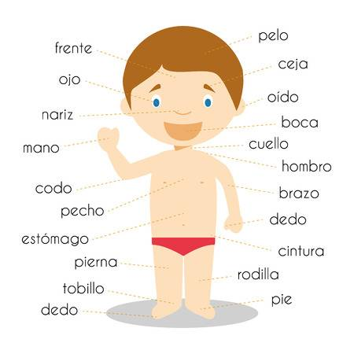

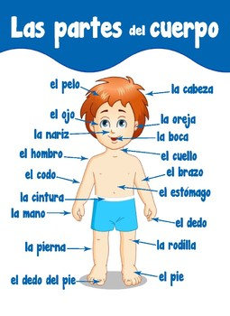

http://www.espanol-ingles.com.mx/phrase\_book/spanish/house.html

## Rooms in the house

Here are the names of common rooms of a house in Spanish. A slightly tricky case is that the Spanish word for bedroom differs depending on the Spanish-speaking region.

|  |  |  |
| --- | --- | --- |
| **está en...** | - | it's/he's/she's in... |
| **están en...** | - | they're in... |
| **el (cuarto de) baño** | - | the bathroom |
| **la cocina** | - | the kitchen |
| **el comedor** | - | the dining room |
| **mi cuarto** | - | my (bed)room |
| **el cuarta de lavado** | - | the washroom |
| **el cuarto de servicio** | - | the washroom, utility room |
| **el cuarto de visitas** | - | the guest room |
| **el/mi/nuestro dormitorio** | - | the/my/our bedroom |
| **la/mi/nuestra recámara** | - | the/my/our bedroom *(Mexico)* |
| **el desayunador** | - | the breakfast bar, breakfast area |
| **la entrada** | - | the hallway, entrance |
| **el estudio** | - | the study |
| **el garaje, la cochera** | - | the garage |
| **el lavadero** | - | the washroom, laundry room *(Spain)* |
| **el pasillo** | - | the passageway |
| **el portal** | - | the porch |
| **el recibidor** | - | the hallway |
| **el salón** | - | the living room |
| **el trastero** | - | the boxroom, junk room |

Feedback [Suggest a change / cambios sugeridos](http://www.espanol-ingles.com.mx/feedback.asp?id=3490c36b449d82764395c03307f8ac1e)

## Floors and sections of the house

A few parts of the house that aren't quite "rooms":

|  |  |  |
| --- | --- | --- |
| **en la escalera** | - | on the stairs |
| **en el descanso** | - | on the landing |
| **en el jardín** | - | in the garden |
| **en el patio** | - | on the patio |
| **(en) la piscina** | - | (in) the swimming pool |
| **(en) la alberca** | - | (in) the swimming pool *(Mexico)* |
| **en la azotea/terraza** | - | on the roof, in the roof garden |

Feedback [Suggest a change / cambios sugeridos](http://www.espanol-ingles.com.mx/feedback.asp?id=3490c36b449d82764395c03307f8ac1e" \t "feedback)

Here is how to say what floor of the house or building things are on:

|  |  |  |
| --- | --- | --- |
| **en el sótano** | - | in the basement/cellar1 |
| **en el desván** | - | in the attic/loft |
| **en el entretecho** | - | in the attic/loft *(Latin America)* |
| **en la planta baja** | - | downstairs, on the ground floor (US: first floor) |
| **en el primer piso** | - | on the first floor (US: second floor) |
| **en el segundo piso** | - | on the second floor (US: third floor) |
| **en el tercer piso** | - | on the third floor (US: fourth floor) |
| **en el cuarto/quinto/sexto piso** | - | on the fourth/fifth/sixth floor (US: fifth/sixth/seventh) |
| **en el piso catorce1** | - | on the fourteenth floor (US: fifteenth) |
| **en el mezanine** | - | on the mezzanine |
| **(en la planta de) abajo** | - | downstairs |
| **(en la planta de) arriba** | - | upstairs |
| **bajar** | - | to go downstairs |
| **subir** | - | to go upstairs |

Feedback [Suggest a change / cambios sugeridos](http://www.espanol-ingles.com.mx/feedback.asp?id=3490c36b449d82764395c03307f8ac1e)

1. If you keep wine in your cellar, you can also call it a **bodega** or **cava**!  
2. The special words for ordinal numbers (**primer(o)**, **segundo** etc) aren't commonly used for high numbers. It's worth learning up to about **sexto** or **séptimo** (seventh).

## Talking about the building

The following Spanish words are useful for describing the actual building or home as a whole, or for things like doors and windows that aren't exactly "furniture".

|  |  |  |
| --- | --- | --- |
| **(en) el piso** | - | (on) the floor |
| **(en) el techo** | - | (on) the ceiling; *(Latin America)* the roof |
| **el tejado** | - | the roof *(Spain)* |
| **las paredes** | - | the (inside) walls |
| **los muros** | - | the (outside) walls |
| **en la pared** | - | on the wall |
| **la ventana** | - | the window |
| **el ventanal** | - | the (full-length) window |
| **la puerta** | - | the door |
| **el tragaluz** | - | the skylight |
| **el domo** | - | the skylight *(Mexico)* |
| **las tuberías** | - | the pipes, the pipework |
| **el desagüe** | - | the drainpipe |

Feedback [Suggest a change / cambios sugeridos](http://www.espanol-ingles.com.mx/feedback.asp?id=3490c36b449d82764395c03307f8ac1e" \t "feedback)

## Next: furniture

Example of the written part due on 1/16/19 DUE 7:30 a.m.

1/21/19 due at 7:30 a.m.

Written project:

¡Hola!  ¡Yo estoy muy bien!

¿Dónde estoy yo?

Hoy estoy en mi casa. Yo voy afuera. Yo estoy enfrente de mi casa. Yo voy alrededor de mi carro. Ahora (now) estoy entre mi casa y mi carro. Ahora voy al lado del jardín.  Ahora estoy cerca de las flores.  Yo toco las flores con las manos

¿Dónde está él?

Él está en mi casa. Él está debajo de la mesa. Él está ahora cerca de mí. Él está  a la derecha del baño y lejos de mi garaje. Él ve su casa con los ojos.

¿Dónde están ellos?

Ellos están en mi garaje.  Ellos están a la izquierda de la puerta.  Ellos están al lado de mi bicicleta. Ellos están atrás de mi carro y enfrente de mí. Ellos caminan con sus piernas.