Spanish II
Chapter 3.1

Useful Websites
http://study.com/academy/lesson/spanish-vocabulary-basic-terms-for-chores-errands.html

3 QUIZLETS = 5 points Due at 7:30 am. On test date.
Daily Routine
https://quizlet.com/50229716/talk-about-your-daily-routine-flash-cards/
https://quizlet.com/93411139/theme-1-talk-about-your-daily-routine-flash-cards/
https://quizlet.com/83793290/vocabulary-1-talking-about-your-daily-routine-flash-cards/ with pictures

3 QUIZLETS = 5 points Due at 7:30 am. On test date.
Chores
https://quizlet.com/54333410/household-chores-flash-cards/ with pictures
https://quizlet.com/44939488/spanish-daily-routine-and-household-chores-flash-cards/ with pictures
https://quizlet.com/102725027/los-quehaceres-domesticos-household-chores-flash-cards/ with pictures

How to make reflexives in the present and preterite
https://www.youtube.com/watch?v=l2ZTZZIiZog
https://www.youtube.com/watch?v=Y0KjPFDkN4A

Daily routines
Unit Essential Questions  - How can you talk about daily routines? | Lesson Essential Questions  How can I describe my daily routine?  - What are your chores?  - How are daily routines in Spanish speaking countries different than in the United States?
Students will know:  - reflexive actions  - household chores  Vocabulary  - Reflexive Verbs | Students will be able to:  - describe some one's daily routine  - compare daily routines in the United States with those in Spanish speaking countries  - identify body parts that relate to daily hygiene

Hoy es de noviembre del dos mil….
¿Cuánto estudias? Yo estudio..... minutos

LEARNING TARGET Spanish I

- House chores
- Daily Routine
- Body Parts
- Reflexive verbs present and preterite

CORNELL NOTES  SHEET | Name: KattyaRomero  Class: Spanish I and II  Topic: Spanish  Date: Hoy es del dos mil quince  Period primero, tercero
PREGUNTAS | APUNTES
What are we studying? | - House chores  - Daily Routine  - Body Parts  - Reflexive verbs present and preterite
What is our focus? | Present and Preterite
What are we reviewing? | We are reviewing reflexive actions and householdchores. Present and preterite
What’s an irregular verb?  What’s a regular verb?  What the endings for ALL verbs in Spanish? | Irregular verbs have a change in the root  Regular verb keeps the same root of the verb  All verbs in Spanish end in –ar, -er and –ir.
What is the vocabulary we are reviewing? | Daily routine, chores and some body parts.
SUMMARY: Write 4 or more sentences describing specific learning from these notes.
I am going to be able to write daily routines, chores and body parts in the present and the preterit.

Chapter 3 Vocabulary

ENGLISH |  |  |  | SPANISH
1. sometimes |  |  |  | 1. a veces
2. to go to bed, lie down |  |  |  | 2. acostarse
3. to take a bath |  |  |  | 3. bañarse
4. to brush one's hair |  |  |  | 4. cepillarse
5. toothbrush |  |  |  | 5. el cepillo de dientes
6. shampoo |  |  |  | 6. champú
7. alarm clock |  |  |  | 7. despertador
8. to wake up |  |  |  | 8. despertarse
9. mirror |  |  |  | 9. espejo
10. to spend, to waste |  |  |  | 10. gastar
11. soap |  |  |  | 11. jabón
12. to get up |  |  |  | 12. levantarse
13. to look at oneself |  |  |  | 13. mirarse
14. normally |  |  |  | 14. normalmente
15. never |  |  |  | 15. nunca
16. toothpaste |  |  |  | 16. pasta de dientes
17. comb (noun) |  |  |  | 17. peine
18. to comb (oneself) |  |  |  | 18. peinarse
19. to put on clothing |  |  |  | 19. ponerse la ropa
20. generally |  |  |  | 20. por lo general
21. quickly |  |  |  | 21. rápidamente
22. typical |  |  |  | 22. típico
23. typically |  |  |  | 23. típicamente
24. towel |  |  |  | 24. toalla
25. every day |  |  |  | 25. todos los días
26. to get dressed |  |  |  | 26. vestirse
27. Whose turn is it? |  |  |  | 27. ¿a quién le toca?
28. to sweep |  |  |  | 28. barrer
29. dining room |  |  |  | 29. comedor
30. bathroom |  |  |  | 30. cuarto de baño
31. garden |  |  |  | 31. jardín
32. to clean |  |  |  | 32. limpiar
33. to tidy up |  |  |  | 33. ordenar
34. floor |  |  |  | 34. piso
35. chores |  |  |  | 35. quehaceres
36. to clear the table |  |  |  | 36. quitar la mesa
37. to water |  |  |  | 37. regar
38. to dust |  |  |  | 38. sacudir el polvo
39. to make the bed |  |  |  | 39. tender la cama
2000-2015 CONJUGUEMOS (Yegros Educational LLC)

Listening

Educational Video GREAT https://www.pinterest.com/pin/26810560256729700/

¿A qué hora se levanta?
¿Qué hace en la ducha?
¿Cuánto dura arreglándose el pelo?
¿Qué hace a su pelo?
¿Cuántos pelos tiene en la cara y que hace con esos pelo?
¿Saben dónde está a las 8:30?
¿Qué le pasa al papá?
¿Qué no tiene el papá?
Nico
https://www.youtube.com/watch?v=NSblebrx6ng
Agustin
https://www.youtube.com/watch?v=7SZbWj-glSI
Dos chicas en su rutina diaria
https://www.youtube.com/watch?v=rSYux9p8ZDI
Me gusta mucho chiquita habla de su rutina diaria los domingos.
https://www.youtube.com/watch?v=J5szxHBRlQc

Listening activity https://www.laits.utexas.edu/spe/vid/beg15ex.html

¿Cuáles son sus actividades diarias?

Liste 5 actividades por lo menos.
1.
2.
3.
4.
5.

Simplified Example: Spanish
Mis actividades diarias siempre incluyen más o menos las mismas cosas. Me despierto a eso de las seis y media de la mañana. Desayuno y voy a la universidad. Después regreso a casa y estudio toda la tarde. Ceno alrededor de las 8:00 de la noche. Veo los noticieros y me duermo.

Excellent sliders on Daily Routine

http://www.slideshare.net/mariannewal/mi-rutina-diaria-by-katie-c?next_slideshow=1

http://study.com/academy/lesson/spanish-reflexive-verbs-uses-conjugation.html
http://www.freeconjugation.com/reflexive-verbs/

Adverbs – Formation and Placement
http://grammar.spanishintexas.org/adverbs/formation-and-placement/
In Spanish as in English, an adverb describes the action of a verb. It answers such questions as where? when?, how?, how long?, or how often? Adverbs are invariable and may be used with almost all verbs. An adverb may also qualify an adjective or another adverb. Consider the sentence below which contains two adverbs.
Ellos hablan el español muy bien.They speak Spanish very well.
Muy qualifies bien and bien describes the action of the verb hablar.

Formation of Regular Adverbs
A large number of Spanish adverbs are derived from adjectives.
They are usually formed by adding -mente to the feminine singular form of the adjective as seen in the following sentence which has the adverb últimamente, derived from the feminine form of the adjective último plus -mente
Una de las cosas que ha hecho últimamente es estar en Facebook como los jóvenes hoy en día.One of the things that he’s done lately is being on Facebook like young people today.

Placement

Adverbs that Modify an Adjective or Another Adverb
Adverbs are placed directly before the adjective or adverb that they modify.
Todos son bien diferentes.They all are very different.

Adverbs that Modify a Whole Sentence
If an adverb is a comment on the entire sentence (desafortunadamente, seguramente), it may be placed at the beginning or end of the sentence. Adverbs of this type include adverbs of time and place.
Ahora es casi un dialecto de San Antonio.Now it is almost a dialect of San Antonio.

What Are Reflexive Verbs
Have you ever stopped to think about your daily routine? You actually do a lot of things from the moment you wake up to the moment you go to bed at night. In Spanish, we express a lot of these actions with reflexive verbs. In English, reflexive verbs are roughly the equivalent of 'self' and 'selves.' For example, he dresses himself, we wake ourselves up, etc.
Let's first have a look at some of the reflexive verbs in Spanish. You'll see that each of the infinitive forms has a 'se' at the end, letting us know that it is a reflexive verb.
despertarse - to wake up
levantarse - to get up
lavarse - to wash (some part of your body)
cepillarse - to brush
peinarse - to comb
bañarse - to take a bath
ducharse - to take shower
maquillarse - to put on makeup
afeitarse - to shave
arreglarse - to get ready
vestirse - to get dressed
ponerse - to put on
quitarse - to take off
acostarse - to go to bed
Here are a few more reflexive verbs that aren't related to your daily routine.
llamarse - to be called
enojarse - to get angry
enfermarse - to get sick
casarse - to get married
Of course, there are many more reflexive verbs, but these are the most common and will be the focus for this lesson.

How to Conjugate Reflexive Verbs
So now we can recognize a reflexive verb, but how do we conjugate it? Easy! Just think of it as a regular -ar, -er, -ir verb with an additional component. Let's first group them into -ar, -er, and -ir verbs.
-AR | -ER | -IR
lavarse | ponerse* | vestirse*
bañarse
afeitarse
ducharse
maquillarse
levantarse
peinarse
quitarse
cepillarse
llamarse
acostarse*
despertarse*
You'll notice that we have more -ar verbs than any other, so we'll start with those.
Let's look at llamarse since you will probably already recognize its conjugations. Reflexive verbs have two parts that need to be conjugated, the infinitive (llamar) and the reflexive pronoun 'se.' In this form, llamarse means 'to call oneself.'

These pronouns come before the conjugated base form.
yo me llamo | nosotros nos llamamos
tú te llamas | vosotros os llamáis
él, ella, Ud. se llama | ellos, ellas, Uds. se llaman

p to the moment you go to bed at night. In Spanish, we express a lot of these actions with reflexive verbs. In English, reflexive verbs are roughly the equivalent of 'self' and 'selves.' For example, he dresses himself, we wake ourselves up, etc.
Let's first have a look at some of the reflexive verbs in Spanish. You'll see that each of the infinitive forms has a 'se' at the end, letting us know that it is a reflexive verb.
despertarse - to wake up
levantarse - to get up
lavarse - to wash (some part of your body)
cepillarse - to brush
peinarse - to comb
bañarse - to take a bath
ducharse - to take shower
maquillarse - to put on makeup
afeitarse - to shave
arreglarse - to get ready
vestirse - to get dressed
ponerse - to put on
quitarse - to take off
acostarse - to go to bed
Here are a few more reflexive verbs that aren't related to your daily routine.
llamarse - to be called
enojarse - to get angry
enfermarse - to get sick
casarse - to get married
Of course, there are many more reflexive verbs, but these are the most common and will be the focus for this lesson.

How to Conjugate Reflexive Verbs
So now we can recognize a reflexive verb, but how do we conjugate it? Easy! Just think of it as a regular -ar, -er, -ir verb with an additional component. Let's first group them into -ar, -er, and -ir verbs.
-AR | -ER | -IR
lavarse | ponerse* | vestirse*
bañarse
afeitarse
ducharse
maquillarse
levantarse
peinarse
quitarse
cepillarse
arreglarse
llamarse
casarse
enojarse
enfermarse
acostarse*
despertarse*
You'll notice that we have more -ar verbs than any other, so we'll start with those.

Let's look at llamarse since you will probably already recognize its conjugations. Reflexive verbs have two parts that need to be conjugated, the infinitive (llamar) and the reflexive pronoun 'se.' In this form, llamarse means 'to call oneself.'
We conjugate llamar as we would any other -ar verb.
yo llamo | nosotros llamamos
tú llamas | vosotros llamáis
él, ella, Ud. llama | ellos, ellas, Uds. llaman
We would be finished if we were conjugating the verb llamar - to call. But we are conjugatingllamarSE - to call oneself. We also need to include the reflexive pronouns. These are:
me | nos
te | os
se | se
These pronouns come before the conjugated base form.
yo me llamo | nosotros nos llamamos
tú te llamas | vosotros os llamáis
él, ella, Ud. se llama | ellos, ellas, Uds. se llaman
So when you are introducing yourself, you are literally saying, 'I call myself?' then, you call yourself, he calls himself, we call ourselves, they call themselves, etc.
Let's look at another - maquillarse. Again, we have the infinitive maquillar and the reflexive pronoun 'se.'
yo me maquillo | nosotros nos maquillamos
tú te maquillas | vosotros os maquilláis
él, ella, Ud. se maquilla | ellos, ellas, Uds. se maquillan
Bien! You would follow this same pattern for all of the other regular -ar verbs.
Did you happen to notice the asterisk next to despertarse and acostarse? That's because these are stem-changing reflexive verbs. Remember the stem change only applies to the verbs inside the boot.
Desp(e)rtarse has a an 'e' to 'ie' stem change. The rest of the conjugations are made as usual.
yo me desp(ie)rto | nosotros nos despertamos
tú te desp(ie)rtas | vosotros os despertáis
él, ella, Ud. se desp(ie)rta | ellos, ellas, Uds. se desp(ie)rtan

Ac(o)starse has an 'o' to 'ue' stem change.
yo me ac(ue)sto | nosotros nos acostamos
tú te ac(ue)stas | vosotros os acostáis
él, ella, Ud. se ac(ue)sta | ellos, ellas, Uds. se ac(ue)stan

Moving on to the -er verb ponerse. Remember, poner has an irregular 'yo' form, and ponerse is conjugated:
yo me pongo | nosotros nos ponemos
tú te pones | vosotros os ponéis
él, ella, Ud. se pone | ellos, ellas, Uds. se ponen

Finally, our -ir verb, v(e)stirse, is another stem changer, this time 'e' to 'i.'

Vestirse to get dressed

Present
Yo | me visto | Nosotros | nos vestimos
tú | te vistes | Vosotros/as (Ustedes) | os vestís
El/Ella | se viste | Ellos/as | se visten
lavarse - to wash yourself
Present tense
yo ME lavo | nosotros NOS lavamos
tú TE lavas | vosotros OS laváis
él SE lava | ellos SE lavan
ella SE lav | ellas SE lavan
ud. SE lava | uds. SE lavan

Acostarse to lay down
yo me acuesto | nosotros NOS acostamos
tú TE acuestas | vosotros OS acostáis
él  ella SE acuesta  usted | ellos  ellas SE acuestan  ustedes

Afeitarse to shave

Present
Yo | me afeito | Nosotros | nos afeitamos
tú | te afeitas | Vosotros/as (Ustedes) | os afeitáis
Ella | se afeita | Ellos/as | se afeitan

Secarse to dry

Present
Yo | me seco | Nosotros | nos secamos
tú | te secas | Vosotros/as (Ustedes) | os secáis
l/Ella | se seca | Ellos/as | se secan

Quitarse to take off

Present
Yo | me quito | Nosotros | nos quitamos
tú | te quitas | Vosotros/as (Ustedes) | os quitáis
Ella | se quita | Ellos/as | se quitan

Maquillarse Indicative

Present
Yo | me maquillo | Nosotros | nos maquillamos
tú | te maquillas | Vosotros/as (Ustedes) | os maquilláis
Ella | se maquilla | Ellos/as | se maquillan

Dormirse Indicative

Present
Yo | me duermo | Nosotros | nos dormimos
tú | te duermes | Vosotros/as (Ustedes) | os dormís
Ella | se duerme | Ellos/as | se duermen

Peinarse Indicative

Present
Yo | me peino | Nosotros | nos peinamos
tú | te peinas | Vosotros/as (Ustedes) | os peináis
Ella | se peina | Ellos/as | se peinan

Cepillarse Indicative

Present
Yo | me cepillo | Nosotros | nos cepillamos
tú | te cepillas | Vosotros/as (Ustedes) | os cepilláis
Ella | se cepilla | Ellos/as | se cepillan

Bañarse Indicative

Present
Yo | me baño | Nosotros | nos bañamos
tú | te bañas | Vosotros/as (Ustedes) | os bañáis
Ella | se baña | Ellos/as | se bañan

Ducharse Indicative

Present
Yo | me ducho | Nosotros | nos duchamos
tú | te duchas | Vosotros/as (Ustedes) | os ducháis
Ella | se ducha | Ellos/as | se duchan

Preterite Reflexive Verbs — Spanish Verb Conjugation
In this lesson, we’ll learn how to conjugate reflexive spine verbs. Remember, if you’re taking a class, your teacher will call “spine” verbs “preterite” verbs. In speaking Spanish, reflexive Spine verbs are conjugated just like normal spine verbs and as usual, when there’s just one verb, the reflexive pronoun (me, te, se, or nos) goes in front.

Let’s take a look at a few examples:
I bathed yesterday | Me bañé ayer
She got tired last night | Se cansó anoche
They brushed their hair | Se cepillaron el pelo
We dried our hands | Nos secamos las manos
They shaved earlier | Se afeitaron más temprano
She worried about him | Se preocupó por él

Before we have an official practice, there are a few irregulars in the reflexive spine group that you need to know about. They have stem changes. Let’s take a look at them here. As with other irregulars, the best way to remember them is to hear them enough that you tune your ear to the right way of saying them. As with other irregular spine verbs, they are just irregular on the bottom row of conjugations.
Are you ready? We’ll start with the verb despedirse (to say goodbye)
(Yo) | me despedí | (Nosotros) | nos despedimos
(Tú) | te despediste | (Vosotros-Spain) | os despedisteis
(El, Ella, Ud.) | se despidió | (Ellos, Ellas, Uds) | se despidieron

The second reflexive verb is sentirse (to feel well or ill)
(Yo) | me sentí | (Nosotros) | nos sentimos
(Tú) | te sentiste | (Vosotros) | os sentisteis
(El, Ella, Ud.) | se sintió | (Ellos, Ellas, Uds) | se sintieron

The third reflexive verb of this type is divertirse (to have fun)
(Yo) | me divertí | (Nosotros) | nos divertimos
(Tú) | te divertiste | (Vosotros) | os divertisteis
(El, Ella, Ud.) | se divirtió | (Ellos, Ellas, Uds) | se divertieron

The fourth irregular reflexive verb of this type is caerse (to fall down)
(Yo) | me caí | (Nosotros) | nos caímos
(Tú) | te caíste | (Vosotros) | os caísteis
(El, Ella, Ud.) | se cayó | (Ellos, Ellas, Uds) | se cayeron

The fifth irregular reflexive verb is vestirse (to get dressed)
(Yo) | me vestí | (Nosotros) | nos vestimos
(Tú) | te vestiste | (Vosotros) | os vestisteis
(El, Ella, Ud.) | se vistió | (Ellos, Ellas, Uds) | se vistieron

There is actually one more irregular reflexive verb. It is the verb “darse cuenta” or “to realize”. You already learned earlier how to conjugate “dar” in the spine, or preterite tense earlier, but we’ll take another quick look at it to help refresh your memory.
(Yo) | me dí cuenta | (Nosotros) | nos dimos cuenta
(Tú) | te diste cuenta | (Vosotros) | os disteis cuenta
(El, Ella, Ud.) | se dio cuenta | (Ellos, Ellas, Uds) | se dieron cuenta

Me llamo _____________________ Hoy es el ____ de ________________
Label the following pictures with the correct reflexive.

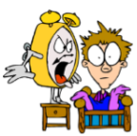 |  | 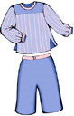a.m. | 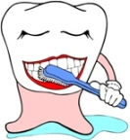 | p.m.
 |  | 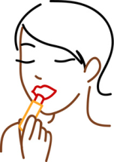 | 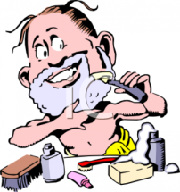 | 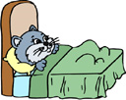

What does it mean for a verb to be reflexive? __________________________________________________________________
What is a non-reflexive verb? __________________________________________________________________
In Spanish, how do we know if a verb is reflexive? In other words, what is our clue? ____________________________________________
True or False: All reflexive verbs can be non-reflexive as well.
Example- Reflexive:___________________
Non reflexive:_________________________________

Now, label the following images with the correct verb. Be careful: some images may be reflexive or non-reflexive.
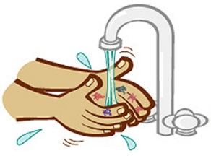 | 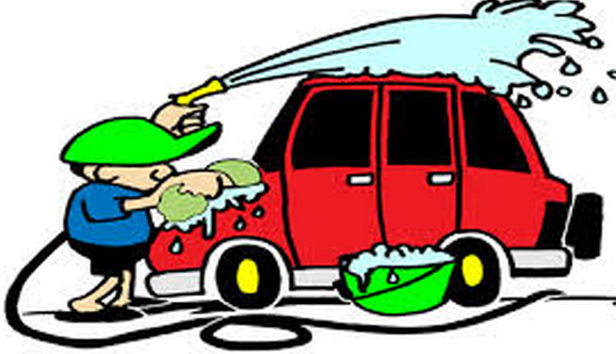 | 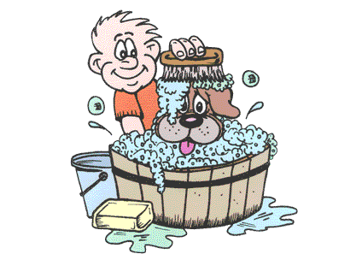 | 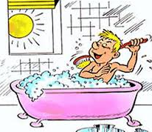 | 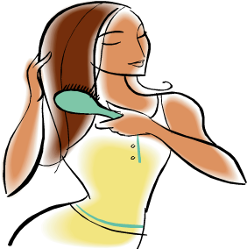
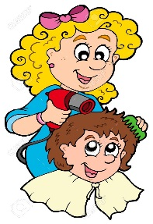 | 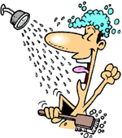 | 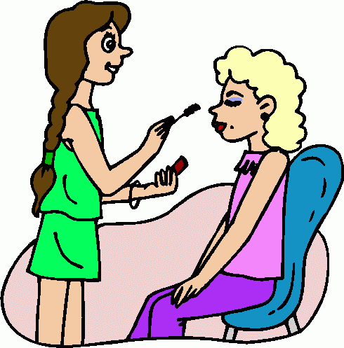 | 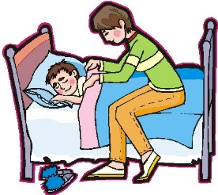

Spanish class resources:
For typing Spanish accents:
http://www.studyspanish.com/accents/typing.htm
Your personal Spanish tutor:
http://www.studyspanish.com
Grammar Review
http://www.languageguide.org/spanish-la/grammar/introduction/
Technology Resources for Video Projects:
Using iMovie to edit a video (start to finish tutorial):
http://computers.tutsplus.com/tutorials/how-to-create-a-movie-from-start-to-finish-with-imovie--mac-59638
How to add voiceover to your IMovie project:
http://www.dummies.com/how-to/content/how-to-record-a-voiceover-in-imovie.html
How to add titles to your IMovie project:
http://www.dummies.com/how-to/content/how-to-add-titles-to-your-movies-in-imovie.html
How to add music/sound effects to your IMovie project:
http://www.dummies.com/how-to/content/how-to-add-music-or-sound-effects-to-your-imovie.html
How to save your IMovie project (in progress):
http://blogs.skokielibrary.info/medialab/software/how-to-save-your-imovie-project/
How to export your finalized movie project:
https://support.apple.com/kb/PH2285?locale=en_US

Written Project

DUE DATES:
Written 12/7/28/18 First part/second part 12/14th/18
Video/presentation 1/11/19

http://spanish.typeit.org/
s
Write a description of your daily routine. Start the description at the time you wake up and end it then you go to bed.
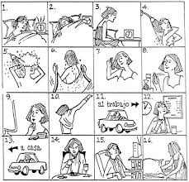

Writing

- Write or type your final copy. Please use google docs. You must use technology. If you don’t have access to a computer please let me know so I can arrange for you to have a computer available to you.

- Only as a last resort you should write the last copy. If so please double space it so I can write in my corrections. Use black or blue pen if you are hand-writing the composition.

- Do not use a translator to write your composition. I will know if you do . You will earn a ZERO if you use a tranlastor.

- You must use the following in your composition

- 10 verbs from 3.1 vocabulary list Underline the verbs for both
- 10 verbs from 3.2 vocabulary list. Underline the verbs
- Write in Italics your transitional words
- Hightlight the words describing the items you use: soap, tooth brush, towel, etc.
- Use at least 4 adverbs telling when or how you do an activity: always, never, normally, etc.mark them in red.

- Transitional Words

Para empezar to begin with
Para comenzar to begin with
Primero First
Segundo Second
Tercero Third
A Continuación Following
Después Afterwards
Luego Later
Por último At last
Finalmente Finally

- Grading

Written work 25 pts. http://education.ohio.gov/getattachment/Topics/Ohios-Learning-Standards/Foreign-Language/World-Languages-Model-Curriculum/World-Languages-Model-Curriculum-Framework/Instructional-Strategies/Scoring-Guidelines-for-World-Languages/2-Presentational-Writing-Rubric_unit_august_2015.pdf.aspx

Oral presentation/video 25 pts. http://education.ohio.gov/getattachment/Topics/Ohios-Learning-Standards/Foreign-Language/World-Languages-Model-Curriculum/World-Languages-Model-Curriculum-Framework/Instructional-Strategies/Scoring-Guidelines-for-World-Languages/1-Presentational-Speaking-Rubric_unit_august_2015.pdf.aspx

Name: _____________________________________ Date:________________

EJEMPLO: Mi rutina diaria del verano pasado
Primero, me desperté a las ocho de media. A continuación, hice muchos quehaceres y muchos pasatiempos. Entonces, me acosté a las nueve de media. Finalmente, a mí me fascinó mi rutina diaria.
Primero, me desperté a las ocho de media. Después, me duché con jabón y con el champú. Luego me duché y me sequé. A continuación, me vestí. Mi madre a veces preparó desayuno. Después, me cepillé los dientes con el cepillo de dientes y con la pasta de dientes. Normalmente me miré en el espejo.
A continuación, hice muchos quehaceres. Para empezar yo hice la cama. Entonces, yo barrí el piso en la sala. Después, yo a veces cuidé su hermano. A continuación yo jugué el béisbol con mis amigos en el parque. Luego, yo regresé a mi casa siempre para lavé los platos en la cocina.
Entonces, me acosté a las nueve de media. Antes de yo me acosté, yo me afeité. Después, me peiné. A continuación, me quité mis calcetines. Entonces, yo gasté tiempo por leí el libro. Por fin, me acosté.
Finalmente, a mí me fascinó mi rutina diaria. A mí me fascinó mi rutina diaria porque, mi rutina diaria fue interesante y fácil.
¡¡Proyecto Video!! DO NOT READ IT! MEMORIZE IT PLEASE!

¿Cuál es tu rutina diaria? Your task:

Make a 1 minute and half video describing your daily routine using REFLEXIVE VERBS AND CHORES vocabulary You can also do a class presentation if you don’t have access to technology to do this project.

Additional vocabulary (such as los artículos personales) to make your sentences rich with vocabulary. You will be graded on the following:
- REFLEXIVE verbs usage 4.CHORES
- CREATIVITY 5. Pronunciation
- Volume 6. Eye contact

I will be showing videos done by students from North during class to show every day so you know what you need to get done!

THIS PROJECT IS WORTH 30 POINTS ¡Buena suerte!

PROJECT VIDEOS: MISSING CHORES ACTIVITIES
Not good because I cannot see the students speaking Spanish but it’s a good video otherwise.
https://www.youtube.com/watch?v=2V-aMP4Ek80
Good but please post SIGNS IN SPANISH and I want to see you speak the whole time.
https://www.youtube.com/watch?v=D8-sMKKp3nY
NIKO good video

https://www.youtube.com/watch/?v=NSblebrx6ng

FUN SONG
https://mail.google.com/mail/u/1/#search/rutina+diaria+project/14ce7d890a31a46e?projector=1

Good student video missing house chores
https://www.youtube.com/watch?v=2vdSt9YwzKE
https://www.youtube.com/watch?v=FJeQXSI5nRY
https://www.youtube.com/watch?v=3Ex-oaEqwKI

