Spanish I
Chapter 3.1 and Chaper 3.2

Listening exercises

http://www.laits.utexas.edu/spe/int02.html
There are 6 natives talking about time…

with scripts

http://www.laits.utexas.edu/spe/vid/int02ex.html
Transcript
Simplified Example: Spanish
Hay diferentes maneras de expresar el tiempo, las más comunes son: ¿qué hora es?, ¿qué horas son? En Latinoamérica se dice "es un cuarto para las tres", pero en España se dice "son las tres menos cuarto". Para dar la hora en los aeropuertos y las estaciones de trenes se dice, "son las cuatro y veintidós" porque es necesario ser preciso. Así que la misma hora puede expresarse de diver

Extra credit websites:
Class subjects:
http://quizlet.com/11970219/ven-conmigo-level-i-31-flash-cards/
https://quizlet.com/6188579/spanish-school-subjects-flash-cards/ with pictures
https://quizlet.com/85007229/school-subjects-flash-cards/ with pictures
https://quizlet.com/37005402/4-1-school-subjects-supplies-flash-cards/ school supplies and classes with pictures
https://quizlet.com/102598522/spa-1-u2l1-vocabulary-school-subjects-time-flash-cards/
with pictures
How to tell time links:
https://quizlet.com/7259458/spanish-telling-time-flash-cards/
http://quizlet.com/15055227/ven-conmigo-131-clock-times-flash-cards/
https://quizlet.com/513706/telling-time-in-spanish-flash-cards/
https://quizlet.com/77360658/i-00-pe-telling-time-in-spanish-flash-cards/ with pictures
https://quizlet.com/27099895/telling-time-in-spanish-flash-cards/ with pictures
https://quizlet.com/2355190/telling-time-flash-cards/ with pictures
https://quizlet.com/90784862/spanish-telling-time-flash-cards/ with pictures

Useful Videos explaining conjugations

- Telling time in Spanish - Explanation (Basic) - YouTube
https://www.youtube.com/watch?v=PvPh6-9BgQU

LEARNING TARGET Spanish I

- Talking about classes and sequencing events
- Telling time
- Verbs SER, TENER
- Numbers

Hoy es de noviembre del dos mil ocho.
¿Cuánto estudias? Yo estudio..... minutos
LEARNING TARGET Spanish I

- Talking about classes and sequencing events
- Telling time
- Verbs SER, TENER
- Numbers
CORNELL NOTES  SHEET | Name: KattyaRomero  Class: Spanish I and II  Topic: Spanish  Date: Hoy es del dos mil quince  Period primero, tercero
PREGUNTAS | APUNTES
What are we studying? | - Talking about classes and sequencing events  - Telling time  - Verbs SER, TENER  - Numbers
What is our focus? | Telling time an classes
What are we reviewing? | Present tense verb conjugations  PLURAL  When word ends in  Vowel: A E I O U- -S  Consonant: N T R- -ES  Except: Z -ces  FEMININE WORDS MACULINE WORDS  -A OR –DAD OR –ión  -O or  Chica, cuidad, nación GREEK end in –MA –TA –PA  El problema  El mapa
What’s an irregular verb?  What’s a regular verb?  What the endings for ALL verbs in Spanish? | Irregular verbs have a change in the root  Regular verb keeps the same root of the verb  All verbs in Spanish end in –ar, -er and –ir.
What is the vocabulary we are reviewing? | - Talking about classes and sequencing events  - Telling time  - Verbs SER, TENER  - Numbers
SUMMARY: Write 4 or more sentences describing specific learning from these notes.
I am learning how to tell time, reviewing numbers and learning how to organized ideas in chronological order.

Telling Time in Spanish http://www.spanish411.net/Spanish-Times-Dates.asp
¿Qué hora es?
To ask someone what time it is in Spanish, say this:
¿Qué hora es?
What time is it?
To tell someone what time it is use this formula:
son + las + the hour
Note: It's also acceptable to write times in numerical format in Spanish
(e.g. Son las 7:00).
Think of it as telling someone how many hours there are (or have been) since 12:00. For example:
Son las siete.  It's 7:00. | Son las once.  It's 11:00.
One major exception occurs at 1:00. Since there is only one hour, switch to a singular verb and article:
Es la una.
It's 1:00.
To indicate that the time is exactly on the hour, include en punto ("on the dot"):
Es la una en punto.  It's exactly 1:00. | Son las siete en punto.  It's 7:00 on the dot.
To express time past the top of the hour use y and the number of minutes:
Es la una y cinco.  It's 1:05. | Son las dos y diez.  It's 2:10.
Note: Don't confuse cuatro (four) with cuarto (quarter).
To express quarter hours you can use either quince or cuarto (quarter):
Es la una y quince.  It's 1:15. | Son las tres y cuarto.  It's 3:15.
To express half hours you can use either treinta or media (half):
Es la una y treinta.  It's 1:30. | Son las cuatro y media.  It's 4:30.
For times greater than a half hour you can either add the appropriate number of minutes or skip ahead to the next hour and subtract:
Es la una y cuarenta.  It's 1:40. | Son las dos menos veinte.  It's 1:40. / It's twenty to 2:00.
Check Out: Current Local Times in Spanish-Speaking Countries
Times past the half hour may also be expressed using para and/or faltar (to lack) like this:
Faltan diez para las dos.  It's 1:50. / It's ten to 2:00. | Son diez para las siete.  It's 6:50. / It's ten to 7:00.

Times in Other Tenses
Note: Use the imperfect tense when stating times in the past.
You are not limited to the present when talking about time:
Era la una de la mañana.
It was 1:00 in the morning.
En dos horas serán las once.
In two hours it will be 11:00.

Other Useful Time Expressions in Spanish
Note: AM stands for Ante Meridiem ("before midday" in Latin). PM stands for Post Meridiem ("after midday" in Latin).
Most Spanish speakers do not use "AM" or "PM." To specify the period of the day you should add de la mañana (in the morning), de la tarde (in the afternoon), or de la noche (in the evening):
Es la una de la mañana.
It's 1:00 in the morning. / It's 1:00 AM.
Son las tres de la tarde.
It's 3:00 in the afternoon. / It's 3:00 PM.
Son las nueve de la noche.
It's 9:00 in the evening. / It's 9:00 PM.
For more information:
24-hour clock
Many digital clocks and printed schedules in Spanish speaking countries use a 24-hour time format for simplicity:
English: |  | Spanish:
9:30 AM  9:30 PM | → | 09:30  21:30
Use mediodía to say "noon." Use medianoche to say "midnight":
Es mediodía.  It's noon. | Es medianoche.  It's midnight.
To ask when something will occur, use a que hora or cuándo:
¿A qué hora es la clase de ciencias sociales?
At what time is the Social Studies class?
La clase es a las doce de la tarde.

Asking at What Time Something Will Occur
When you need to ask the time that a meeting or certain activity is going to take place, you can use the phrase:
¿A qué hora . . . ? (At what time . . .?). You can express the answer to that question with A la una or A las + any time after 1:
- ¿A qué hora vienen? (At what time are they coming?)
- A la una. (At 1 o’clock.)
- A las tres y cuarto. (At 3:15.)

Mi clase de ciencias es a las (it’s at) tres y cuarto.

https://conjuguemos.com/print_vocabulary_list.php?id=136&source=public

Verb Conjugations

TO NEED
I need | We need
You need  informal | You all need
He  She need  You formal | They need  You plural formal need

NECESITAR TO NEED

Yo NECESITo | nosotros NECESITamos
tú NECESITas | vosotros NECESITáis
él  ella NECESITa  usted | ellos  ellas NECESITan  ustedes

To Have
I have | We have
You have  Informal singular | You all have
He she you formal singular  Have | They have  You plural formal have

TENER
Yo tengo | Nosotros tenemos
Tú tienes | vosotros tenéis
él  ella tiene  usted | ellos  ellas tienen  ustedes

HABER THERE IS-ARE COSTAR TO COST

HAY

CUESTA | CUESTAN

Verb Conjugations

Querer
Yo quiero | Nosotros queremos
Tú quieres | vosotros queréis
él  ella quiere  usted | ellos  ellas quieren  ustedes

To want
Singular Plural
I want | We want
You want  Informal singular | You all want
He  She want  You formal singular | They want  You plural formal want

Review from chapter 1
TO BE SER USED FOR
CHARACTERISTICS
NATIONALITY
ORIGIN
TIME
EVENT
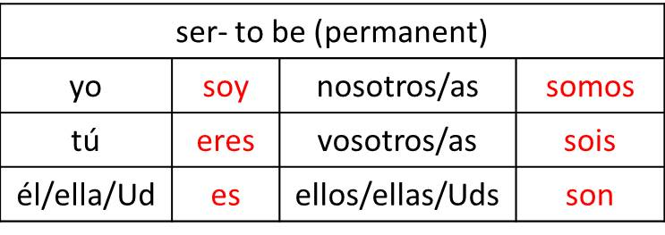
ESTAR TOBE
USED FOR LOCATION (WHERE ARE YOU?) AND CONDITION I AM WELL, ETC.

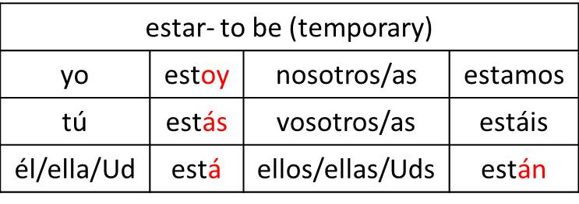

Chapter 3.2 Oral Spanish I

Student 1 Hello! How are you?

¡Buenos días! ¿Cómo estás?

Student 2 I am fine, thank you!

¡Yo estoy bien, mal, horrible, etc., gracias!

Student 3 What is your schedule in the morning (afternoon, vening)?

¿Cuál es tu horario en la mañana, tarde, noche?

Student 4 My schedule in the morning first…, second…, third…, then…,
later...,finally….

Mi horario es primero....., segundo...,tercero..., después..., luego...,
por fin..., finalmente...

Student 1 At what time do you have your…. class (lunch, recess)?

¿A qué hora tienes el almuerzo, la clase de..., el
descanso?

Student 2 My lunch it’s at 2. Mi almuerzo es a las dos.
What time is it? ¿Qué hora es?

Student 3 It’s…… I am late! I am in a hurry…
¡Estoy atrasada(o)!. ¡Tengo prisa!

Student 4 Yes, you are late! You are running late… Hurry up!

¡ Sí. Estás atrasada(o)!. ¡Date prisa!

All students I have to go! Let’s go! See you later!

¡Tengo que irme! ¡Vámonos! ¡Hasta luego!

Chapter 3.2 Oral Spanish I

Student 1 Hello! How are you?

Student 2 I am fine, thank you!

Student 3 What is your schedule in the morning (afternoon, vening)?

Student 4 My schedule in the morning first…, second…, third…, then…,
later...,finally….

Student 1 At what time do you have your…. class (lunch, recess)?

Student 2 What time is it?

Student 3 It’s…… I am late! I am in a hurry…

Student 4 Yes, you are late! You are running late… Hurry up!

All students I have to go! Let’s go! See you later!

