Spanish I
Chapter 1.3
Useful websites:

https://quizlet.com/54955714/ven-conmigo-13-sports-music-food-with-pix-flash-cards/
https://quizlet.com/47492428/gustar-encantar-fascinar-chocar-flash-cards/
https://quizlet.com/subject/chapter-8-food-spanish-1-conmigo/page/2/
https://quizlet.com/220093503/gustar-encantar-fascinar-chocar-con-vocabulario-flash-cards/
https://quizlet.com/90315873/ven-conmigo-113b-music-food-pix-flash-cards/

LEARNING TARGET Spanish I

1. Intro to Spanish speaking world/Nombres en español
2. Descripciones
3. Origen
4. Los números (0-100)
5. Presentaciones
6. Gustar

LEARNING TARGET Spanish I

1. Intro to Spanish speaking world/Nombres en español
2. Descripciones
3. Origen
4. Los números (0-100)
5. Presentaciones
6. Gustar

CORNELL NOTES  SHEET | Name: KattyaRomero  Class: Spanish I and II  Topic: Spanish  Date: Hoy es del dos mil quince  Period primero, tercero
PREGUNTAS | APUNTES
What are we studying? | Names of countries and nationalities
What is our focus? | How to use adjectives. Sentence structure
What are we reviewing? | Present tense verb conjugations
How do we use Gustar?  Y no Gustar? | See notes for the 5 steps on how to use gustar  Gustar doesn’t use Yo  Gustar has two forms Gusta and Gustan
What is the vocabulary we are reviewing? | Sports  Numbers  Food  Dislikes and likes
SUMMARY: Write 4 or more sentences describing specific learning from these notes.
I can use likes and dislikes, introduce myself, talk about basic needs .I learned food, music and school vocabulary.

Food /COMIDA
el limón | the lemon | el aperitivo | the appetizer
la lima | the lime | el aguacate | the avocado
los frijoles | the beans | la carnederes | the beef
el tomate | the tomato | el desayuno | the breakfast
la remolacha | the beet | la coliflor | the cauliflower
el rábano | the radish | el apio | the celery
la spalomitasdemaíz | the popcorn | el queso | the cheese
la mantequilla | the butter | el pollo | the chicken
la miel | the honey | el postre | the dessert
la nuez | the nut | la cena | the dinner
el maní | the peanut | el huevo | the egg
la mermelada | the jam | el pescado | the fish (cooked)
la jalea | the jelly | la hamburguesa | the hamburger
la mantequilla de maní | the peanut butter | el hotdog | the hotdog
el jugo | the juice | las papas fritas | the french fries
el dulce | the candy | el almuerzo | the lunch
la mayonesa | the mayonnaise | la lechuga | the lettuce
el kéchup | the ketchup | el plato principal | the main dish
la mostaza | the mustard | la leche | the milk
la piña | the pineapple | el puerco | the pork
la banana | the banana | las papas | the potatoes
el durazno | the peach | la ensalada | the salad
el albaricoque | the apricot | el sándwich | the sandwich
la pera | the pear | la sopa | the soup
la uva | the grape | el azúcar | the sugar
la pasa | the raisin | el pavo | the turkey
la harina | the flour | el agua | the water
la comida | the food | el helado | ice-cream
Los útensilios
Los platos | the plates
El tenedor | fork
La cuchara | spoon
El cuchillo | knife
La servilleta | napkin
El vaso/la copa | Glass/cup

http://www.spanish.cl/grammar-rules/gustar.htm

jugation rules (the way you change the verb) are a little different from normal verbs.
In English you would say I LIKE but in Spanish you would NOT say yo gusto (incorrect).
In Spanish you would say ME GUSTA or ME GUSTAN.
- Me gusta la playa (I like the beach)
- Me gusta el perro (I like the dog)
- Me gustan los perros (I like dogs)
- Me gusta cantar (I like to sing)
Why is this? Because instead of directly meaning like, it actually means that something is pleasing for you.

When do you use Gusta or Gustan?
Knowing whether to use Gusta or Gustan depends on the words that come after it (the things that you like).
If you want to say that you like doing something, then you use Gusta + Infinitive (verb)
- A mí me gusta bailar (= I like to dance)
- A nosotros nos gusta cocinar (= We like to cook)
- A ellos les gusta ir al cine (= They like to go to the movies/cinema)
BUT when we talk about liking things, then we use GUSTA if that thing is in singular form
- A mí me gusta el fútbol (= I like football/soccer)
- A nosotros nos gusta la película (= We like the movie)
- A ellos les gusta la canción (= They like the song)
We use GUSTAN if we like something that is in plural form
- A mí me gustan los libros (= I like books)
- A nosotros nos gustan las películas de terror (= We like horror movies)
- A ellos les gustan las canciones (= They like the songs)

A mí, A tí, A él...
You will notice that many times we have the prepositional phrase A + mí (or tí etc.) before the me gusta (o te gusta etc.). This is sometimes used to give more emphasis about the person who is liking the thing but also to clarify when they may be a doubt about who that person is.
For example if we say Le gusta comer, we don't know if the person who likes to eat is a man, a woman or even you. So to clarify we had the prepositional phrase A + él (or ella, usted). Compare the difference:
- A él le gusta comer (= he likes to eat)
- A ella le gusta comer (= she likes to eat)
- A usted le gusta comer (= you like to eat)

Negative Sentences using GUSTAR
Making a negative sentence with the verb gustar is simple. You just add NO between the prepositional phrase A + mí(or tí etc.) and the Indirect Object Pronoun (me, te, le etc.)
- Affirmative: A mí me gustan los gatos. (= I like cats)
- Negative: A mí no me gustan los gatos. (= I don't like cats)
- Affirmative: A ella le gusta cantar. (= She likes to sing)
- Negative: A ella no le gusta cantar. (= She doesn't like to sing)

Gustar Summary chart
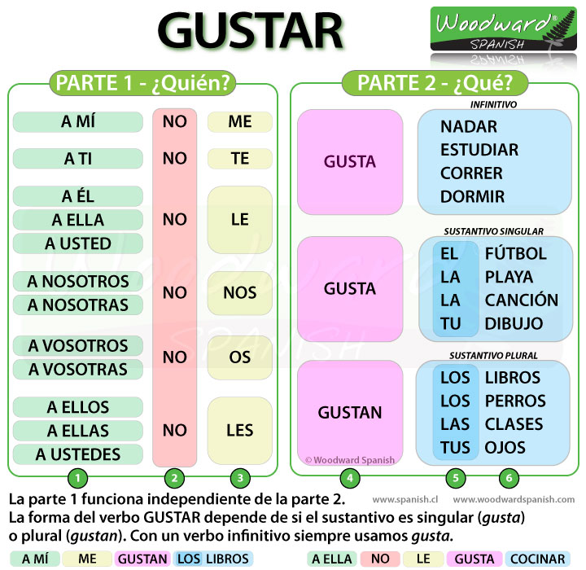

Practice: Fill in the spaces with the correct form of the indirect object and gustar.
- _______________me ________________la comida china.
- _____________nos_________________las ensaladas.
- _____________te ________________las bananas (los bananos)
- ____________os ____________________los días de campo.
- _________________ le ______________las frutas.
- _______________les ____________comer helado de vanilla.
- _______________me ________________los frijoles.
- _____________nos_________________comer pizza con cubiertos, servilleta, tenedor ni cuchara .
- _____________te ________________los vegetales/las legumbres/las verduras.
- ____________os ____________________la carne/el pollo/el cerdo.
- _________________ le ______________las cebolas.
- _______________les ____________beber refrescos/jugos/leche.

Ven Conmigo 1: Chapter 1
https://conjuguemos.com/print_vocabulary_list.php?id=134&source=public
The vocabulary in red is the one we are covering right now. Chapter 1.3

ENGLISH |  |  | SPANISH
1. Goodbye |  |  | 1. Adiós
2. Good night |  |  | 2. Buenas noches
3. Good afternoon |  |  | 3. Buenas tardes
4. Well, I have class now |  |  | 4. Bueno, tengo clase
5. Good morning |  |  | 5. Buenos días
6. 'bye |  |  | 6. Chao
7. See you later |  |  | 7. Hasta luego
8. See you tomorrow |  |  | 8. Hasta mañana
9. Hello |  |  | 9. Hola
10. sir, mr. |  |  | 10. señor
11. ma'am, miss |  |  | 11. señorita
12. I have to go |  |  | 12. Tengo que irme
13. What's your name? |  |  | 13. ¿Cómo te llamas?
14. Delighted to meet you (masc.) |  |  | 14. Encantado
15. This is my friend (girl) |  |  | 15. Ésta es mi amiga
16. This is my friend (boy) |  |  | 16. Éste es mi amigo
17. same here |  |  | 17. igualmente
18. My name is |  |  | 18. Me llamo
19. Nice to meet you |  |  | 19. Mucho gusto
20. His/Her name is |  |  | 20. Se llama
21. I am |  |  | 21. Soy
22. And you? |  |  | 22. ¿Y tú?
23. How are you? |  |  | 23. ¿Cómo estás?
24. I'm well, thanks |  |  | 24. Estoy bien, gracias
25. Great |  |  | 25. Estupendo
26. Excellent |  |  | 26. Excelente
27. Thank you |  |  | 27. Gracias
28. horrible |  |  | 28. horrible
29. so-so |  |  | 29. más o menos
30. very bad |  |  | 30. muy mal
31. How's it going? |  |  | 31. ¿Qué tal?
32. okay |  |  | 32. regular
33. I |  |  | 33. yo
34. me too |  |  | 34. yo también
35. How old is he/she? |  |  | 35. ¿Cuántos años tiene?
36. How old are you? |  |  | 36. ¿Cuántos años tienes?
37. number |  |  | 37. el número
38. I'm fourteen years old |  |  | 38. Tengo catorce años
39. She/He is fifteen years old |  |  | 39. Tiene quince años
40. Where are you from? |  |  | 40. ¿De dónde eres?
41. Where is she/he from? |  |  | 41. ¿De dónde es?
42. He/She is from |  |  | 42. Es de
43. to be |  |  | 43. ser
44. I'm from |  |  | 44. Soy de
45. basketball |  |  | 45. el baloncesto
46. baseball |  |  | 46. el béisbol
47. cafeteria |  |  | 47. la cafetería
48. chocolate |  |  | 48. el chocolate
49. english class |  |  | 49. la clase de inglés
50. mexican food |  |  | 50. la comida mexicana
51. italian food |  |  | 51. la comida italiana
52. chinese food |  |  | 52. la comida china
53. the (masc.) |  |  | 53. el
54. salad |  |  | 54. la ensalada
55. Spanish |  |  | 55. el español
56. fruit |  |  | 56. la fruta
57. soccer |  |  | 57. el fútbol
58. football |  |  | 58. el fútbol norteamericano
59. jazz |  |  | 59. el jazz
60. the (fem.) |  |  | 60. la
61. more |  |  | 61. más
62. I like |  |  | 62. Me gusta
63. I like more |  |  | 63. Me gusta más
64. a lot |  |  | 64. mucho
65. classical music |  |  | 65. la música clásica
66. pop music |  |  | 66. la música pop
67. rock music |  |  | 67. la música rock
68. music by |  |  | 68. la música de
69. swimming |  |  | 69. la natación
70. no |  |  | 70. no
71. I don't like |  |  | 71. No me gusta
72. but |  |  | 72. pero
73. pizza |  |  | 73. la pizza
74. What do you like? |  |  | 74. ¿Qué te gusta?
75. yes |  |  | 75. sí
76. homework |  |  | 76. la tarea
77. Do you like? |  |  | 77. ¿Te gusta?
78. tennis |  |  | 78. el tenis
79. volleyball |  |  | 79. el voleibol
80. Delighted to meet you (fem.) |  |  | 80. Encantada

Números: http://www.spanishdict.com/topics/show/24
Videos: https://www.youtube.com/watch?v=RrT2R9kJCdc
Song rap: https://www.youtube.com/watch?v=3Ox8o8CbP9c

Cardinal numbers (0-100)

Overview
While you may not think about it, numbers are adjectives too! Cardinal numbers are adjectives that answer the question, "How many?" They indicate a specific number of a noun but don’t have to match that noun in gender or number except for a few cases (uno, ciento).
- Uno, dos, tres, cuatro, cinco. (One, two, three, four, five.)
- Mi madre tiene seis hijos. (My mom has six kids.)
- Ahora son las doce y veinte. (Right now it is twelve twenty.)
Basic Cardinal Number Forms 0-100
0 | cero | 15 | quince
1 | uno (un) / una | 16 | dieciséis
2 | dos | 17 | diecisiete
3 | tres | 18 | dieciocho
4 | cuatro | 19 | diecinueve
5 | cinco | 20 | veinte
6 | seis | 30 | treinta
7 | siete | 40 | cuarenta
8 | ocho | 50 | cincuenta
9 | nueve | 60 | sesenta
10 | diez | 70 | setenta
11 | once | 80 | ochenta
12 | doce | 90 | noventa
13 | trece | 100 | cien
14 | catorce
Cardinal numbers do not change according to gender or number except for uno and ciento and any derivatives of uno.
Uno is only used when counting. It changes to un in front of singular masculine nouns and una in front of singular feminine nouns.
- un libro (one book)
- una casa (one house)
- veintiún mil (twenty-one thousand)
- veintiuna manzanas (twenty-one apples)
Cien changes to ciento in numbers above 100 and changes according to the gender of the noun (cientos, cientas).
- cien (one hundred)
- ciento y uno (one hundred one)
- Quiero trescientos libros. (I want three hundred books.)
- Hay doscientas casas en este barrio. (There are two hundred houses in this neighborhood.)

Irregular Verb Table
estar, ser, ir,
tenerhttps://app.oncoursesystems.com/school/webpage/354624/808709
This table gives you the subject pronouns in English and Spanish (I/yo, you/usted).

ESTAR TO BE RULES
CONDITION
AND LOCATION
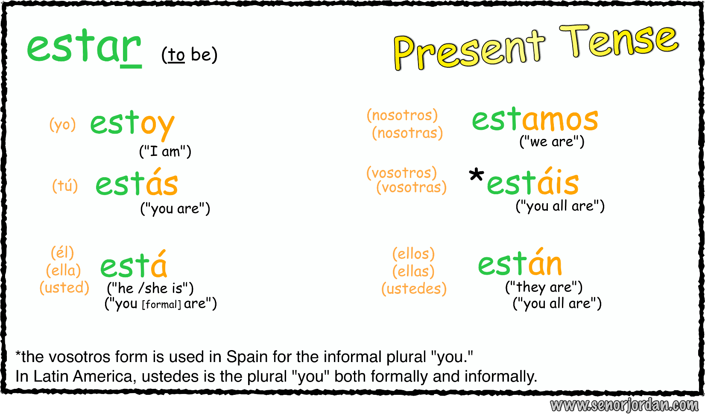

TO BE SER RULES
CHARACTERISTICS TALL, SHORT, BAD, HANDSOME
NATIONALITY AMERICAN
ORIGIN I AM FROM COSTA RICA
TIME IT’S 3:00 p.m.
EVENT A party, a dance, etc.
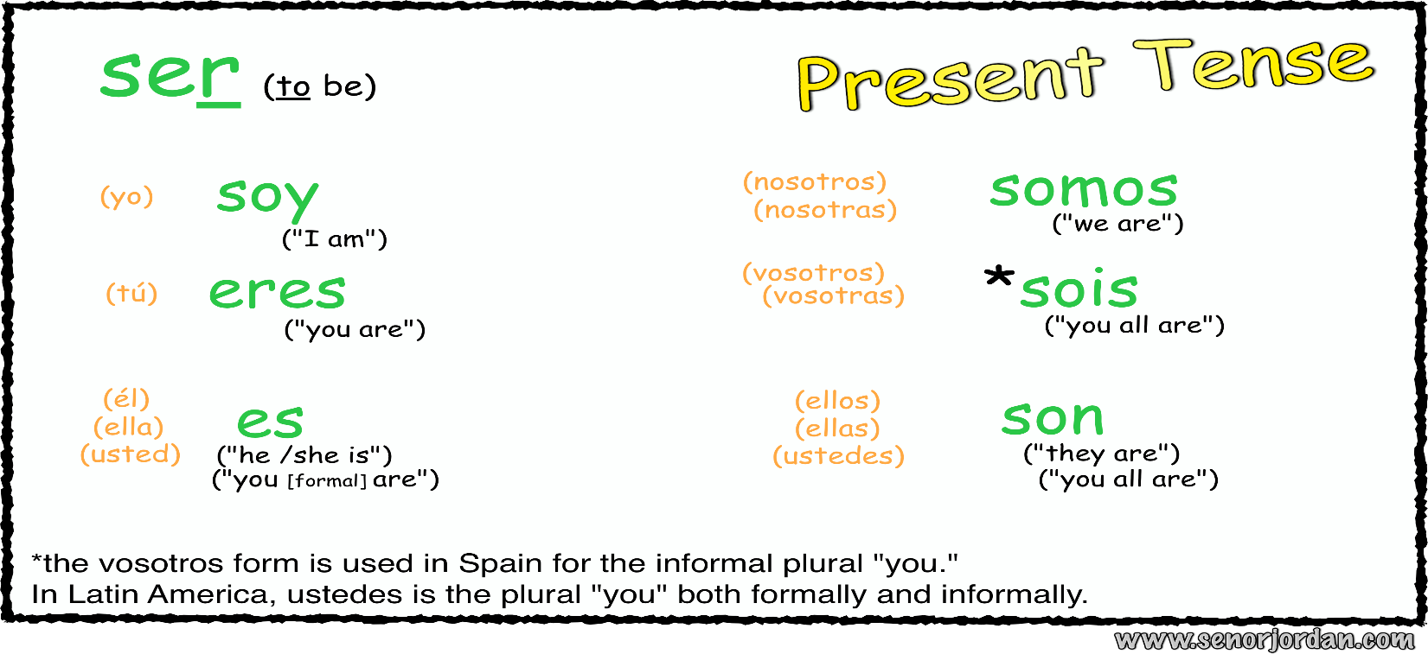

TENER FOR AGE
