Spanish I
Chapter 3.3
https://www.youtube.com/watch?v=w_D08ltoOns&list=PL81D49AFE2942F3F4

Hoy es de enero del dos mil diez y siete.
¿Cuánto estudias? Yo estudio..... minutos

LEARNING TARGET Spanish I

- Review SER vs ESTAR
- Uses of SER and ESTAR
- Adjectivies
- GUSTAR
CORNELL NOTES  SHEET | Name: KattyaRomero Class: Spanish I  Topic: Spanish  Date: Hoy es del dos mil quince Period primero, tercero
PREGUNTAS | APUNTES
What are we studying? | - Review SER vs ESTAR  - Uses of SER and ESTAR  - Adjectivies  - GUSTAR
What is our focus? | Gender and # agreement  Singular vs Plural  plural of vowel A E I O U -S  plural of consonants VDF -ES  EXCEPTION Z CES  SER VS ESTAR
What are we reviewing? | All of the above and ADJECTIVIES
What’s an irregular verb?  What’s a regular verb?  What the endings for ALL verbs in Spanish? | The root has changes.  The root does not change.  -AR, -ER,-IR
What is the vocabulary we are reviewing? | ADJECTIVES/PREPOSITION
SUMMARY: Write 4 or more sentences describing specific learning from these notes.

We are learning to describe THINGS AND PEOPLE.

Useful Websites
https://quizlet.com/4702862/ch-3-ven-conmigo-tercer-paso-part-1-flash-cards/
https://quizlet.com/19160289/spanish-1chapter-3-tercer-paso-flash-cards/
https://quizlet.com/64186423/vc1-chapter-3-tercer-paso-flash-cards/
https://www.youtube.com/watch?v=6QzEmSJvHPw
https://www.youtube.com/watch?v=w6TjefGxfPY
https://www.youtube.com/watch?v=Yi8VW4xKciQ
https://www.youtube.com/watch?v=O45wjys1Cu0
http://www.cram.com/flashcards/ven-conmigo-level-1-ch-33-1460320

http://quizlet.com/20277455/learn
http://quizlet.com/22987153/spanish-adjectives-with-pictures-flash-cards/
http://www.spanish.cl/Grammar/Games/Adjetivos.htm
http://www.spanish.cl/Grammar/Games/Adjetivos.htm
http://www.softschools.com/matching_games/spanish/spanish_adjectives/855/

HOW to use Adjectives and the Verb ser

https://www.youtube.com/watch?v=1x7VDs_8c0s
https://www.youtube.com/watch?v=v2ALpg1HaYs

Listening

Listening activity

http://faubionspanish.weebly.com/lab-5---ser.html
https://miclaseessuclase.wordpress.com/2014/11/07/cancion-de-la-semana-soy-guapo-por-senor-wooly/

¿Cómo es el señor Wooly?
¿Qué piensa el Sr. Wooly de él mismo?
¿Cómo es el otro hombre?
¿Por qué es feo el otro hombre?

https://www.pinterest.com/pin/123145371032411511/

¿Cómo son los jeans del chico?
¿Qué adjetivos usa la niña/chica/mujer?

GREAT VIDEOS AND EXPLANATIONS:

https://video.search.yahoo.com/search/video;_ylt=AwrBTztcq1xWJCIAIupXNyoA;_ylu=X3oDMTEyYjUwMmQzBGNvbG8DYmYxBHBvcwMxBHZ0aWQDQjExNzlfMQRzZWMDc2M-?p=Webbly+Lesons+On+Ser+Spanish&fr=mcafee#id=25&vid=d9593de5a5bfa03b8d676f15ca988e8e&action=view

http://conjuguemos.com/print_vocabulary_list.php?id=136&source=public
VOCABULARIO CHAPTER 3 STEP 3
41. boring | 41. aburrido
42. tall | 42. alto
43. disagreeable | 43. antipático
44. short | 44. bajo
45. pretty | 45. bonito
46. good | 46. bueno
47. funny | 47. cómico
48. What is he like? | 48. ¿Cómo es él?
49. What are they (masc.) like? | 49. ¿Cómo son ellos?
50. friend, pal | 50. el compañero
51. difficult | 51. difícil
52. fun, amusing | 52. divertido
53. they (masc.) | 53. ellos
54. You are (fam.) | 54. Tú eres
55. He is... | 55. Él es...
56. strict | 56. estricto
57. easy | 57. fácil
58. ugly | 58. feo
59. big | 59. grande
60. good-looking | 60. guapo
61. intelligent | 61. inteligente
62. interesting | 62. interesante
63. bad | 63. malo
64. dark haired, dark skinned | 64. moreno
65. Do not worry | 65. No te preocupes
66. new | 66. nuevo
67. small | 67. pequeño
68. teacher (masc.) | 68. el profesor
69. blond | 69. rubio
70. nice | 70. simpático
71. We are | 71. Somos
72. the dance | 72. el baile
73. the concert | 73. el concierto
74. Which? | 74. ¿Cuál?
75. the sports | 75. los deportes
76. the exam | 76. el examen
77. the exams | 77. los exámenes
78. favorite | 78. favorito
79. the party | 79. la fiesta
80. teacher (fem.) | 80. la profesora
81. the novel | 81. la novela
82. the game | 82. el partido
83. Why? | 83. ¿Por qué?
84. because | 84. porque
85. the videogame | 85. el videojuego
86. the videogames | 86. los videojuegos
87. the (fem. / pl.) | 87. las

Adjectives – adjetivos
Adjective – a word that describes a noun or distinguishes it from a group of other nouns.
In English an adjective comes before the word it is describing and has one form.
Ex: the red car the red cars

Before car it has the same form even though there are more cars
In Spanish, an adjective comes after the noun and must agree with it in number and gender. So each adjective that ends in an “o” has four forms: masculine, feminine, singular and plural. Adjectives that end in an “e” or a consonant have two forms: singular and plural. Use these charts to help:
Adj. that end in “O” have four forms. Let’s look at the word for “tall”
 | Singular | Plural
Masculine | Alto | Altos
Feminine | Alta | Altas
Examples: The tall boy = el muchacho alto
The tall girl = la muchacha alta
The tall boys = los muchachos altos
The tall girls = las muchachas altas

Notice that the article, noun, and adjective must match in gender and number.
Don’t forget that the adjective comes after the noun in Spanish!
Adjectives that end in “e” or a consonant have only two forms.
 | Singular | Plural
Adjective that end in “e” | Inteligente | Inteligentes
Consonant | Popular | Populares
If an adjective ends in a vowel, simply add an “s” to make if plural. If it ends in a consonant, you add an “es”. Examples:
The popular boy = el muchacho popular
The popular girl = la muchacha popular
The poplar boys = los muchachos populares
The popular girls = las muchachas populares

The intelligent boy = el muchacho inteligente

Possessive Adjectives
Useful videos explaining the possessive adjectives
https://www.youtube.com/watch?v=rUaX5OqTEzE
https://www.youtube.com/watch?v=9-TFyxNwWQM
https://www.youtube.com/watch?v=zT1kIpCRBqM

Possessive Adjectives and "De"
Your assessment on Possessive Adjectives and "De"
You can show relationship or possession in two ways:
"De" (of/from) Ella es la hermana de Ariana. (She is the sister of Ariana.)
Es el libro de Miguel. (It is Miguel's book. / It is the book of Miguel.)

Adjectives and Ser
- Quizlet
1. Click on the link below to practice adjectives with ser.
http://quizlet.com/6709178/adjectives-ser-flash-cards/

- Possessive adjectives
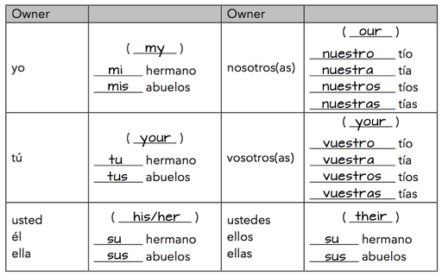

Conjugation and Uses of SER

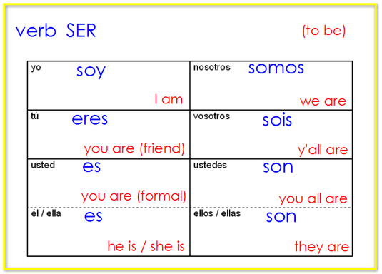

You know the correct form of ser to use based on the subject pronoun. You can also infer the subject pronoun based on the form of ser if the subject pronoun is missing.
1. Click here to hear all the forms of ser
http://quizlet.com/8892022/ser-flash-cards/
2. Click here to practice spelling the subject pronouns and forms of ser: https://quizlet.com/8892022/spacerace
3. Click here to take a practice test in ENGLISH AND SPANISH. Start with English, next select Spanish, and create a new test: http://quizlet.com/8892022/test

Short practice assessment: Formative Escritura
The quiz for ser and subject pronouns is very similar to the activity below. Fill in the correct subject pronoun or the correct form of ser.

Answer these on the back of your handout.

1. ____ soy inteligente.
2. Señor Anaya ____ profesor.
3. Usted ____ alto.
4. ____ eres guapo.
5. Andres y Diego ____ locos.
6. ____ somos de Texas.
7. Ella ____ bonita.
8. Nosotros ____ estudiantes buenos.
9. _____ sois de España.
10. Yo ____ especial.

REVIEW OF ALL VERBS LEARNED UP TO KNOW

GUSTAR
https://www.youtube.com/watch?v=masuGwmv9q0
https://www.youtube.com/watch?v=P7RP3Mw5mNM

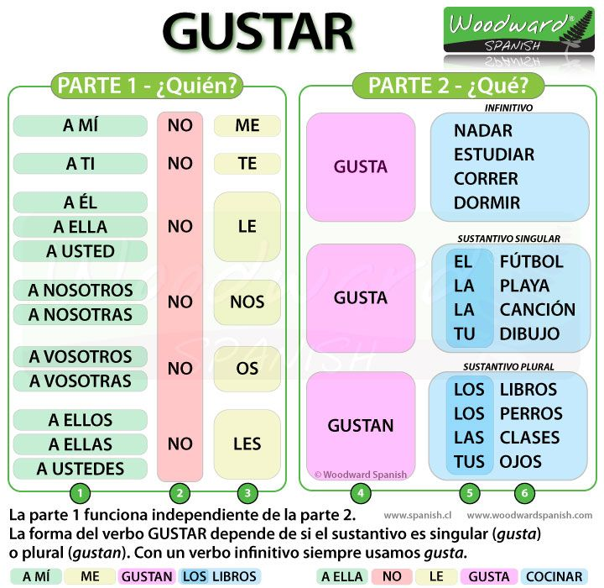

http://users.ipfw.edu/jehle/VERBLIST.HTM
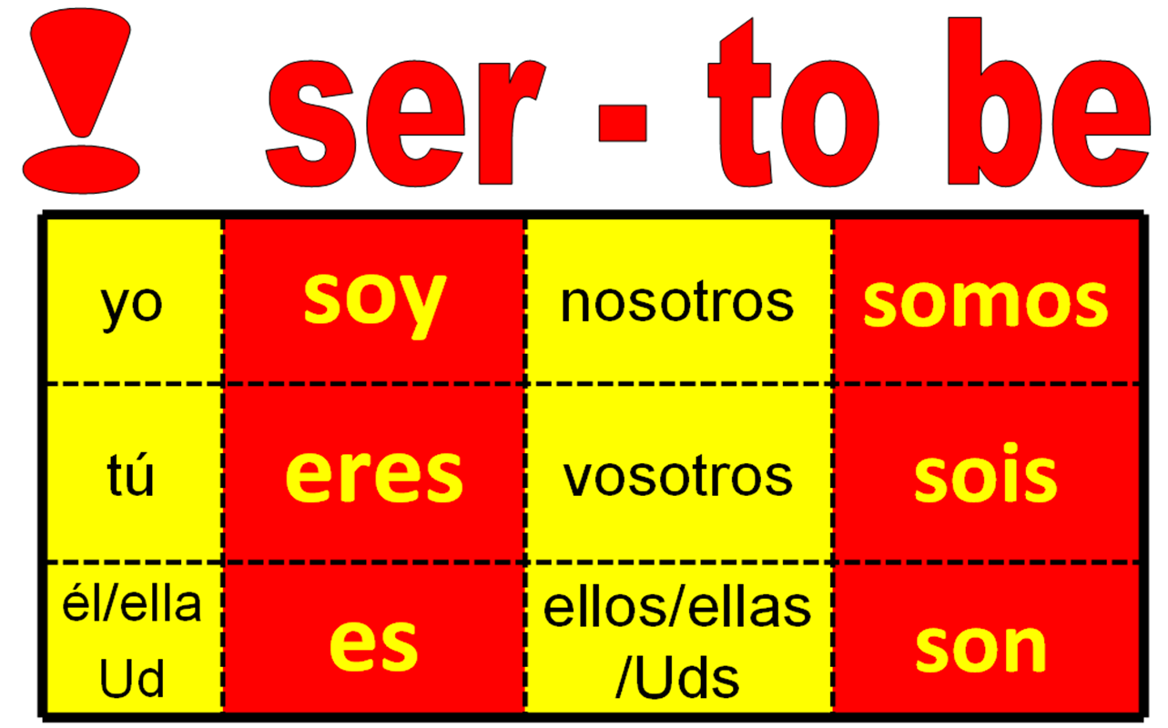

Uses of ser: descriptions

http://www.spanishdict.com/topics/show/42

Overview
Ser and Estar can be confusing since they both can mean “to be;” however, there are some simple generalizations that can help you remember when to use one or the other. In general, Ser is used for Descriptions, Origins, and Time, or D.O.T. This article covers Descriptions.

Descriptions with Ser
Ser is used for all permanent/long-term and personal descriptions. You would use ser to answer the question, “How would you describe ____?”. Ser is used with the essential qualities that define a person or thing and that are not likely to change in the near future. These can be:
physical descriptions
Soy alta y delgada. - I am tall and thin.
- Silvia es pelirroja y baja. - Silvia is red-headed and short.
names
Soy Raúl. - I am Raúl.
- Son Adela y Amalia. - They are Adela and Amalia.
the job a person has
Soy profesora de español. - I am a Spanish teacher.
- Son jardineros. - They are gardeners.
the relationship a person has with someone else
- Anita es mi hermana. - Anita is my sister.
- Aaron es su prometido. - Aaron is her fiancé.
a person’s religion
- Andrés es católico. - Andres is Catholic.
- Mis padres son budistas. - My parents are Buddhists.

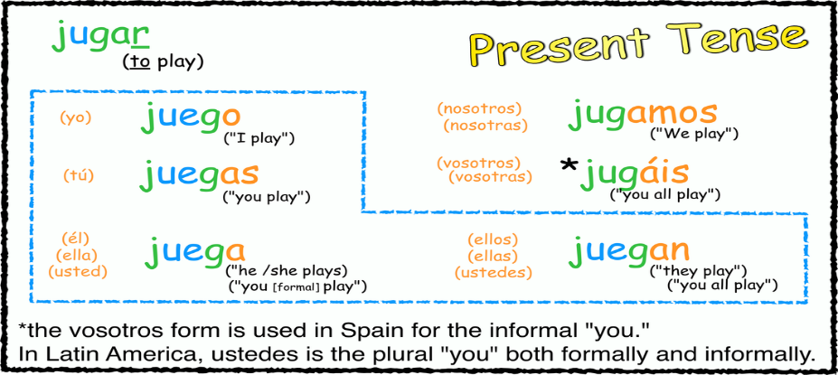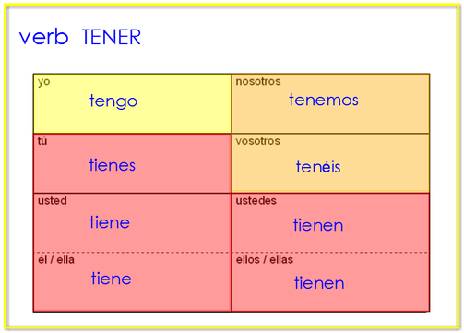

All verbs learned so far:

Present Indicative: Regular -AR verbs
tocar: to touch or to play an instrument
yo toco | nosotros tocamos
tú tocas | (vosotros tocáis)
él/ella/Ud. toca | ellos/ellas/Uds. tocan

Present Indicative: Regular -AR verbs
DESCANSAR: to rest
yo descanso | nosotros descansamos
tú descansas | (vosotros descansáis)
él/ella/Ud. descansa | ellos/ellas/Uds. descansan

Present Indicative: Regular -AR verbs
Bailar: to dance
yo bailo | nosotros bailamos
tú bailas | (vosotros bailáis)
él/ella/Ud. baila | ellos/ellas/Uds. bailan

Present Indicative: Regular -AR verbs
Caminar: to walk
yo camino | nosotros caminamos
tú caminas | (vosotros camináis)
él/ella/Ud. camina | ellos/ellas/Uds. caminan

Dibujar: To draw
yo dibujo | nosotros  dibujamos
tú dibujas | (vosotros  dibujáis)
él/ella/Ud. dibuja | ellos/ellas/Uds.  dibujan
Present Indicative: Regular -AR verbs
ESCHUCHAR: To listen
yo  escucho | nosotros  escuchamos
tú  escuchas | (vosotros  escucháis)
él/ella/Ud.  escucha | ellos/ellas/Uds.  escuchan
ESTUDIAR: TO STUDY
yo  estudio | nosotros  estudiamos
tú estudias | (vosotros  estudiáis)
él/ella/Ud.  estudia | ellos/ellas/Uds.  Estudian
DIBUJAR: TO DRAW
yo  DIBUJo | nosotros  DIBUJamos
tú  DIBUJas | (vosotros  DIBUJáis)
él/ella/Ud.  DIBUJa | ellos/ellas/Uds.  DIBUJan
Present Indicative: Regular -AR verbs
Hablar: to talk
yo  Hablo | nosotros  Hablamos
tú  Hablas | (vosotros  Habláis)
él/ella/Ud.  Habla | ellos/ellas/Uds.  Hablan
Present Indicative: Regular -AR verbs
Lavar: to wash
yo lavo | nosotros lavamos
tú lavas | (vosotros laváis)
él/ella/usted lava | ellos/ellas/Ustedes lavan
Present Indicative: Regular -AR verbs
Mirar: to watch, to look at

yo miro | nosotros miramos
tú miras | (vosotros miráis)
él/ella/Ud. mira | ellos/ellas/Uds. Miran
Present Indicative: Regular -AR verbs
Montar: to ride
yo Monto | nosotros Montamos
tú Montas | (vosotros Montáis)
él/ella/Ud. Monta | ellos/ellas/Uds. Montan
Present Indicative: Regular -AR verbs
Nadar: to swim
Yo Nad o | nosotros Nadamos
tú Nadas | (vosotros Nadáis)
él/ella/Ud. Nada | ellos/ellas/Uds. Nadan
Present Indicative: Regular -AR verbs
Pasar (el rato con amigos): to spend time with friends
yo Paso | nosotros Pasamos
tú Pasas | (vosotros Pasáis)
él/ella/Ud. Pasa | ellos/ellas/Uds. Pasan
Present Indicative: Regular -AR verbs
Pintar: to paint
yo Pinto | nosotros Pintamos
tú Pintas | (vosotros Pintáis)
él/ella/Ud. Pinta | ellos/ellas/Uds. Pintan
Present Indicative: Regular -AR verbs
Practicar: to practice
yo practico | nosotros practicamos
tú practicas | (vosotros practicáis)
él/ella/Ud. practica | ellos/ellas/Uds. practican
Present Indicative: Regular -AR verbs
Preparar: to prepare
yo Preparo | nosotros Preparamos
Tú Preparas | (vosotrosPreparáis)
él/ella/Ud. Prepara | ellos/ellas/Uds. PreparAn
Present Indicative: Regular -AR verbs
Regresar: to return

yo Regreso | nosotrosRegres amos
tú Regresas | (vosotros Regresáis)
él/ella/Ud. Regresa | ellos/ellas/Uds. Regresan
Present Indicative: Regular -AR verbs
Sacar: to take out sacar la basura take out the trash
Sacar fotos take pictures
Sacar buenas notas earn good grades
yo Saco | nosotros Sacamos
tú Sacas | (vosotros Sacáis)
él/ella/Ud. Saca | ellos/ellas/Uds. Sacan
Present Indicative: Regular -AR verbs
Tomar: to take or to drink
yo Tomo | nosotros Tomamos
tú Tomas | (vosotros Tomáis)
él/ella/Ud. Toma | ellos/ellas/Uds. Toman
Present Indicative: Regular -AR verbs
Trabajar: to work
yo Trabajo | nosotros Trabajamos
tú Trabajas | (vosotros Trabajáis)
él/ella/Ud. Trabaja | ellos/ellas/Uds. Trabajan

GRAMMAR:
To talk about doing things with someone else, con is used with a pronoun like the following chart:
Conmigo | With me | Con nosotros/as | With us
Contigo | With you | Con vosotros/as | With you (plural)
Con usted | With you | Con ustedes | With you (plural)
Con él | With him | Con ellos | With Them

Examples:
I talk with you. Yo hablo contigo.
You talk with me. Usted habla conmigo.

USES de SER CNOTE vs
ESTAR LOCATION AND CONDITION

Los usos de SER  DESCRIBE THE ESSENCE  (Example: ice=cold)  (Paco & Pablo Have Never Cooked Insect Oatmeal 4 ME.) | Los usos de ESTAR  DESCRIBE A CHANGE  in state, condition, or motion  (Example: was happy, now is sad)  (Santa Clause Loves Pizza.)
Características  Personalidad/Profesión  Posesión  1. (las entradas) son de él | Sentimientos  - está muy triste  - estamos muy emocionados
Nacionalidad  Soy estadounidense  Soy costarricense | Condiciones y Salud
Origen  Soy de Costa Rica | Lugar  - está en NY  - está en NY
Time  Es la una  Son las dos | Presente Progresivo  - está visitando  - estamos contando
Evento
- es en Los Angeles
- es a las 7:30

Conjugation of ESTAR
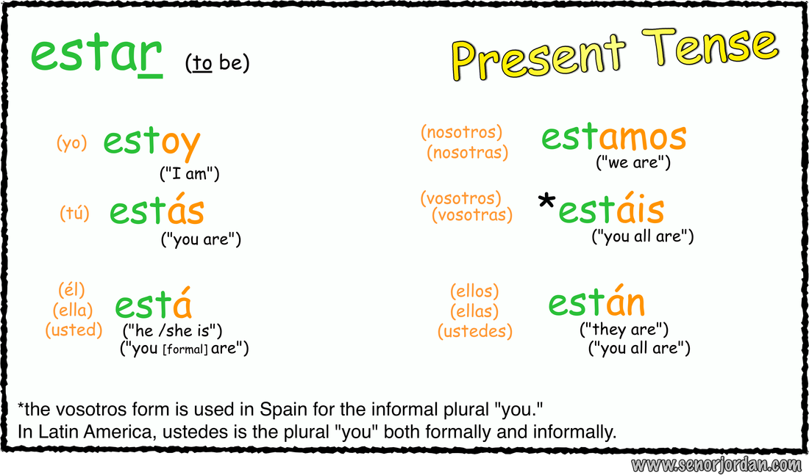
CONJUGATION OF SER:

LAS FRASES DEL TIEMPO

Weather Expressions with “Hace…”
Hace buen tiempo It’s nice weather
Hace mal tiempo It’s bad weather
Hace fresco It’s cool
Hace (mucho) frío It’s (really/ very) cold
Hace (un poco)calor It’s (a little/a bit) hot
Hace viento It’s windy
Hace sol It’s sunny

Weather Expressions with “Está…”
Está nublado It’s cloudy
Está lloviendo It’s raining (right now)
Está nevando It’s snowing (right now)

Other Expressions
Llueve It rains/ is raining
Nieva It snows/ is snowing

