Spanish I
Chapter 2.1
Useful websites: 3 quizlets= 5 points sent via e-mail to Mrs. Romero on test date. Minimum score B- on each quiz B-.

https://quizlet.com/7624648/ven-conmigo-1-ch-21-flash-cards/
https://quizlet.com/4847065/book-1-21-flash-cards/
http://www.conjuguemos.com/print_vocabulary_list.php?id=135&source=public
https://www.youtube.com/watch?v=zqoKnA9SFXo
https://www.youtube.com/watch?v=YJCk6y3fO9g
https://www.youtube.com/watch?v=sIwFPNfUoik
https://quizlet.com/17251615/ven-conmigo-1-chap-21school-supplies-flash-cards/

Song for –ar verbs:
http://www.senorjordan.com/2015/02/01-ar-verb-endings-song/

Native speakers videos:
https://www.laits.utexas.edu/spe/

Videos on vocabulary speaking:
https://www.youtube.com/watch?v=VtOzgv5ncb8

https://www.youtube.com/watch?v=QiZtSy_4NtE
Cute songs:
https://www.youtube.com/watch?v=izbVTWnzBLU
https://www.youtube.com/watch?v=KeX5TjsF700-

Videos Student Projects:
https://www.youtube.com/watch?v=FhYPPpiuSy0
https://www.youtube.com/watch?v=1wS47GsXB3M
https://www.youtube.com/watch?v=8Axh5jGr_s0
https://www.youtube.com/watch?v=W4kQQ_3N528

LEARNING TARGET Spanish I

- Cosas en tu clase (things, school objects)
- Verbos tener, querer, necesitar, ser, estar (verbs to have, to want, to need, to be)
- Definite and Indefinite articles
- How to make nouns and adjectives plural
- Feminine and Masculine words

Hoy es martes veinte de octubre del dos mil quince.
¿Cuánto estudias? Yo estudio..... minutos
Hace buen tiempo. No llueve. No neva

LEARNING TARGET Spanish I

- Cosas en tu clase (things, school objects)
- Verbos tener, querer, necesitar, ser, estar, gustar (verbs to have, to want, to need, to be, to like)
- Definite and Indefinite articles
- How to make nouns and adjectives plural
- Feminine and Masculine words

CORNELL NOTES  SHEET | Name: KattyaRomero  Class: Spanish I and II  Topic: Spanish  Date: Hoy es del dos mil quince  Period primero, tercero
PREGUNTAS | APUNTES
What are we studying? | - Cosas en tu clase  (things, school objects)  - Verbos tener, querer, necesitar, ser, estar, gustar  (verbs to have, to want, to need, to be, to like)  - Definite and Indefinite articles  - How to make nouns and adjectives plural  - Feminine and Masculine words
What is our focus? | How to use adjectives. Sentence structure
What are we reviewing? | Present tense verb conjugations  PLURAL  When word ends in  Vowel: A E I O U- -S  Consonant: N T R- -ES  Except: Z -ces  FEMININE WORDS MACULINE WORDS  -A OR –DAD OR –ión  -O or  Chica, cuidad, nación GREEK end in –MA –TA –PA  El problema  El mapa
What’s an irregular verb?  What’s a regular verb?  What the endings for ALL verbs in Spanish? | Irregular verbs have a change in the root  Regular verb keeps the same root of the verb  All verbs in Spanish end in –ar, -er and –ir.
What is the vocabulary we are reviewing? | School supplies and 5 verbs to have, to want, to need, to be and to like
SUMMARY: Write 4 or more sentences describing specific learning from these notes.
I am going to be able to write out my wants, needs and describe how the objects in the class are. I am going to be able to make nouns and adjective agree in number and gender.

http://www.conjuguemos.com/print_vocabulary_list.php?id=135&source=public

ENGLISH CHAPTER 2.1 |  |  | SPANISH CHAPTER 2.1
1. ballpoint pen |  |  | 1. el bolígrafo
2. Well... |  |  | 2. Bueno...
3. calculator |  |  | 3. la calculadora
4. folder |  |  | 4. la carpeta
5. high school |  |  | 5. el colegio
6. notebook |  |  | 6. el cuaderno
7. dictionary |  |  | 7. el diccionario
8. He |  |  | 8. Él
9. She |  |  | 9. Ella
10. eraser |  |  | 10. la goma de borrar
11. pencil |  |  | 11. el lápiz
12. bookstore |  |  | 12. la librería
13. book |  |  | 13. el libro
14. bookbag,backpack |  |  | 14. la mochila
15. She needs |  |  | 15. Ella necesita/necesita
16. to need |  |  | 16. necesitar
17. You need (fam.) |  |  | 17. Tú necesitas/necesitas
18. I need |  |  | 18. Yo necesito/necesito
19. paper |  |  | 19. el papel
20. to want |  |  | 20. querer
21. She wants |  |  | 21. Ella quiere/quiere
22. You want (fam.) |  |  | 22. Tú quieres/quieres
23. I want |  |  | 23. Yo quiero/quiero
24. ruler |  |  | 24. la regla
25. I have |  |  | 25. Yo tengo/tengo
26. a,an (masc. singular) |  |  | 26. un
27. a,an (fem. singular) |  |  | 27. una
28. some, a few (fem.plural) |  |  | 28. unas
29. some, a few (masc. plural) |  |  | 29. unos
30. already |  |  | 30. ya

Verb Conjugations

TO NEED
I need | We need
You need  informal | You all need
He  She need  You formal | They need  You plural formal need

NECESITAR TO NEED

Yo NECESITo | nosotros NECESITamos
tú NECESITas | vosotros NECESITáis
él  ella NECESITa  usted | ellos  ellas NECESITan  ustedes

To Have
I have | We have
You have  Informal singular | You all have
He she you formal singular  Have | They have  You plural formal have

TENER
Yo tengo | Nosotros tenemos
Tú tienes | vosotros tenéis
él  ella tiene  usted | ellos  ellas tienen  ustedes

Verb Conjugations

Querer
Yo quiero | Nosotros queremos
Tú quieres | vosotros queréis
él  ella quiere  usted | ellos  ellas quieren  ustedes

To want
Singular Plural
I want | We want
You want  Informal singular | You all want
He  She want  You formal singular | They want  You plural formal want

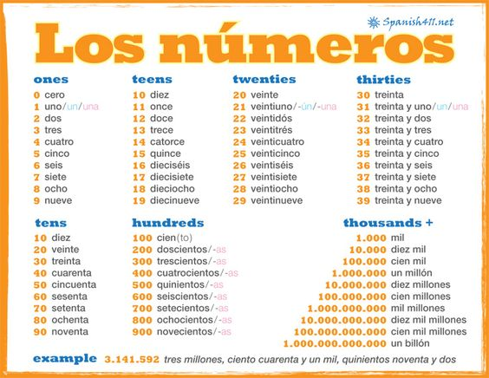

Classwork

B. Fill in the spaces with the indefinite article.
A AN

SOME

- Jacob calculadoras.
- Ellos regla.
- Yo computadora.
- Tú lápices.
- Nosotros gomas de borrar.
- Vosotros marcadores.

- Translate into Spanish.

- I need 20 books. I have some books.
- You need 15 pens. You have a pen.
- He needs 11 pencils. He has some pencils.
- We need 30 calculators. We have a calculator
- You all need 5 papers. You all have some papers.
- They masculine plural need 1 ruler. They have a ruler.

Canción Song School supplies

https://rockalingua.com/videos/school-supplies-and-subjects

