SPANISH 1
Capítulo Preliminar

Useful websites:

https://quizlet.com/28631277/ven-conmigo-chapter-1-colors-flash-cards/
http://www.spanishspanish.com/free_ven_conmigo/vc1_intro_cap1_1A_preloader.html
http://go.hrw.com/hrw.nd/gohrw_rls1/pKeywordResults?keyword=wl%20spanish%20l1
https://quizlet.com/13718907/ven-conmigo-1-capitulo-1-primer-paso-flash-cards/
https://quizlet.com/11817/spanish-numbers-0-30-flash-cards/

IMPORTANT:

Teacher will ask you to do these short assessments at the end of each week of school:

First week: https://quizlet.com/13718907/test?mult_choice=on&prompt-with=1&limit=20
Second week: https://quizlet.com/28631277/test?mult_choice=on&prompt-with=1&limit=10
Third week: https://quizlet.com/19723667/ven-conmigo-152a-verbs-ar-er-ir-flash-cards/

Sra. Romero will ask you to take the quizzes. Then send her a copy of the results. Sra will teach you and remind you in Power School and in class to send it to her via e-mail to: Kattya.Romeromora@WESchools.org.

Week 1-2 LEARNING TARGET Capítulo Preliminar

1. Intro to Spanish speaking world/Nombres en español
2. Frases útiles/ los cognados
3. El Alfabeto
4. Los Colores
5. Los números (0-30)

LEARNING TARGET Capítulo Preliminar

1. Intro to Spanish speaking world/Nombres en español
2. Frases útiles/ los cognados
3. El Alfabeto
4. Los Colores
5. Los números (0-30)

CORNELL NOTES  SHEET | Name: KattyaRomero  Class: Spanish I and II  Topic: Spanish  Date: Hoy es jueves 20 de agosto del dos mil quince  Period primero, tercero, quince, sexto, séptimo
PREGUNTAS | APUNTES
WHAT ARE WE LEARNING? | ALPHABET  NUMBERS  DESCRIPTIONS  COLORS
WHY ARE WE LEARNING THIS? | TO BE ABLE TO COMMUNICATE IN SPANISH
HOW MANY LEARNING ARE THERE IN THE SPANISH ALFABETO? | 27
HOW DO YOU PRONOUNCE THE ALFABETO? | SEE NOTES
SUMMARY: Write 4 or more sentences describing specific learning from these notes.

__________________________________________________________________________________________
__________________________________________________________________________________________
__________________________________________________________________________________________
__________________________________________________________________________________________

This is how you should start your notes every day. Write down the date I have on the board. The question and the answer.

Hoy es miércoles veinte de agosto del dos mil quince.

¿Cuánto estudias? How much did you study?
Yo estudio treinta minutos. I studied …. Minutes.

Then you set up your notebook as follows:

- Alfabeto 2. Palabras (words colors) 3. Números
1.
2.
3.
4.
5.
6.
7.
8.
9.
10.

4. Preguntas y respuestas Questions and answers

¿Cómo te llamas tú? What is your name?

Yo me llamo . My name is…
¿Y tú? And you?
Yo soy I am

Alfabeto en español: Things to note about the Spanish alphabet:
The Spanish alphabet in Spanish is called "abecedario or alfabeto"
In the Spanish alphabet there are 27 letters: a, b, c, d, e, f, j, h, i, j, k, l, m, n, ñ, o, p, q, r, s, t, u, v, w, x, y, z. Previously, the phoneme and letter Ch counted as such, but this classification is no longer used.

Song: https://www.youtube.com/watch?v=JUcu9PUh9_A
Alfabeto Lesson: https://www.youtube.com/watch?v=ZAp28thZsKs

A B C D E F

(ah) (bay) (say) (day) (ay) (efay)

G H I J K L

(hay) (ahchay) (ee) (hota) (kah) (elay)

LL M N Ñ O P
(ayay) (emay) (enay) (enyay) (oh) (pay)

Q R RR S T U
(koo) (airray) (errAHray) (essay) (tay) (oo)

V W X Y Z
(vay) (doblay) (eh7keys) (eegreah) (say7tuh)

Alphabet: https://search.yahoo.com/search?fr=mcafee&type=C211US0D20120928&p=Learn+Spanish+%2F+Espa%C3%B1ol+Alphabet+-+ABC+Flash+Cards+(HD)+youtube.com

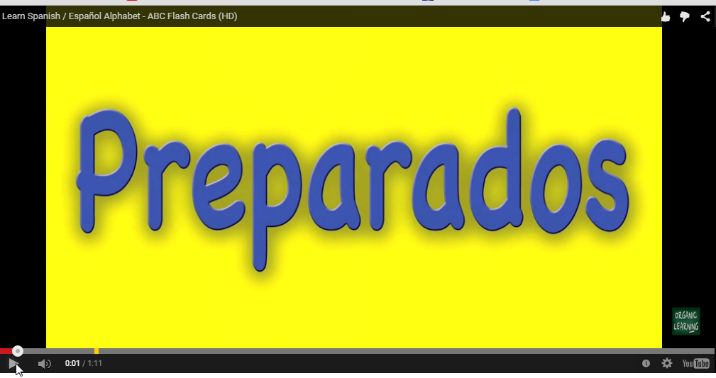

Colores: (colors) http://www.europa-pages.com/lessons/spanish-colors.html videos and vocabulary
Practice numbers: http://www.spanishspanish.com/numbers/Spanish_numbers.html
Game: http://www.vocabulary.co.il/foreign-language/spanishenglish-color-match/

Los Colores:

black  negro  (NAY-groh) | blue  azul  (ah-SOOL) |  | brown  café  (kah-fay) | gray  gris  (GREESS)
green  verde  (BAYR-day) | orange  anaranjado (ah--nah-ran-HA-do)  (naranja) (nar-AHN-hah) |  | pink  color (de) rosa, rosado  (Roosahdoh) | purple  morado  (moor-AH-do),
red  rojo  (ROH-hoh) | white blanco (BLAHN-koh) yellow amarillo (AH-mah-REE-yoh)

Números 0-30 http://www.spanishclassonline.com/vocabulary/numbers0to30.htm
Videos: https://www.youtube.com/watch?v=dqIKdVY53FY
https//www.youtube.com/watch?v=_u5oBwZsfgg
Song rap: https://www.youtube.com/watch?v=L26jwqF9Zro

Numbers: 0-31 Spanish | English
cero | 0
uno | 1
dos | 2
tres | 3
cuatro | 4
cinco | 5
seis | 6
siete | 7
ocho | 8
nueve | 9
diez | 10
once | 11
doce | 12
trece | 13
catorce | 14
quince | 15
Dieciséis or diez y seis | 16
Diecisiete diez y siete | 17
Dieciocho diez y ocho | 18
Diecinueve diez y nueve | 19
veinte | 20
Veintiuno veinte y uno | 21
Veintidós veinte y dos | 22
Veintitrés veinte y tres | 23
Veinticuatro veinte y cuatro | 24
Veinticinco veinte y cinco | 25
veintiséis | 26
Veintisiete veinte y siete | 27
Veintiocho veinte y ocho | 28
Veintinueve veinte y nueve | 29
treinta | 30
treinta y uno etc. | 31 etc.

ORAL PROJECT 1.1
Student 1
¡Hola! Hello
¡Buenos días! Good morning!
¡Buenos tardes! Good afternoon!
¡Buenos noches! Good evening!

Student 2 responds
¡Hola! Hello
¡Buenos días! Good morning!
¡Buenos tardes! Good afternoon!
¡Buenos noches! Good evening!

Student 2 asks student 3
¿Cómo estás tú? How are you doing?

Student 3answers Yo estoy bien I am well!

Student 3 says to student 4 ¿Y tú? And you?

Student 4answers Yo estoy mal ( or más o menos) I am badly (so so)

Student 4 asks Student 1 ¿Cómo te llamas tú? What is your name?

Student 1 answers Yo me llamo ...... My name is _________

Student 1 asks student 2 ¿Y tú? And yours?

Student 2 responds Yo soy ...... I am _______________

All students say ¡Adiós! ¡Hasta Luego! ¡Hasta mañana!

Good-bye See you later! See you tomorrow!

VOCABULARY LIST

Title: | Ven Conmigo 1: Chapter 1

ENGLISH |  |  | SPANISH
1. Goodbye |  |  | 1. Adiós
2. Good night |  |  | 2. Buenas noches
3. Good afternoon |  |  | 3. Buenas tardes
4. Well, I have class now |  |  | 4. Bueno, tengo clase
5. Good morning |  |  | 5. Buenos días
6. 'bye |  |  | 6. Chao
7. See you later |  |  | 7. Hasta luego
8. See you tomorrow |  |  | 8. Hasta mañana
9. Hello |  |  | 9. Hola
10. sir, mr. |  |  | 10. señor
11. ma'am, miss |  |  | 11. señorita
12. I have to go |  |  | 12. Tengo que irme
13. What's your name? |  |  | 13. ¿Cómo te llamas?
14. My name is or I am |  |  | 14. Me llamo or Yo soy
15. And you? |  |  | 15. ¿Y tú?

