Spanish I
Chapter 2.2
Extra credit websites:

https://quizlet.com/11290395/spanish-bedroom-items-flash-cards/
https://quizlet.com/59168714/ven-conmigo-1-chapter-22-organizate-flash-cards/
https://quizlet.com/32421032/ven-conmigo-1-chapter-2-segundo-paso-flash-cards/
https://quizlet.com/subject/necesitar-tener-querer-verbs-conjugation/page/6/

Useful Videos explaining conjugations
https://www.youtube.com/watch?v=zqoKnA9SFXo
https://www.youtube.com/watch?v=sIwFPNfUoik
https://www.youtube.com/watch?v=YJCk6y3fO9g
https://www.youtube.com/watch?v=yDNny95Zy2M
https://www.youtube.com/watch?v=3F5WNHt0Fso
https://www.youtube.com/watch?v=HZlzlgPvdn0

Song for –ar verbs:
http://www.senorjordan.com/2015/02/01-ar-verb-endings-song/
https://www.youtube.com/watch?v=w_D08ltoOns

LEARNING TARGET Spanish I

- Bedroom vocabulary
- Verbs to have, to need, to like, to really like, to want, to be
- Review of school supplies
- Review numbers and feminine and masculine words

Hoy es de noviembre del dos mil diez y siete.
¿Cuánto estudias? Yo estudio..... minutos

LEARNING TARGET Spanish I

- Bedroom vocabulary
- Verbs to have, to need, to like, to really like, to want, to be
- Review of school supplies and plurals
- Review numbers and feminine and masculine words

CORNELL NOTES  SHEET | Name: KattyaRomero  Class: Spanish I and II  Topic: Spanish  Date: Hoy es del dos mil quince  Period primero, tercero
PREGUNTAS | APUNTES
What are we studying? | - Bedroom vocabulary and regular and irregular verbs  - Review school supplies
What is our focus? | How to use adjectives. Sentence structure
What are we reviewing? | Present tense verb conjugations  PLURAL  When word ends in  Vowel: A E I O U- -S  Consonant: N T R- -ES  Except: Z -ces  FEMININE WORDS MACULINE WORDS  -A OR –DAD OR –ión  -O or  Chica, cuidad, nación GREEK end in –MA –TA –PA  El problema  El mapa
What’s an irregular verb?  What’s a regular verb?  What the endings for ALL verbs in Spanish? | Irregular verbs have a change in the root  Regular verb keeps the same root of the verb  All verbs in Spanish end in –ar, -er and –ir.
What is the vocabulary we are reviewing? | Review School supplies, Bedroom vocabulary and 5 verbs to have, to want, to need, to be and to like
SUMMARY: Write 4 or more sentences describing specific learning from these notes.
I am going to be able to write out my wants, needs and describe how the objects in the class are. I am going to be able to make nouns and adjective agree in number and gender.

http://www.conjuguemos.com/print_vocabulary_list.php?id=135&source=public
Vocabulary 2.2 Ven conmigo Chapter 2.2
30. already | 30. ya
31. closet | 31. el armario
32. bed | 32. la cama
33. poster | 33. el cartel
34. How much? (masc. sing) | 34. ¿Cuánto?
35. room | 35. el cuarto
36. desk | 36. el escritorio
37. there is, there are | 37. hay
38. lamp | 38. la lámpara
39. table | 39. la mesa
40. my | 40. mi
41. a lot (masc. sing.) | 41. mucho
42. many, a lot (masc. pl.) | 42. muchos
43. door | 43. la puerta
44. What's in your room? | 44. ¿Qué hay en tu cuarto?
45. radio | 45. la radio
46. clock, watch | 46. el reloj
47. magazine | 47. la revista
48. clothes, clothing | 48. la ropa
49. chair | 49. la silla
50. his | 50. su
51. TV set | 51. el televisor
52. to have | 52. tener
53. She has | 53. Ella tiene
54. You have | 54. Tú tienes/tienes
55. your | 55. tu
56. window | 56. la ventana
57. tennis shoes | 57. las zapatillas de tenis
58. shopping mall | 58. el centro comercial
59. to buy | 59. comprar
60. to get to know someone | 60. conocer
61. thing | 61. la cosa
62. money | 62. el dinero
63. dollar | 63. el dólar
64. to find | 64. encontrar
65. to do, to make | 65. hacer
66. to go | 66. ir

Verb Conjugations

Hay - there is, there are
Hay is a very common Spanish expression. It is equivalent to the English expression there is or there are.
Hay un libro en la mesa. There's a book on the table.
Hay tres hombres en la clase. There are three men in the class.
Hay muchas cosas a hacer. There's a lot to do (There are lots of things to do).

TO NEED
I need | We need
You need  informal | You all need
He  She need  You formal | They need  You plural formal need

NECESITAR TO NEED

Yo NECESITo | nosotros NECESITamos
tú NECESITas | vosotros NECESITáis
él  ella NECESITa  usted | ellos  ellas NECESITan  ustedes

To Have
I have | We have
You have  Informal singular | You all have
He she you formal singular  Have | They have  You plural formal have

TENER
Yo tengo | Nosotros tenemos
Tú tienes | vosotros tenéis
él  ella tiene  usted | ellos  ellas tienen  ustedes

Verb Conjugations

Querer
Yo quiero | Nosotros queremos
Tú quieres | vosotros queréis
él  ella quiere  usted | ellos  ellas quieren  ustedes

To want
Singular Plural
I want | We want
You want  Informal singular | You all want
He  She want  You formal singular | They want  You plural formal want

Review from chapter 1
TO BE SER USED FOR
CHARACTERISTICS
NATIONALITY
ORIGIN
TIME
EVENT
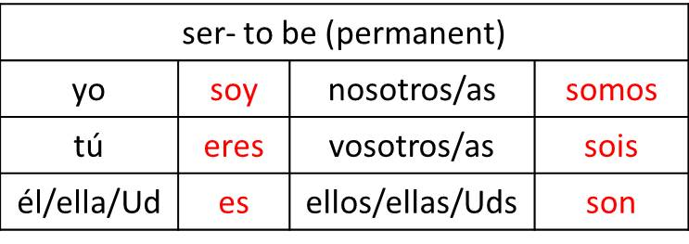
ESTAR TOBE
USED FOR LOCATION (WHERE ARE YOU?) AND CONDITION I AM WELL, ETC.

